**Life in the Novitiate, East Africa Delegation**

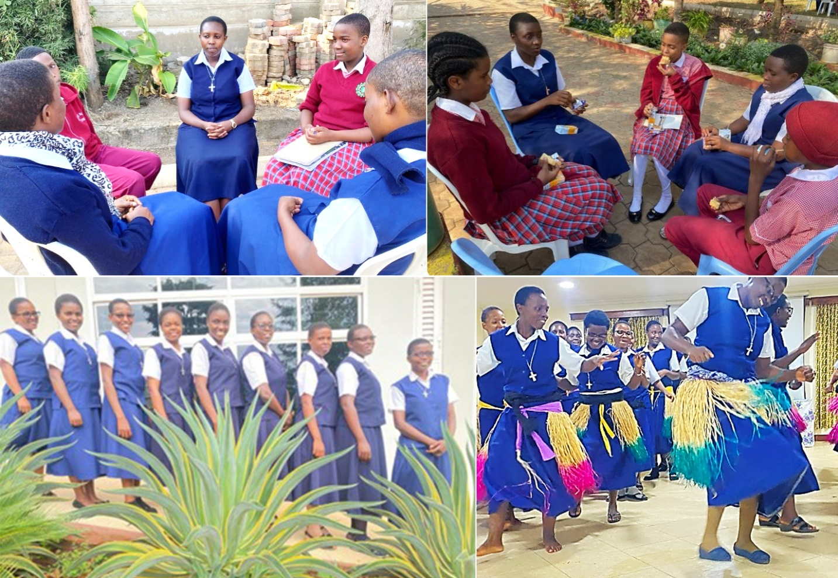

The International Novitiate—Njiro, Arusha, Tanzania—is the powerhouse of prayer, and the novices are the living stones that build up this spiritual house. Everyone who visits the Novitiate experiences a warm welcome and hospitality and becomes bonded to this family through prayers. Many get to know that it is an international Novitiate with Ugandans, Kenyans, Mozambicans, and Tanzanians as the novices introduce themselves. However, people question, “What is a novice?”

The life of a Notre Dame novice in East Africa begins at the investment ceremony. The novice receives a congregational habit, a crucifix, and the constitutions. It is through these symbols that a novice grows and gets transformed into a Christ-like image. To be Christ-like, one has to grow spiritually, physically, emotionally, and psychologically. These aspects lead the novices into a variety of classes and seminars that deepen their understanding and widen their self-awareness. Classes are mostly based on the history of the congregation and the constitutions. The novices learn to follow Jesus according to the evangelical counsels of poverty, obedience, and chastity.

Spiritually, a novice is exposed to daily Mass and participation in the prayers of the church. Days of recollection, annual retreats, presentations, and integration sessions are provided to help a novice in the process of discernment. This is often taken to mean only those processes of careful, prayerful deliberation that one undertakes when faced with a particularly important decision. However, choices are what give shape and direction to all our lives. A tremendous amount of attention is given to a novice during the two years of formation in the Novitiate house. Under the guidance of the director, novices learn to be attentive and generous to the action of the Holy Spirit. A novice is given an opportunity to grow physically by eating well, doing body exercises, going for checkups, and sleeping well. Again, a novice is encouraged to develop talents and skills such as music, card making, decorations, cooking, gardening, and running projects like the chicken project. Through these formative activities, novices sustain and enhance their living.

In addition, during the second year, a novice has an opportunity to go on a community experience. One participates in prayers, community life, and ministries.

Building up values and virtues in the successful years of formation, a novice prepares for her temporary profession of vows.