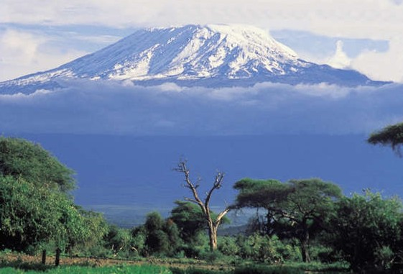

From the Roof of Africa

Sisters of Notre Dame
Holy Spirit General Delegation

October 2019 Newsletter Volume 11 #3

Outreach Opportunities in our Holy Spirit General Delegation

Impressions of My UN/UNANIMA Experiences
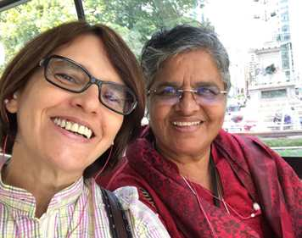
Three weeks at the UN has been an awesome experience
to feel the way the world is moving. Being in the US,
especially at the UN for the first time brought the Global
Realities very close. My time with UNANIMA
International began with a guided tour around the
United Nations Headquarters that was extremely
informative. Every day, new doors were opened bringing
more light on the efforts made by many committed people
at the UN and around the globe regarding Homelessness,
Sustainable Development Goals, Climate Change, Culture
of Peace, NGO Committee on Migration, Efforts to End
Homelessness, Gender Equality (Leaving No Woman behind) and so on. I was very happy to get a better understanding about UNANIMA and about the impact made by Religious at the UN (RUN) and the Civil Society. There were many opportunities to listen to many outstanding leaders talk on a various topics. I was really inspired by his Excellency, the King of Ghana who talked about ‘Culture of Peace’ and Greta Thunberg, a sixteen year old activist who challenged the world to act fast to save the future generation.

station wagon August 2019 Newsletter Volume 11 #3 Page 2
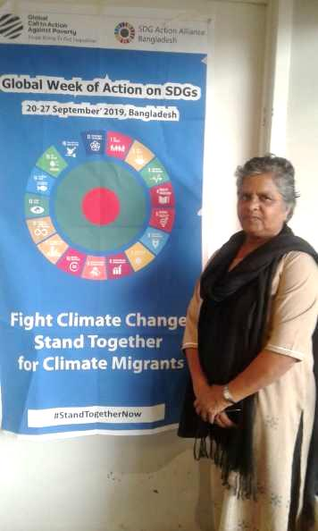
Some of the side-events like ‘Season of Creation, Laudato Si’ by Christina Leano, associate Director of Global Catholic Climate Movement, Inter-Religious Healing Prayer, World Peace Festival hosted by ‘United for human Rights’ and ‘World Fellowship of Inter - Religious Councils’ (WFIRC) and Quaker Meeting of ‘Earth Silence, Holding the World in Light’ were very enlightening.
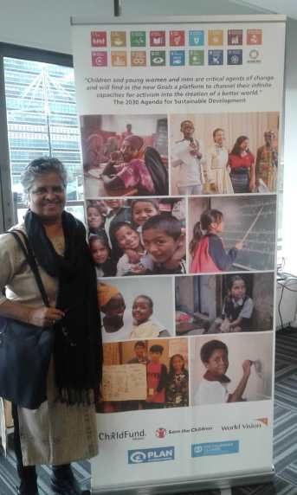

One unique experience was to
be part of the opening prayer
before the UN General Assembly
where the delegate of the Pope,
UN Secretary General, and the
President of 74th UN Assembly
were present alongside many
diplomats and outstanding
Church Leaders. It was wonderful to attend the UNANIMA Board
meeting where we had the
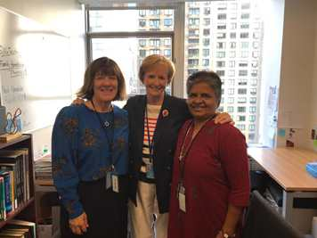
opportunity to meet the members
of the Board and also to share
about ourselves. I could
experience a true sense of
solidarity among us. Sharing
from those doing research on
‘Homelessness’ under the
guidance of UNANIMA
International brought home the
importance of tackling the
growing issue of homelessness in the world. I am looking forward to the time I have left to benefit more from all my experiences. By: Sister Mary Rashmi, SND

Caring for Mother Earth
“Education Oriented towards community Service
Kenyan students have a new curriculum from PPI (Preparatory One to Class IV) knownas CBC- Competency Based Curriculum. This year Class III had an assessment on community service. The students were asked to clean up a market with improvised cleaning materials. The students, 100 in number of Class III, grouped into six each, went with their teachers to clean up Athi River Market about 15 km from our school. The program started with a warming exercise, cleaning, disposing and disposing garbage. Each teacher had to take a photo of each student doing the activity and report it to Kenya National Examination Council. Though it was a
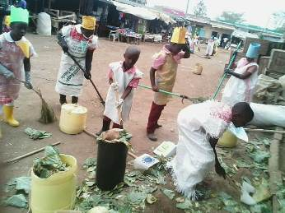

station wagon October 2019 Newsletter Volume 11 #3 Page 3
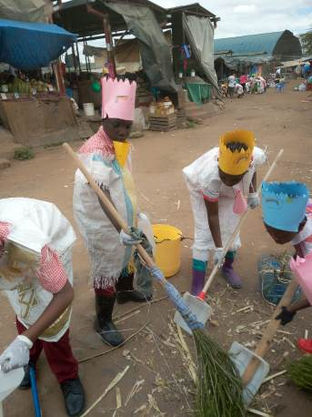
tedious task for the Head Teacher to get the permission from the county officer and arrange for this assessment in a faraway market, the outcome was very rewarding.
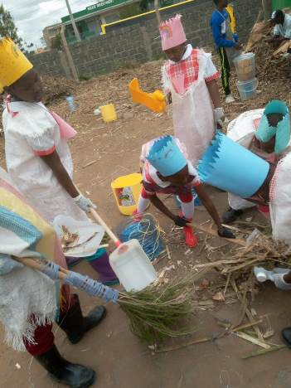

The students learned to make improvised cleaning materials at home and the parents had to take pictures of them doing this activity and send to the school. The students in this assessment learned to keep surroundings clean.

2019 TTC Group in Syokimau, Kenya
We began with an introduction to Jesus, the Master Teacher from Sister Regina Alfonso’s new book, Go Teach! And Jesus Showed Us How. This provided the impetus to begin the first part of the six-month SND Teacher Training Programme for 2019.

A few years ago, Sister Mary Nishkalanka from the Patna Province in India, had issued educational bulletins for the Sisters and these became the basis for the “Notre Dame Educational Heritage” section of the TTC presentations. Sister Mary Annete also improvised and made PPTs for each of the 10 papers that Sister Mary Nishkalanka had made. One Sister in the TTC group shared this:
“I feel privileged to have an opportunity to learn about our Educational heritage. Reading and highlighting what touched me, prompted me to reflect back on my ministry time in the past year and evaluate my apostolic life experience. I acknowledge the beauty hidden in our four corner stones and the awareness I gained. With much gratitude, I appreciate our first educators for the strong foundation of holistic education. I was most touched by this phrase referring to Sister Maria Girolama, “….she was an educator who spoke a hundred times more to God about her pupils than to her pupils about God!” This comes after experiencing God’s goodness and image in all those I minister to and with. I was touched by our dependence on God, seeing God’s image in all, valuing the dignity of everyone and proclaiming the transformative power of God. I feel blessed to have had this opportunity. By Sister Mary Catherine, SND

Sister Mary Rita Geoppinger’s videos on the four corner stones on our SND website gave further information and they were able to surprise her by composing a song on the dignity of each person. When it was sent to her over WhatsApp, she was surprised and overjoyed.

Sister Mary Jyosita shared her skills in Communications as each Sister applied what she
was learning by making classroom teaching aids, charts, and bulletin boards. They learned how to be creative, how to be practical, ways to take good photos, different ways of communicating and so much more.

station wagon October 2019 Newsletter Volume 11 #3 Page 4
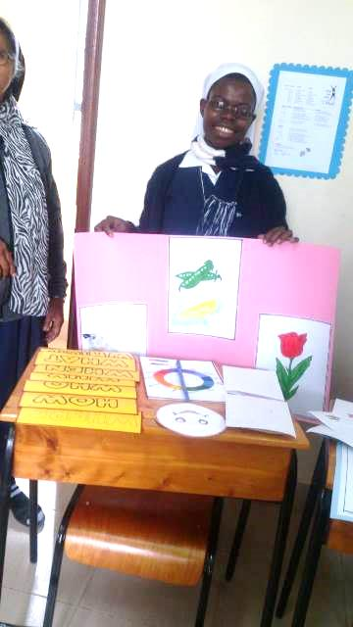
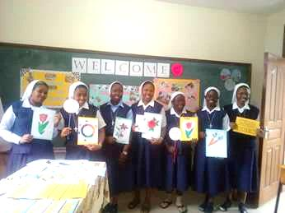

Towards the end of this particular section of the programme, they had a display in their classroom of all they had made. The Sisters in our community at that time had the wonderful
opportunity to share by viewing their wonderful accomplishments.

This year’s group also had the unique experience of going to the Mukuru Slum to get a first-hand experience of how to be with and teach children who are physically and mentally disabled.

Sisters Without Borders
We have had several opportunities here in our delegation to have Sisters come for the Sisters Without Borders experience. Sister Marge Mouch from Covington is presently in Uganda sharing her gifts and talents and also learning from various experiences and travels. She will share more with us next year on her experience over the past few years.

Sister Mary Anjali from Patna, India is presently on her “Sisters Without Borders” experience. She began in Njiro, Tanzania sharing her gifts and talents with our novices and candidates. In October she came to our delegation centre and began working with one small group from the
Teacher Training Class, while the others were engaged in the slum experience. Utilizing Sister Mary Anjali’s expertise with the computer, the Sisters were able to learn the basics of Word, using the keyboard, Excel, Power Point, Publisher, card making, etc. They had as their final thanksgiving in chapel, a wonderful sharing of those skills learned through a beautiful power point prayer service.
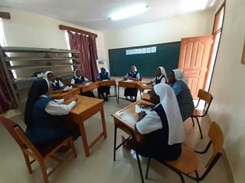
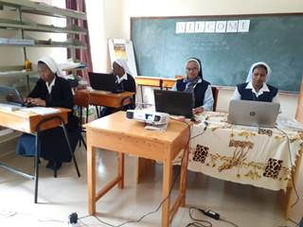

station wagon October 2019 Newsletter Volume 11 #3 Page 5

Sister Mary Anjali is also using her experience
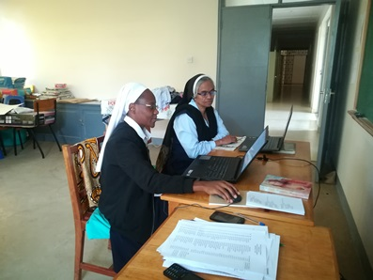
as provincial secretary, to help prepare Sister
Mary Teopista during September for that ministry
in our delegation. Sister Mary Teopista will
continue working with Sister Mary Annete in
the coming few years.

There is so much more to share, Theological
Reflection, Social Work, Catechesis, schemes of work,
etc. but this newsletter will hold only so much.
Presently, the group is now in Uganda for a
continuation of this first part of the programme and
will continue in January for part 2 in their ministry appointment and be supervised during that time.

Sister Mary Anjali will return to Njiro, Tanzania to complete her time in the programme and continuing working with our novices and candidates before returning to India in December. We are so very grateful for her time with us and all she has shared.

We Celebrate
We the Novices were eagerly waiting to celebrate our Novice Directress’ feast day on October 4th but we could not do it the way we wanted to as all the novices were attending a seminar at Canossa Spirituality Centre. So we had a quiet celebration for the real day and decided to do it in style with a high tea and also with a play and inviting all the Sisters from our Njiro Community, Zinduka, and also the Candidates.

We had secretly prepared a biblical play the entitled “Debtors” with the help of Sister Mary Neelima. The Good Shepherd Hall was the venue, the audience was on time, and we began the play at 4:00 P.M. All of us looked so different in our Jewish costumes.
The story goes like: There was a man who borrowed a great deal of money from his master. He had this money for a long time but he borrowed more and then more. People said that he did not try to repay his debt. In the end his master forgave his one thousand pound debt. He went home very happy. There his wife reminded him about the small debt that his friend owed him and he called this man and demanded that he pays it immediately. The man begged for a little more time and was ill-treated. A few neighbors who heard about this took him to their master and reported what happened.

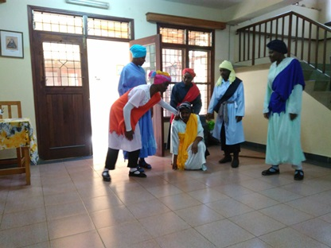

station wagon October 2019 Newsletter Volume 11 #3 Page 6
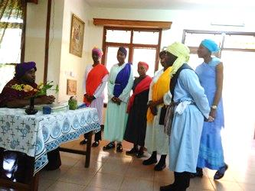
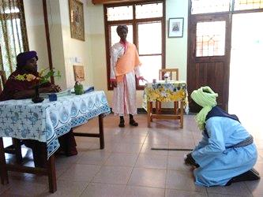

He put the man in prison because the man would not forgive his friend, although he himself had been forgiven much. Everyone enjoyed the play. We performed well and our costuming was superb. By: All the Novices
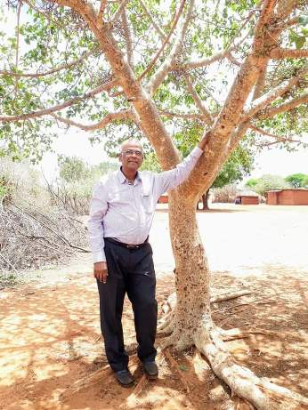

Outreach from India

Fr. Robert Athickal, SJ and Devopriya Dutta came
from India to give sessions to the Christian Brothers.
Fr. Robert Athickal, founded Taru Mitra
(Friend of Trees) in response to what he saw as a
growing environmental crisis. He set up a student
forum in Patna to encourage residents to stop
cutting down trees for firewood.

While here, Devopriya, Notre Dame graduate from
our secondary school in Patna, is what Sister Mary
Sreeja says is a “Universal Notre Dame. Truly she
lives the spirit of Notre Dame from head to toe. She
presented sessions for our Notre Dame School children
on global warming, climate change, pollution,
conservation of our Mother Earth and our common future. She also visited Syokumau, Simanjiro, Kiomboi, and Zinduka.

Both Fr. Robert and Devopriya hope to come back again to visit our schools in Uganda. The students responded positively and were very active during her sessions and were so enamored with the way she can engage the students in activities and discussions. She was very inspired by our school and students.
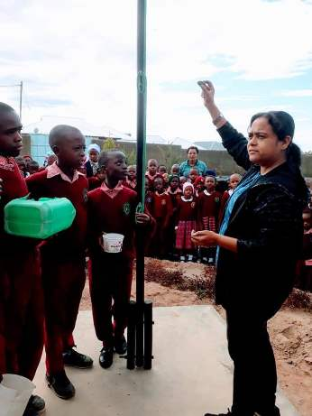
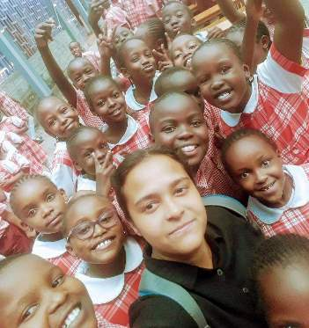

station wagon October 2019 Newsletter Volume 11 #3 Page 7

Sister Marge, who has been in Uganda with the
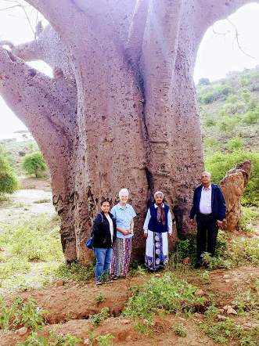
Sisters Without Borders Programme, was visiting
in Kenya and Tanzania and had an opportunity to
travel with Devopriya and Fr. Robert to Simanjiro
and stood by one of the baobab trees in Tanzania.
This tree is known as “The Tree of Life” because
during the rainy season it absorbs and stores water
in its vast trunk, enabling it to produce a
nutrient-dense fruit in the dry season when all
around is dry and arid.

Of all their experiences, they were most
Impressed with all that is taking place in Simanjiro.
They were able to meet with Sister Maria Almuth
and the group from the Dialog Projekt and
witness all that they contribute to building up our
Mission there. In our next newsletter, we will
highlight some of the Dialog Projekt’s work in
Simanjiro.

Before they left Kenya, they had one last special
visit. Sister Mary Roshini took them to visit with Sister Merie Jessie, AC who was Devopriya’s English Professor and Principal of Patna Women’s College,

Seminars:
Sisters Mary Roshini, Annete, Anjali, and Teopista attended a seminar sponsored by the Leaders’ Guild Centre for Leadership and Management. The topic was Religious Spirituality and Leadership Integration and was held at the Dimesse Retreat Centre in Kenya. The seminar was well attended by over 200 Sisters from various congregations. Each presenter’s message was well received and the Sister participants asked to have more seminars like this in the future.

Sister Therese Marie Nabakka attended a seminar on “Legal Issues that Affect the Religious” which took place in Chemchemi from 13th and 14th of September, 2019. The workshop dealt with land issues, labour laws and taxation policies in a Kenyan context. We were advised to have all our land registered properly, to study and know labour laws and employment Acts for example, labour protection policies, how to handle different leaves, employee benefits, etc. We were also advised to avoid giving loans to our workers since the loan is tax free. This is viewed by the government as helping the employees in evading tax. Also, we were cautioned on VAT, that is, we should endeavor to get receipts with VAT so that if we apply for VAT exemption, we will have no problem. We were also advised to have sisters trained in accounting so that they can be able to deal with taxes so as to avoid unnecessary penalties.
By Sister Therese Marie Nabakka, SND

station wagon October 2019 Newsletter Volume 11 #3 Page 7

A Few Farewells
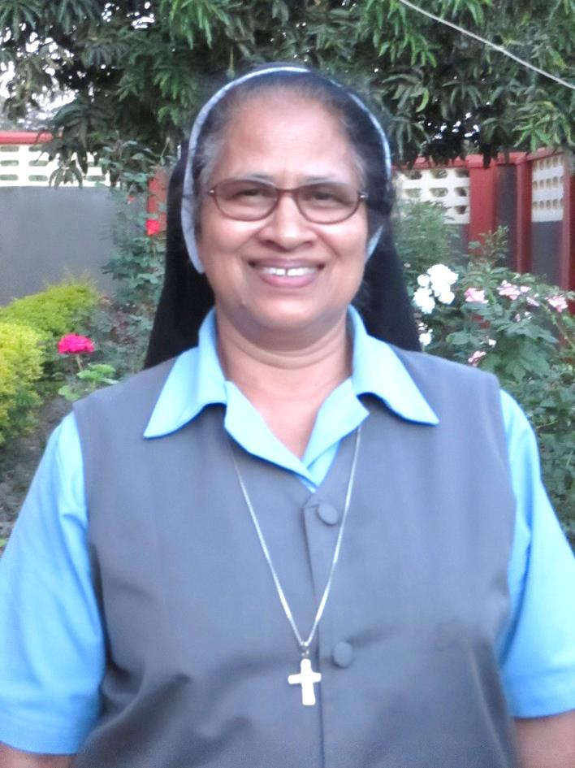
On September 7, we said our farewell to one of our “Pioneer Sisters”, our dear Sister Mary Thara. We wish you all
the best dear Sister as your return to India to continue your ministry there. You have been a blessing to all of us.

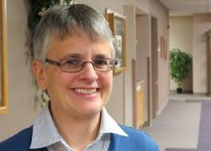

On October 5th, we again said goodbye, this time to our dear Sister Mary Tina. Sister returned to the USA, to her province in Toledo Ohio and will continue in ministry at one of the schools. God’s blessings on your Sister and know we are grateful for all you contributed to our delegation.
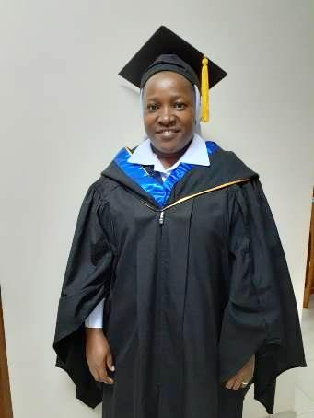

Congratulations
Sister Mary Teresa Kimario graduated on October 25, 2019
from Africa Nazarene University with a B.Ed in Mathematics.
Sister has been attending holiday classes for several years and
is happy for this completion and for receiving second honours. . She will begin her Masters in Education and Management at SAUT which is St. Augustine University, Tanzania.

Sister Sicholastica Marie graduated on October 25th and received a Diploma in Primary Education from the University of Kisubi.

We hope you enjoyed our “newsy” newsletter with all the happenings here in our delegation. In December our final newsletter for 2019 will hold even more exciting happenings.
From the Newsletter Team: Sisters Mary Annete, Neelima and Namita, SND

