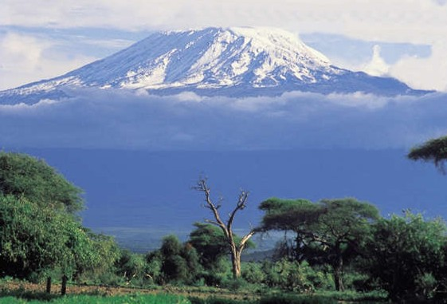

From the Roof of Africa

Sisters of Notre Dame
Holy Spirit General Delegation

December 2018 Newsletter Volume 10 #4

Bagomoyo Pilgrimage
I had an opportunity to join the Religious Congregations from Singida Diocese for a pilgrimage at Bagamoyo as the Catholic Church in Tanzania celebrates 150 years of Christianity. We had one day set apart for touring different places beginning with the Catholic Church museum to get the history of how the Missionaries came to the country. We visited the graveyard where 48 Priests, Brothers and Sister Missionaries were laid to rest. Because of the healings that took place there, we visited the grotto of Our Lady of Lourdes which was built in 1967 by the late Pope St. Paul VI, blessed by the late Pope St. John Paul the II. The slaves were healed of their wounds when they prayed to Our Lady. We also went to the Cross, next to the Indian Ocean, that marks the beginning of Christianity.
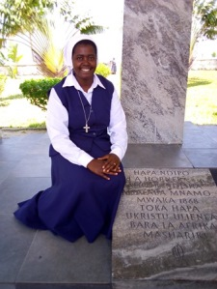
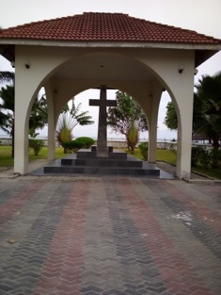

station wagon December 2018 Newsletter Volume 10 #4 Page 2

We learned how Islam began, although Islam is 800 years old compared to Christianity, and visited the Islamic graveyard. The next day we had our pilgrimage day beginning with the Way of the Cross, the Rosary, the Sacrament of Reconciliation and Holy Mass. It was a great blessing for me, our Kiomboi Community and our Delegation to be on this pilgrimage. By Sister Mary Susan, SND

Notre Dame Primary, Njiro - Maria Montessori Day

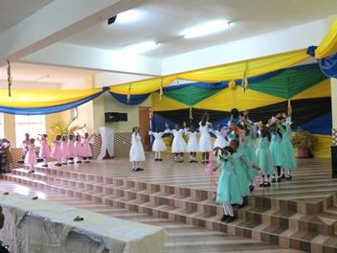
On 25th August, our Notre Dame Primary School, Njiro celebrated Montessori Day. The venue was Lourdes Hall and the celebration began at 10:00 A.M. The programme started with a prayer dance led by Montessori III. The girls looked so beautiful in their pink, white, and green dresses and the boys in their black trousers and white shirts. The children presented elocutions, poems, plays, and songs. All the items were very educative and inspiring especially the poem about “Parents Give Us Time.” The poem stressed that parents should be more available to their children at home and at school.

The children were very confident and determined in their presentations on stage, and the parents, teachers, and all present were happy to see them express themselves. A special thank you goes to the teachers who trained them, to the Head Teacher, Sister Mary Elizabeth, who organized the day, and all who supported us with their prayers. By the First Year Novices: Sisters Mary Rebecca,
Juliet, Justina, Magdaline, Catherine, Hilda, Elizabeth Marie and Maria Eva, NND
.

Notre Dame Secondary School, Njiro
A journey of many miles begins with a single step. It was a memorable day for each one of us, especially for our dear Form Four students. The celebration was on 29th September and we were blessed to have a Religious Chief Guest, Sister Dr. Hellen, the Director of St. Augustine University of Tanzania, Arusha Branch. She was very happy to be with us for this occasion and to give a word to our 52 outgoing students. Sister Dr. Hellen had prepared a very touching speech which left all of us in awe. She emphasized to our students to take the lead in being future leaders. She said she will
be happy to hear that a student from Notre Dame Secondary School is an engineer or any other profession rendering quality service to the citizens of Tanzania. She urged the parents to give quality education to the girls. She said, "To educate a girl child, you have educated the whole society.” Parents were very happy and showed a lot of
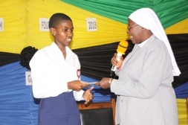
interest and all responded that they will do so. As Sisters
working in the school, we experienced a lot of great
support from our School Board Chairperson, Dr. Maleto
and his team. They all worked hand in hand with us for
the successful accomplishment of this great day for our
students.

station wagon December 2018 Newsletter Volume 10 #4 Page 3

We, too, had a very collaborative staff who were behind the students’ program which was very good and kept everybody awake all through. The students conveyed very meaningful messages to their companions, hopefully contributing towards shaping their future life.
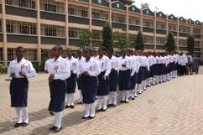

In the presence of all assembled, the best four performing science students, were each awarded 50,000Tsh by the School Board. They contributed 600,000Tsh towards the staff as well. May our Dear Good God continue to bless each one.
NOTRE DAME STUDENT IN DODOMA
One of the Form Three students, Najma Mohamed, Girl Guide from Notre Dame Secondary School representing the Arusha region, was sent to Dodoma on 8th September 2018, together with other girl guides and scouts from all other regions in the country, to participate in the seminar on Food, Health and Nutrition. It was a three-day conference in which these 31 adolescent youth representatives discussed about “Nutrition for Adolescent Youths, Taking Boys and Girls to School, Work, Early Pregnancies, Prevention of HIV/AIDS and Prevention of Sexual Abuse.” Najma was selected to present the report on the same to the Prime Minister of The United Republic of Tanzania who was the Chief Guest of the day; there were other ministers and members of the Parliament in the Treasury Square in Dodoma. The Prime Minister affirmed the effort made by these young people, and promised to work on the challenges faced by Tanzanian adolescent youth. Najma was commended and received a certificate for her good involvement and sharing in the conference. She also was nominated to participate in the Girl Guiding Training on Health and Nutrition in the Head Quarters of the Tanzania Girl Guide Association (TGGA) in Upanga, Dar-es Salaam in November or December of 2018.
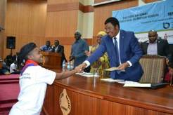
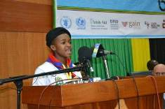

International Novitiate
Sister Mary Neelima gave the incentive for the First Year Novices to present their learnings about Church History. The Sisters from the Zinduka and Njiro communities were invited as well as the Candidates. The opening song “You are my strength” was sung by all the 1st year novices and this was followed by an elocution by three novices on the Scriptures they had chosen.

station wagon November 2018 Newsletter Volume 10 #4 Page 4

Four novices then presented the early church history until the period of the Middle Ages. The second group of novices presented from the Middle Ages to Vatican II. The novices acted out the emergence of Anglicanism and Protestantism which brought more life to the audience.

Sister Mary Neelima gave a few words of encouragement and a small gift which was presented to us by Sister Mary Elizabeth. The programme ended with evening tea for everyone present. The Sisters appreciated and thanked us. We were grateful to the Sisters, especially Sister Mary Neelima, for giving us this opportunity to share our newest learnings. By the First Year Novices: Sisters Mary Rebecca, Juliet, Justina, Magdaline, Catherine, Hilda, Elizabeth Marie and Maria Eva, NND

Notre Dame Community Lulumba, Kiomboi
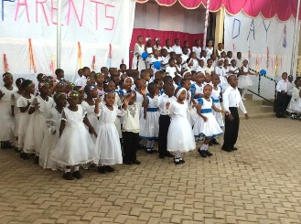
On 20th October 2018, the Notre Dame
School held their Parents’ Day, a day when
the pupils present for their parents what they
have been learning including some entertainment.

The chief Guest for the day was the District
Education Officer (D.E.O), Madame Oliver
Mgeni. In her speech, she said “Education
without discipline or good morals is of no
use.” She and the parents appreciate the good
morals we are imparting together. The parents
were very grateful to the Sisters, teachers and
the non-teaching staff for the hard work that is
helping to mould the pupils to be good leaders and citizens of our Nation.
We thank God for the good results we received from these pupils for the Regional Mock Exams in October. Our school was in position number one in the Iramba District and our pupils were among the first ones in the Singida Region. We hope to have the best results in the coming National Exams. Sister Mary Sawmya, the Head Teacher of our Notre Dame School, along with the pupils, arranged a nice programme to appreciate the hard work of the Teachers, Sisters, and the Non-teaching staff.

Thank you and farewell!
Our community was privileged to have Sister Mary Ida, a Second year Novice, for the past three months of her community experience. She completed her experience and the community feels sad to say farewell to her, yet we thank God for having an opportunity to be with her. We pray that the dear

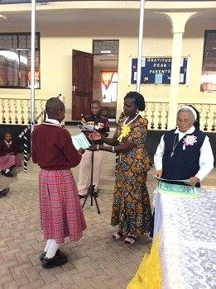

good God may continue to bless her and keep close to Him.
The Article was prepared by the Sisters at our Convent and School in Kiomboi, Singida.

station wagon December 2018 Newsletter Volume 10 #4 Page 5

JPIC: A Unique Parents’ Day, Syokimau, Kenya
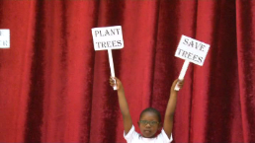

A JPIC message from “The Giving Tree” story…
Plant Trees….Save Trees. That was echoed throughout the presentation for Parents’ Day from our Notre Dame School in Kenya.

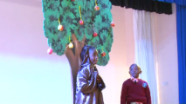

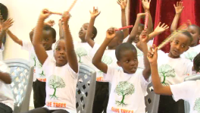

Every year the parents of Notre Dame School in Syokimau look forward to “Parents’ Day” because the programme holds a special message. This year the entire presentation, whether it was a dance, song, or skit, was centered around, “Protect Mother Earth, Save Trees.” All the children were wearing a specially designed T-shirt with this message. The skit on the book The Giving Tree was done by Class III, and the song of The Giving Tree was sung by all the students of Classes 1-3. The entire programme culminated with the children playing drums along with the message from the trees, “All that we wanted to say is that no one cares for us.” We all realized in a new way that it is our bounden duty to care for Mother Earth. The cooperation of the parents, the hard work of the teachers, and the wonderful performance of the 452 students were highly appreciated.
By Sister Mary Namita, SND
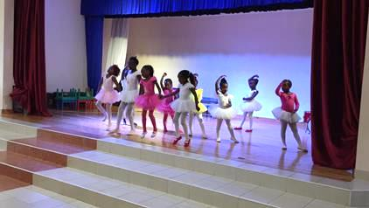

Music Camp in Syokimau

This year during the long school
holiday that started at the end of
October to December, a music camp
was conducted by Katangoma Music
and Dance group for those students who
would like to excel in singing, playing
instruments and dance, both traditional
and ballet. This being the first time
this was offered, the response from the
parents and the effort of the students
was commendable. On the last day of the camp, the students had a performance for the other

wagon Dec December 2018 Newsletter Volume 10 #4 Page 6

students and parents and those who completed the course were given certificates. We are sure that most of them will continue with their practice as they have chosen their favourite musical instrument or dance. By Sister Mary Namita, SND

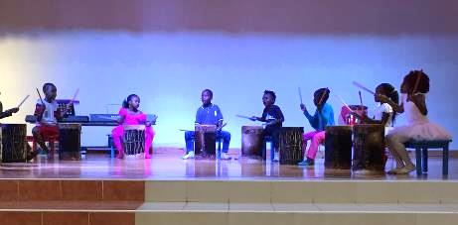
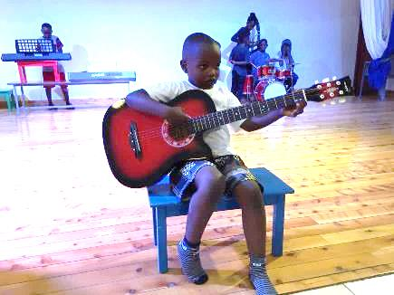

Special Visitors in Uganda
We had the great joy to have Sister Josefa Maria, the Provincial Superior of Coesfeld, Germany with us in Uganda for a few days. Sister came after the General Conference in Arusha and enjoyed the green country, the “Pearl of Africa,” and of course, the people, the students in our schools.
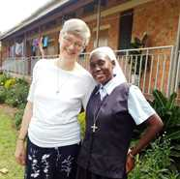

First we visited the nursery school in Mpala and then the ` convent, house of studies and Sister Mary Prerna and the 13 Postulants from Kenya, Uganda, Tanzania and Mozambique. Sister admired the farm with the cows, the chickens and goats and the great variety of fruit and vegetables in the swamp garden.

On our trip to Buseesa, she was impressed with the beauty of the environment, the forests, banana plantations, cassava fields, hills and rocks. The sisters and the students gave her a warm welcome. She had time to visit and admire the progress and development from a pure bush area into a little town with a nursery, a primary boarding school for boys and girls and the secondary school for girls. She also could witness the building of the A-level section. During her stay with us, she visited some classes, was part of our visiting day for the boarders, and enjoyed the entertainment program with a traditional dance and our Western Choir conducted by Sister Maria Bernarde. The parents found an opportunity to thank, through her, the people in Germany for their generous contributions to our St. Julie Mission. She then visited our farm and spent some time with our 14 Candidates.

When our parish priest, Fr. Godfrey, visited Germany and Vechta some years ago, it was Sister Josefa Maria who took care of him. So it was a great joy for both of them to spend some time together on a Saturday morning. Our parish is building a new large church in order to accommodate all the schools around and the many parishioners. She could admire this wonderful building and exchange ideas and experiences with Fr. Godfrey. One morning we visited the clinic in Kyabicholi where Sister Mary Lilian, one of our Temporary Professed, is in ministry as a nurse. This clinic was founded by Dr. Em from California.

wagon Dec December 2018 Newsletter Volume 10 #4 Page 7

Sister Mary Lilian introduced us to the staff and gave us a tour around the small clinic which is a real blessing to the surrounding villagers. Every month they treat around 300 - 400 patients who mostly come with malaria, syphilis, typhoid, flu. etc. They also have a maternity ward and deliver babies.

On the last day before I escorted Sister to the airport, we visited two historical sites in Kampala and the surrounding area. The first one was Namugongo where the Ugandan Martyrs were tortured and burnt alive on June 3, 1886. The other sight was a little fisher village called Kiggungu on Lake Victoria where the first two White Fathers, Father Lourdel Mapera and Father Asams landed in the first half of the 19th century. From there, they began to evangelize the Ugandan people. It was a short but full visit for Sister Josefa Maria. The Sisters were very grateful that she spent some of her precious time with us in Uganda. Sister left with manifold impressions and was happy that she had taken these days. All of us hope she will come back to the St. Julie Mission one day in the future.
By Sister Maria Bernarde, SND

Congratulation Graduates
Hearty Congratulations to Sisters Mary Berita and Edna on receiving their Montessori Certificates. Both Sisters graduated with “Distinction” and we are so proud of them. They have already begun their classes for a Montessori Diploma from the Montessori Teachers’ Association of Kenya
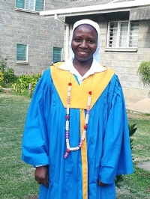
First and foremost, I thank God for God’s blessings throughout my studies. As Maria Montessori said, “Help me do it myself.” I want to extend my sincere thanks to our Delegation Superior, Sister Mary Roshini and the Council, for sending me for higher studies. During this training, I attained various skills on how to come up with teaching aids independently how to help young children to grow and become confident, patient and independent. It gave me a different view of the child, as the child is already equipped to learn, and the teacher simply directs the child’s energy in the right direction. During this past year of my internship, I taught in Montessori III in our school and can testify, as I worked with these children, that the Montessori Method is the best gift the world can give to children. By Sister Mary Berita, SND

These past two years of my Montessori Training is a gift and blessing from God and I am grateful. I want to thank Sister Mary Roshini and the Council for sending me for higher studies. After completing this certificate course, I have already begun the courses for my Diploma. I thank all the sisters who supported me with their prayers and especially Sister Mary Namita and the Syokimau community, and my own community in Njiro especially Sister Mary Neelima and Elizabeth for all your support in school. I believe that my success is your success and my joy is your joy. Working and studying together with my companion, Sister Mary Berita, has been a gift and blessing! By Sister Mary Edna, SND
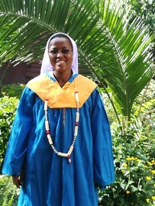

wagon Dec December 2018 Newsletter Volume 10 #4 Page 8

Groundbreaking

On November 21st, the Feast of the Presentation of Mary, even though the early morning brought some unexpected rain, the groundbreaking for the new “House of Children” began. This new construction will house our youngest Montessori children, thus making room in the school for the new government curriculum changes. We will be beginning Class 4 next year according to these
new changes and then, in 2020 add Class 5 and then in 2021 add Class 6. All government schools will have to make provisions for the new adaptation, either by adding Classes 7, 8, and 9 and/or 10 11, and 12.
So, we have begun and hope that this rainy season will not give us too many delays. We are grateful to our good and provident God for the insight and vision of our Head Teacher, Sister Mary Namita, in collaboration with our Delegation Superior, Sister Mary Roshini, for creating this new structure for our children. May God continue to bless all our efforts.

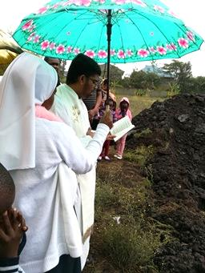
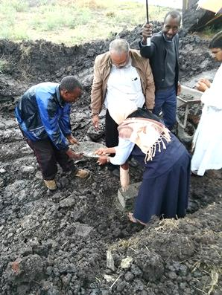

.

Happy Feastday to all our Associates
On December 2, in anticipation of the Patronal Feastday of our ND Associates in Kenya on December 8th, we had a special inspirational movie, The Song of Bernadette, where Our Lady identifies herself as the Immaculate Conception. Everyone was so touched by this movie and it provided a new spiritual impetus for each of us. Afterwards, we celebrated tea together with a special cake which is a tradition here in Africa. Our Associates were then presented with a special coloured photo of Our Lady of the Immaculate Conception with the girl, Bernadette.
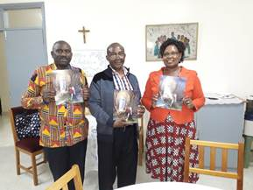
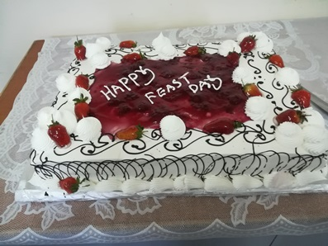

This is our last letter of the year 2018. Can you even believe a new year is soon to begin? Thank you, Sisters, for all your contributions and interest in our newsletters this year, and to all our “readers.” We hope you have enjoyed reading about all that has been happening in our Holy Spirit General Delegation. We anticipate more contributions from you, Sisters, and we know that each of you will enjoy reading with interest.
The newsletter team: Sisters Mary Annete, Neelima and Namita, SND

