From the Roof of Africa

Sisters of Notre Dame Holy Spirit General Delegation

April, 2016 Newsletter Volume 8 #2

A heart full of love and more!
“The most poswerful asset of a person is not a head full of knowledge but a heart full of love, an ear open to listen and a hand willing to help.” As part of Sister Mary Sujita’s sessions on justice, peace, integrity of creation and world realities, the tertians began an experince in one of the slums. Sisters Mary Phyllis, Susan and Therese Marie helped at St. Catherine Primary School for the less fortunate children from the Mukuru Slum in Nairobi County.
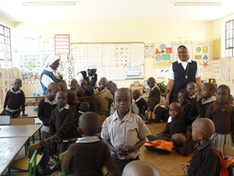

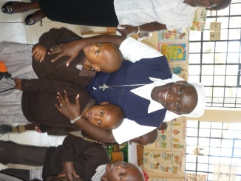
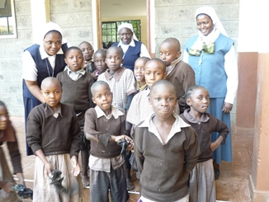

“We reached out to the children, teaching them in the classrooms. Here, children have poor faith formation and lack of basic needs. In the slum, they are affected by fire and floods that cause sleepless nights. These problems contribute to the children’s poor concentration in the classroom, even finding them sleeping when one is trying to teach them. The children also suffer from various diseases such as HIV/AIDS, malaria and cholera. The houses are congested and cases of rape,

April 2016 Newsletter Volume 8 #2 Page 2

prostitution, drugs, child abuse, theft, poor shelter and poor drainage systems are prevalent. It was such a challenging experience that opened our eyes and ears to see and lisen to the cry of the people of the slums. ‘Freedom is to know and do what is right.’ Our experience has moved us to live our Vow of Poverty more consciously by the choices we make such as living with less, sparing water, food, money, electricity, taking care of Mother Earth as Pope Francis encouraged.
Sisters Mary Kellen and Winfred worked in the Songa Mbele na Masomo (Moving Forward with Education) Centre with children with learning disabilities, those physically and mentally challenged and with school dropouts.
Sister Mary Winfred was teaching differently abled children using songs, pictures, stories, etc. which enabled them to learn with better understanding. Sister Mary Kellen was at the day care participating in caring for the physically and mentally challenged children. The children were in special wooden chairs to keep them stable.
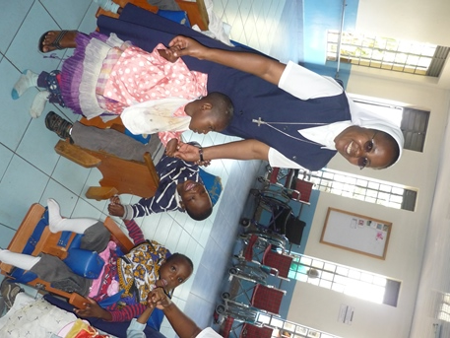

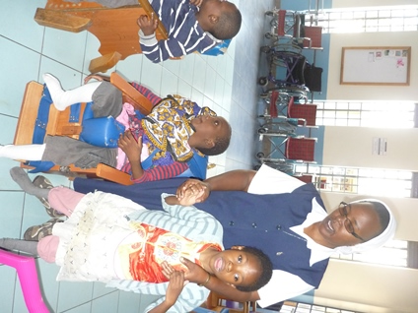

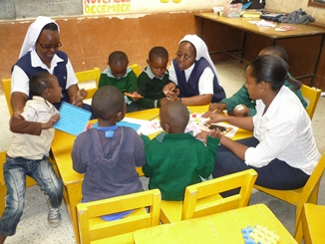
They also visited families in the slum.
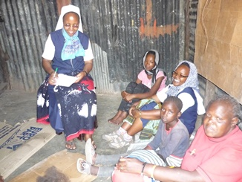

It was very challenging to see how congested the family home is. One family shares one small room which serves as bedroom, bathroom, kitchen, storeroom and sitting room.
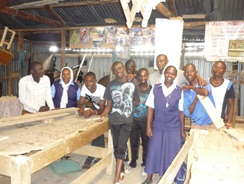
Sisters Mary Margaret and Teresa ministered at
St. Immaculate Centre for slum street children and drug
addicts.
“When I was hungry you gave me to eat.
When I was homeless you gave me a home.
When I was naked you clothed me.
When I was laughed at, you stood by my side.”
Mt. 25: 35…adapted
This was the verse from the Bible that was alive
and active for us as we experienced the life of the street

April 2016 Newsletter Volume 8 #2 Page 3

boys at the rehabilitation centre. The programme is to rehabilitate the boys from drugs and maladaptive behaviours and prepare them to continue with education from where they stopped
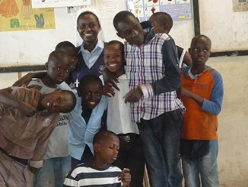
The centre has three ways of getting the street boys to the centre. First is by “walk in” where the boys decide by themselves to come and become part of the centre. Second is by referral cases from government officials, police or from other centres. Third is when the staff of MIRC goes to the streets, gather the boys at one place, talk to them about what they do at the centre and those who are ready and most needy are brought to the centre.

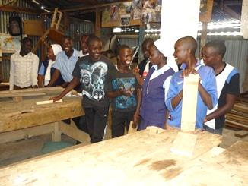

We were priviledged to help in taking the interviews
for new street boys for the year 2016. The life history
of each child was very sad and hard to listen to.

The most encouraging part was the readiness of the boys
to change their life styles, to learn good moral
behaviours and their deep desire to continue with
education
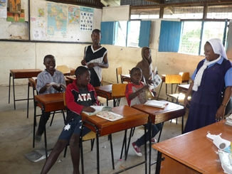
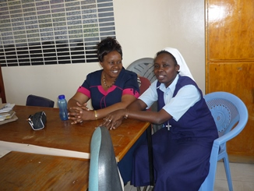

However, the boys find it very challenging to stop
taking drugs, being in the street environment and
abruptly adapting to the new environment and food. At the same time it was encouraging to see the boys who had gone through rehabilitation for one year. Having learned from life experiences from the streets, they had become very responsible, disciplined and focuced in the process of becoming better people. It was interesting to listen ot their future dreams. However, it was challenging for the adminisration to get admission for the boys in formal schools after hearing that they were once street boys. Glory to God for the chance provided to spend time with part of the needy of today sharing God’s mercy in this Jubilee Year of Mercy.

