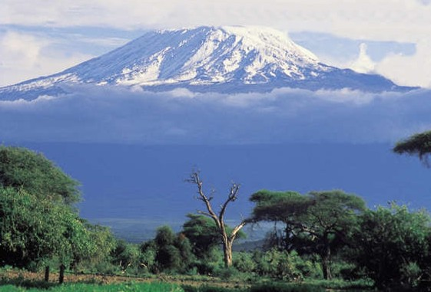

From the Roof of Africa

Sisters of Notre Dame
Holy Spirit General Delegation

January 2021 Newsletter Volume 13 #1

Holy Spirit General Delegation Assembly

WE’RE MOVING FORWARD!
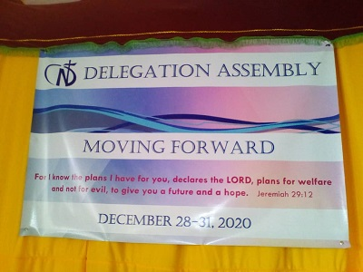

If you had any doubts, have no fear, she has us all moving forward! Yes, our dear Sister Mary Sreeja was with us for our Delegation Assembly from December 28-31, 2020. She was ready and so were we as you can see in the background! Every day was a reminder of God’s presence within and around us as we heard presentations, participated in discussions, entered into discernment for our next delegation superior and simply celebrated our life together. Our day always began with Lectio Divina where we could unwrap and share God’s word; a real blessing.

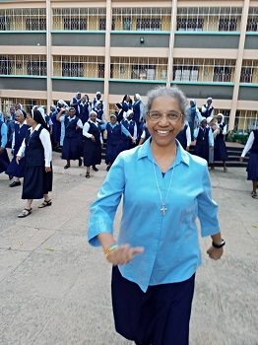

Pascalia
Margaret
Teopista

wagon O January 2021 Newsletter Volume 13 #1 Page 2

There were 52 of the 71 Sisters present for the Assembly and all were vibrant and alive with hopes and dreams and cherishing our legacy as Sisters of Notre Dame, conscious of the tremendous gift of our missionary Sisters who have gone before us. God is truly so very good! We thank all our Sisters in the Congregation for praying for us and journeying with us.
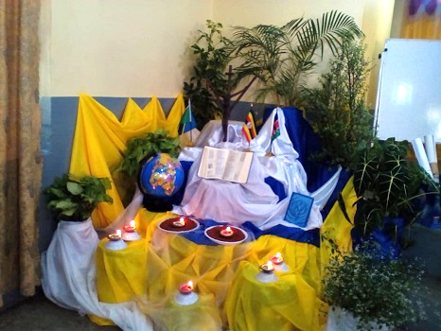
Creativity is an Art
This beautiful ambience was set up for the days of Assembly by Sisters Mary Rashmi, Veronica, Noela, Maria Jackline and Violet Marie. Each day the lamps were lit, and all the symbols used were very symbolic with the theme of the Assembly which was “Moving forward.” The plants, globe, Bible, lamps, flags, a copy of our Constitutions, the Coesfeld cross, millet growing, and a variety of colours used in the ambience created a very pleasing atmosphere for the Assembly. Everyone enjoyed looking at it.

Divine Reading and Sharing
Each day at the Assembly, Sister Mary Sreeja, our Mission Coordinator and now the one who facilitated the Assembly in East Africa, had different scripture passages for the Lectio Divina that was done at the start of the meeting. Different Sisters received an opportunity to lead the Lectio Divina with Sister Mary Sreeja. The picture on your right shows Sisters Mary Sreeja and Emmah Cindy leading the prayer. After some minutes of self-reflection, all the Sisters could get into groups of three for a short sharing.
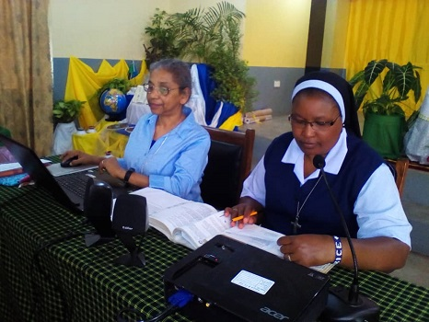

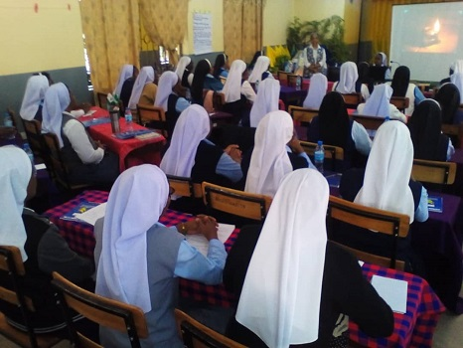
The sharing was so good! You could marvel at the presence of the Holy Spirit in each Sister in the room. To begin with this kind of prayer was a very good idea because, as Christians and very especially as Religious, we ought to give God the first priority so that all may go on well for us. Truly the Holy Spirit was and is like an outpouring of energy in our missionary work.

wagon O January 2021 Newsletter Volume 13 #1 Page 3
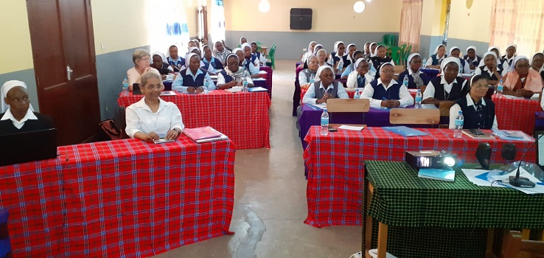

Time to review and share
A panel discussion was held in which Sister Violet Marie was the facilitator. Sisters Mary Olive, Esther, Rozaria, Mary and Noela shared beautifully on how they have incarnated the love of our good and provident God through education, social action, formation and pastoral ministries. The rest of the Sisters listened attentively to their very interesting presentations.
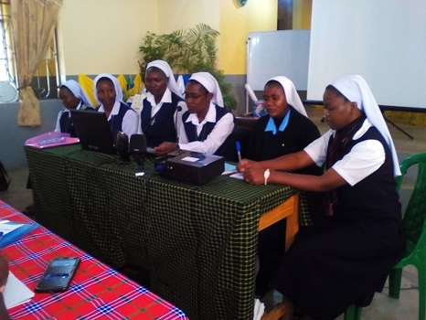

Presentations using charts
An opportunity was given to consider our profile for 2025, expressions of hopes and dreams that had been identified, and reflecting on the organogram of our present reality. Looking at all the Sisters had shared and presented spoke of the great planning and the tremendous work of the Holy Spirit. Sisters were able to present their sharings which gave us the momentum to continue moving forward. Each group considered the best practices in the delegation. Time was taken to consider the meaning of the term, legacy, already discussed in our zoom presentations. Each Sister came to a better understanding of the legacies left behind by our missionary Sisters and those that we are leaving as a legacy for the future ND generation.

wagon O January 2021 Newsletter Volume 13 #1 Page 4

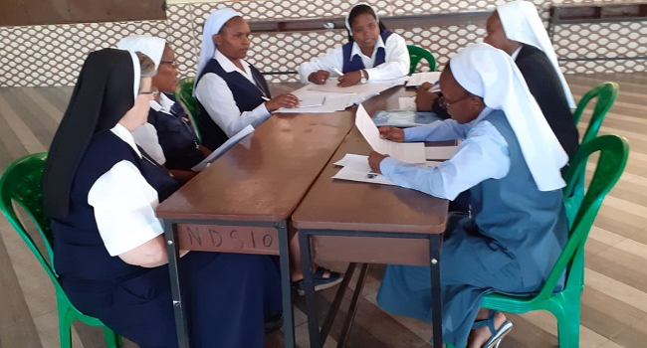
World Caffe
After an hour of silence and prayer before the exposed Blessed Sacrament, each Sister discerned four names and qualities of the Sisters whom they would consider for Delegation Superior. Following this, there were nine group leaders who were prepared to conduct the World Caffe activity. This listening and sharing lasted for a period of two hours without any interruption. These nine table leaders took note of the names suggested by each member as well as their respective qualities. Each participant made at least six rounds among the nine tables. The exercise ended with tallying the Sisters who were suggested. These nine leaders then submitted the names and the number of times indicated.

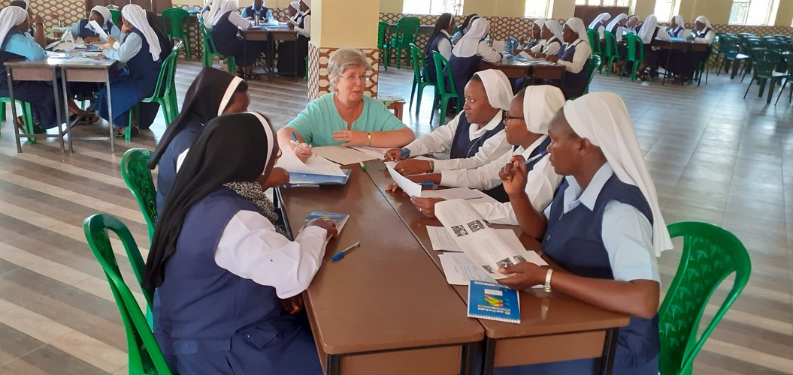

The list was then presented to Sister Mary Sreeja who compiled the top names suggested.
These Sisters were met individually and had the opportunity to leave their names on the list
as a possible candidate for Delegation Superior or remove their names with reasons shared
with Sister Mary Sreeja. The top four names were then announced to the Assembly. The
Sisters gathered again before the exposed Blessed Sacrament for another hour of prayer
before making their suggestions for their 1st and 2nd choice for Delegation Superior.
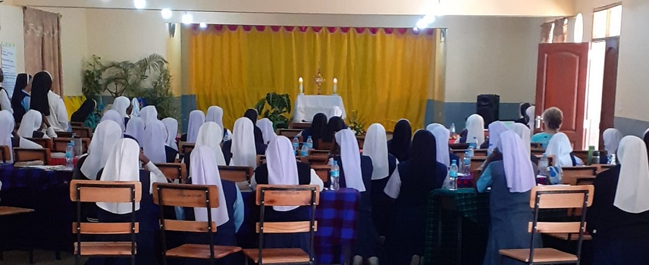

wagon O January 2021 Newsletter Volume 13 #1 Page 5

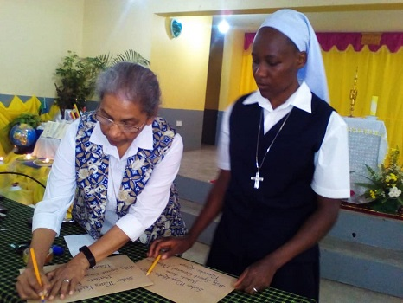

It was a solemn moment! Sisters Mary Sreeja and Teopista moved around the Assembly collecting the papers from the Sisters, counting them to make sure all 52 Sisters present submitted their suggestions. They sealed the two envelopes provided with Sister Mary Kristin’s name on the envelopes, as the rest of the Sisters sang a joyful Magnificat. Sister Mary Sreeja will take these envelopes back with her to Rome as the Sisters in the Delegation await the announcement of our new Delegation Superior elect.

Here we are!
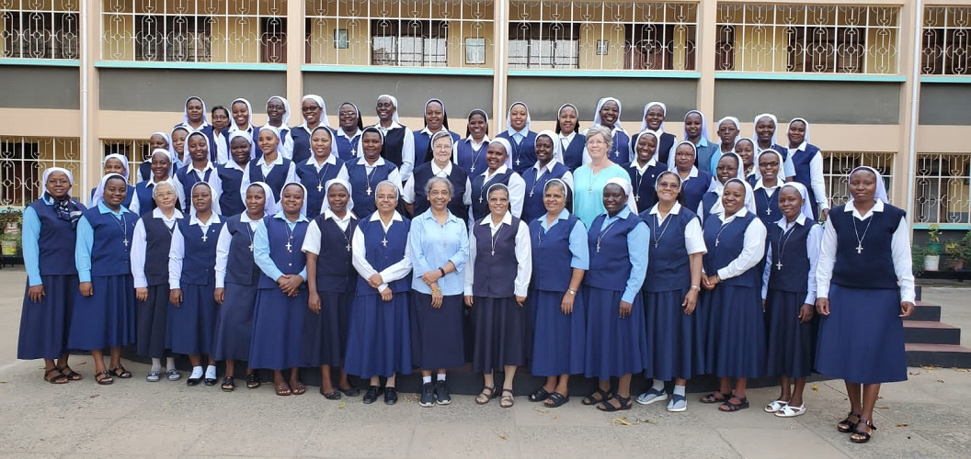

Members at the Holy Spirit General Delegation Assembly
All 52 Sisters who were able to attend the Delegation Assembly considered it a graced experience. It was a time of sharing life and truly “moving forward.” Everyone felt that the Assembly was successful during the period of the pandemic. We thank all our Sisters in the Congregation for journeying with us prayerfully during the Assembly. How very good is our good and provident God!

wagon O January 2021 Newsletter Volume 13 #1 Page 6

Beginning to move forward!

In a special prayer service in the early afternoon, with all the Temporary Professed Sisters present, Sister Mary Mukti presented a lit candle to Sister Mary Margaret who will now be the new Director of the Temporary Professed Sisters.

In her years in this ministry, Sister Mary Mukti travelled much to visit the Temporary Professed Sisters in their various communities, held special classes with them, companioned each of them on their formation journey and was held in high regard. We thank her for giving of herself so generously in this ministry and ask special blessings on Sister Mary Margaret who began her new ministry on January 1, 2021.
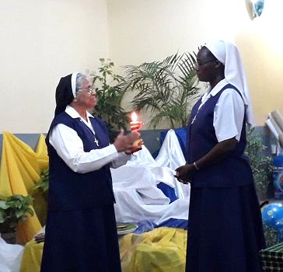
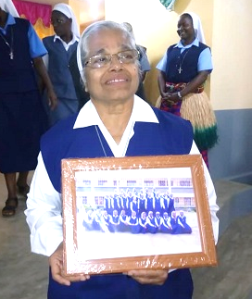

As we bring this special newsletter on our Delegation Assembly to a close, we are grateful to all our Sisters, not only in our Holy Spirit General Delegation, but in our world-wide Notre Dame family for your love and support. Our Sisters gathered for this Assembly from Uganda, Kenya and Tanzania. Crossing borders to arrive in Tanzania took a lot of planning and arranging with drivers, each Sister and driver having to take the COVID-19 test and more. We thank our good and provident God for that divine protection we all pray for daily and we thank those Sisters who stayed behind to keep our convents safe and protected.

We ask all of you, our readers near and far, to keep us in your prayers as we continue our journey of “Moving Forward.” Namita,
From the newsletter team: Sisters Mary Annete, Teopista, and Namita, SND

