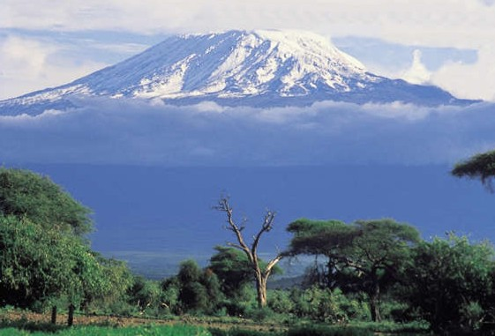

From the Roof of Africa

Sisters of Notre Dame
Holy Spirit General Delegation

November 2020 Newsletter Volume 12 #3

General Conference 2020 A Global Experience on Zoom
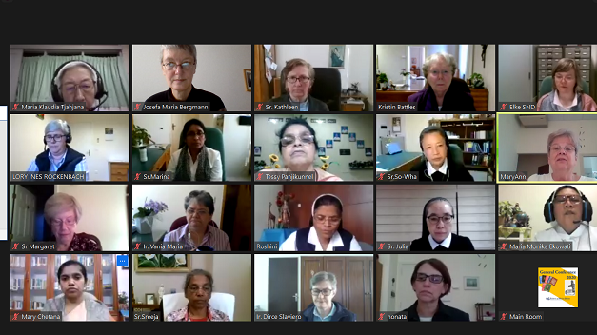

wagon O November 2020 Newsletter Volume 12 #3 Page 2

It is with much happiness and fulfillment I want to share with you the joy of our General Conference on Zoom. We felt as though we were all gathered in one hall. Sister Mary Kristin’s opening address put us in the mood of the conference. Weren’t we lucky to have the arrival of the new encyclical of Pope Francis, “Fratelli Tutti”, at the right time.

You received the rest of the news and all about the conference from the recent letter of Sister Kristin; I will be sending additional communications in the near future. Our beautiful and relevant theme, “Renew the Face of the Earth…Cultivate a Culture of Encounter and Caring”, for the General Chapter should lead us to prepare ourselves for the 2022 General Chapter and for a renewed way of life and ministry in this post pandemic age. By Sister Mary Roshini, SND

From Rome to Home
It is with immense joy that I once again thank you, Sister Mary Kristin and the General Council, Sister Mary Roshini and her Council, you dear Sisters in Casa Madre Community and all of you my beloved Sisters in the Holy Spirit General Delegation. My beautiful experience of being in Rome was so much because of your Sisterly love and concern; I owe each one of you much gratitude. From January 2019 to July 2020, I was privileged to participate in the UISG (International Union of Superiors General) Formators’ Programme, the Notre Dame Formation Program, and one year of additional courses from the Angelicum University to equip me for the mission of Notre Dame in the Delegation and for my personal growth. I appreciate each and every opportunity that was given to me to learn and grow.

However much I missed the Sisters in our Delegation and my family at home, I must sincerely say that my Casa Madre Community in Rome was a “home away from home,” an ideal community of the Sisters of Notre Dame, an exemplary community of internationality and intercultural living. Bravo to all the Sisters in Casa Madre! I am happy and excited to be back home. I am looking forward to all the surprises that the Holy Spirit has for me and the Delegation. Once again, I thank all of you for helping me reach this far. “Thanking God every moment I think of you and when I pray for you, I pray with joy.” By Sister Mary Margaret, SND

Successful completion of my Studies
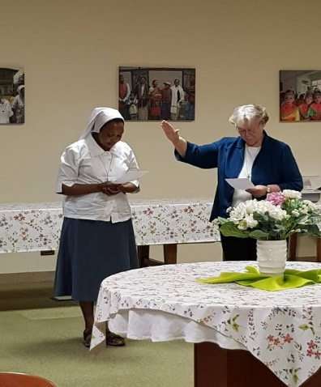
First and foremost, I am very grateful to God for bringing me to the end of my three years’ studies at the University of St. Thomas Aquinas-Angelicum in Rome. This could not happen were it not for the help and support of the Congregation, my Delegation, my community in Casa Madre, my professors, my classmates, and friends.

Words are not enough to express my sincere gratitude
to Sister Mary Kristin, our Superior General, Sister Mary
Sreeja, Assistant Superior General and our mission
coordinator, the whole General Council and General
Administrative team for making it possible for me to study
in Rome. I was a beneficiary of the SND Congregational Fund

wagon O November 2020 Newsletter Volume 12 #3 Page 3

that covered my school fees, study materials and my entire stay in Rome. I will always remain grateful for this.

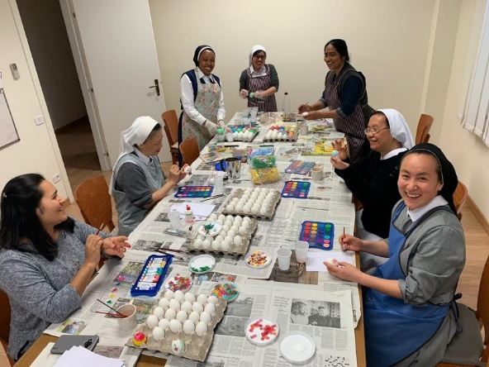
I extend my gratitude to our Delegation Superior, Sister Mary Roshini, her Council and all the Sisters of the Holy Spirit General Delegation for freeing me from responsibilities in the Delegation. This made it possible for me to stay away for the three years. Although I was far, I experienced a lot of encouragement and support from all of you. I count it as a big blessing to have lived in Casa Madre, our Generalate, in Rome. Thank you, Sister Linda Marie and the Community.

When I look back to the 11th September 2017 on the flight on my way to Rome, I remember many thoughts crossing my mind. I wondered how life would be, how I could live with the Sisters from all over the world, how my school life would be, and how I would integrate myself into the life of the new community. Immediately after my arrival, the warm welcome and the hospitality I experienced from the Casa Madre Community left me with no doubt this will be a wonderful home for me. Yes, indeed it was.

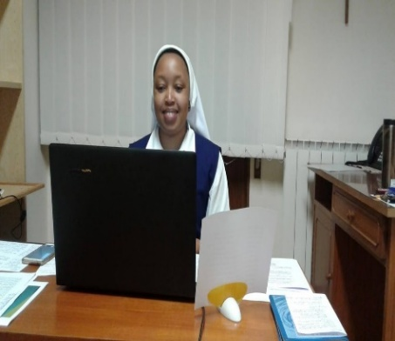
Living and studying in Rome gave me many opportunities. I have learned much from our Sisters both in the community and all those who visited the community from our different provinces and delegation. I experienced and lived the internationality of the Congregation. This way I learned a lot about the other units of our Congregation. The Sisters who came to Rome for gatherings, pilgrimages, meetings, conferences, and visits also enriched my life. It is very amazing to see how many comings and goings take place in Casa Madre in a year. Thumbs up for the hospitality of the community! Indeed, it was a great lesson for me.

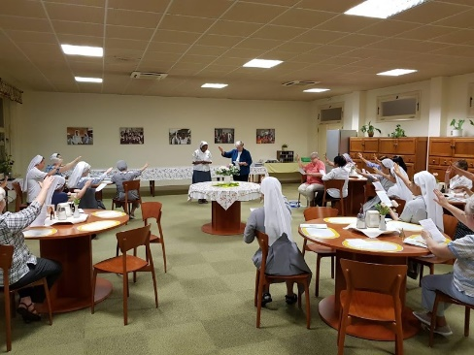
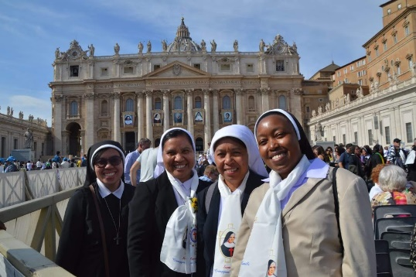
Our Sisters from different provinces who came to Casa Madre for the English Language Course every year have been a great inspiration for me. Their great effort, zeal, and readiness to learn English always challenged me. I will remain ever grateful for the opportunity to visit different places within Rome and outside Rome. Visits to St. Peter’s, Major Basilicas in Rome and different historical places gave me a deeper understanding of the Church in the past, now and the position of the church in her universality and diversity. The call to embrace the diversity and live in communion was constant. The interconnectedness of the whole universe, care and respect for our one common home was always emphasized.

wagon O November 2020 Newsletter Volume 12 #3 Page 4

My studies at the Angelicum helped me to acquire a Philosophical and Theological background. My completion of a Bachelor’s Degree in Religious Sciences helped me to deepen my knowledge of God through scripture studies and theology. The Philosophical subjects have helped my reasoning towards deepened knowledge of God, man, and myself. This has been a preparation for mission in the Church. As the Congregation sends me forth to live our charism, spirit, and mission, I take these studies as a tool to help me “dive into the deep” in the experience of God’s goodness and his provident care.
By Sister Mary Pascalia, SND

Great Joy in Simanjiro, Tanzania
This is an historical time for the Sisters of Notre Dame in Simanjiro, Tanzania and our Maasai people. “The dear God knows best; what he does is well done.". Sister Mary Rashmi had applied to the Congregational Fund for a Water Project to get clean and safe drinking water for the Maasai people. On September 8th, the Feast of the Birth of Mary was the day intended to begin the work
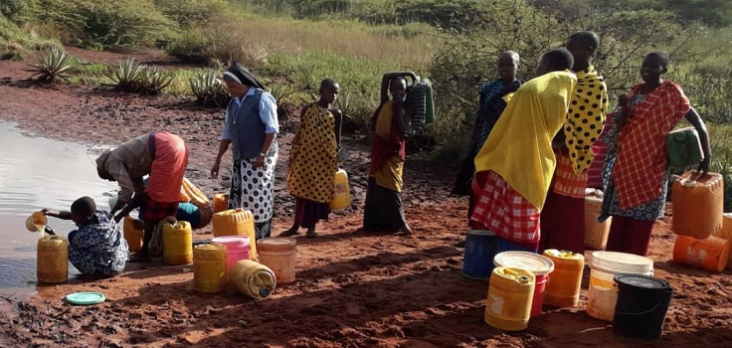

Our Maasai people in Simanjiro, Tanzania
have been longing to have clean water.
Our people have been struggling for water
from any stagnant water hole. They crowd
together once a week to collect water from
the place where cattle, goats and sheep are
provided with their water and they use
donkeys to carry water or carry it on their back.
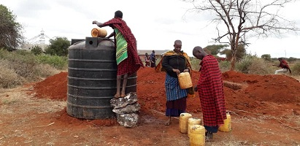

With this new project, Sister Mary Rashmi had asked the people to start collecting materials and start praying. They collected 12 leads of stones, 10 loads of sand, 5000 burnt bricks and use trees as poles.

When we heard that we would have official visitors, our children gathered and lined the drive into the compound as a sign of welcome and respect. Our former Prime Minister Honorable Peter Pinda, Member of Parliament, Honorable Christopher Ole Sandeka and other dignitaries visited the site and expressed gratitude and appreciation for our involvement in the developmental program of the area.

wagon O December 2020 Newsletter Volume 12 #3 Page 5

Along with them would come the District Commissioner and other leaders from the District, Region, different Wards, etc. The minute the former Member of Parliament stepped out of the car, he asked Sister Mary Rashmi the same words our Archbishop uttered when he came here, “Sister, how did you

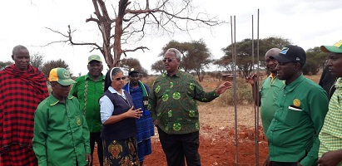

manage to reach here so far away?" We all know that the ministry in Simanjiro is a special ministry of the Sisters of Notre Dame as we have gone to the margins to be with God’s people in need.

The Maasai community gathered along with all the local government leaders, had speeches and prayers over all the materials and started cleaning the place where the tank would be. Because there is a well, the pump house will be built near the well
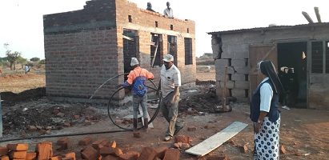
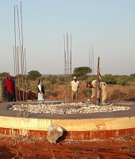

The progress on the water tank in moving along and is
beginning to take shape; the people are filled with hope and
gratitude.

There were many comments from different people about our school, the work of Sisters of Notre Dame, etc. especially as we shared tea together at the site. One person said, " Surely, there is a place reserved for you in heaven for the work you are doing. We can't thank you enough." We thank you dear Sisters around our Notre Dame world for your prayerful support and for the work and contributions of the Dialog Projekt in Germany.

We can surely shout for joy as we say a huge thank you to God and our Notre Dame family!

wagon O November 2020 Newsletter Volume 12 #3 Page 6

E-learning in Syokimau, Kenya
Sister Mary Namita, the Head Teacher of our Notre Dame School wrote: Covid-19
is a big void between the parents, students, and the
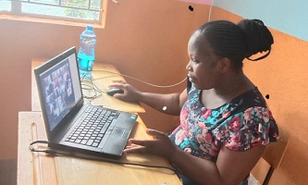
school. With no students present, and no personal
communication with the parents, the only option
was to train teachers for digital learning. It
necessitated furnishing the classrooms to have the
e-learning classes be conducted from the school.
Mr. Policarp and Mrs. Miriam, our resource persons,
not only trained the teachers, but also did the
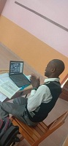
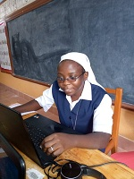

follow-up of the program to make it interesting for both the students and the teachers. This being a new experience for all, there were many hurdles in the beginning. Now the students from Pre-primary 1 to Class 5 enjoy the classes including the physical exercise offered to them using the web cameras.
By Sister Mary Namita, SND

As a result of the Covid-19 pandemic, most schools were closed and had to switch to virtual learning as the only alternative. Online learning experiences have had their own share of merits and challenges. The merits include: (1) most teachers who were not computer literate were able to learn how to use computers and social media in teaching; (2) both students and teachers were able to interact through learning platforms such as Zoom and Google classes. Some challenges experienced with online learning included: (1) it is hard to control hyperactive students; (2) the slow learners were not able to get personal attention from the teachers due to limited time; (3) there were network problems and technical problems with the laptops. All in all, it has been a learning experience for everyone.
From the E-learning teachers at Notre Dame School, Syokimau, Kenya
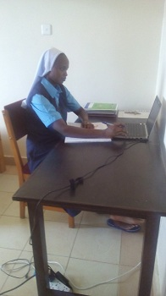
More E-learning:
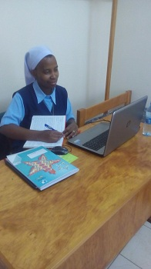
This happened not only
in Notre Dame School
but also in our convent!
Our seven Sister Students
each had classes over
Zoom and other internet
possibilities from their
respective universities.

wagon O November 2020 Newsletter Volume 12 #3 Page 7

Classes continued, exams were taken, assessments given and all because of Covid-19. Nevertheless, each one felt that their educational programme could continue despite challenges with internet and electricity. Now all are back in their universities except Sister Mary Irene because, all the students that were taking classes through the education department at Tanganza University, could not be accommodated on campus; therefore, those students were asked to remain at home for their online classes.

Environment – Kuni Safi – Save Trees
Kuni Safi means clean firewood that is made out of compressed sugar cane waste into cakes to be used in place of firewood for cooking. Notre Dame School in Syokimau has made many efforts to create awareness of protecting nature and saving the trees through cultural programs, printing of T-shirts, songs, making seed bombs, and planting trees within the school compound. We have introduced Kuni Safi (in place of firewood) to cook food for 800 people a day. Mr. Musyoka from Acacia Enterprise gave a demonstration to our Class 4 students about the use of Kuni Safi and how it helps to protect the forest. “Use Kuni Safi, save the trees, protect mother earth.”
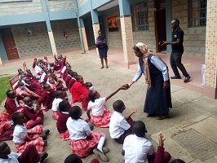
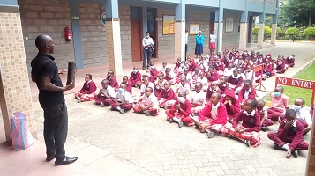

Postulants Arrive in Uganda
November 5th became another important day
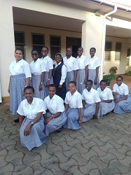
in our Mpala Community as our Postulants
from Buseesa, Uganda and Arusha, Tanzania
arrived to meet their Postulant Director,
Sister Mary Prerna. The following day,
the Postulants from Mozambique arrived.
Because of Covid-19 these 12 Postulants had
to begin their Postulancy in their respective
countries. Finally, with the possibilities of travel
to Uganda, the journey began for all of them.
Their arrival brought great joy to all in that
community and especially to the Postulants.

wagon O November 2020 Newsletter Volume 12 #3 Page 8

Our Missionaries Return to India

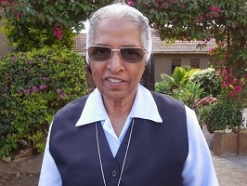
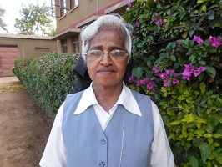

Sister Mary Pramila, SND Sister Mary Neelima, SND
On August 29 we said farewell to our dear Sisters Mary Pramila and Neelima who returned to Patna, India. Both Sisters will have a time of renewal before beginning a new ministry and Sister Mary Neelima will also have her Golden Jubilee celebration. Sisters, you have been an important part of our life and ministry here and we will miss you greatly. God bless both of you.

We bring this newsletter to a close and look forward to meeting you in the New Year. We pray God’s blessing on each one as we will soon approach the Advent Season in anticipation of the great celebration of the Incarnation….Christ coming to birth in each of us and in our world so in need of Christ’s presence and healing.

May God bless you and keep you safe and healthy.
Your newsletter team: Sisters Mary Annete, Namita and Teopista, SND

