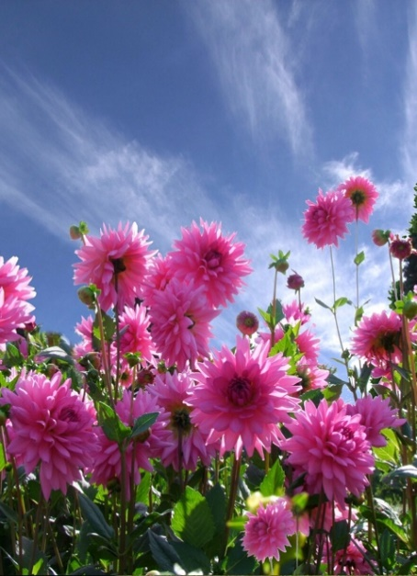

Season of Creation
Pope Francis called for a year of celebrating the encyclical on integral ecology,
Laudato Si'. We continue to learn and discover ways we can more deeply experience the connectedness of all of creation.

The Global Catholic Climate Movement is committed to helping us put Laudatio Si' into action. The Laudato Si' Animators program is a ten-week course that encourages ecological conversion so that we can educate and advocate for all who inhabit our common home.

If you are a Laudato Si' Animator or interested in becoming one, contact Ann Clark at aclark@sndusa.org or call 440-279-1182.

“Perhaps, before we can care for
our global common home, we must first love and value and nurture our own
corners of creation.”
– Bill Patenaude, author of the Catholic Ecology blog

JPIC National Office
Co-Directors Ann Clark Katie Drager
Co-Chairs
Sr. Joyce Bates, SND Sr. Kathleen Ryan, SND

Saint Kateri Habitats
The Saint Kateri Conservation Center is a national Catholic conservation group that promotes faith, integral ecology and life. One of their endeavors is called the Saint Kateri Habitat program that encourages individuals and groups
to restore and maintain healthy habitats for people and wildlife.

June 2020 celebrated the fifth anniversary of the promulgation of Laudato Si'. In celebration, the SNDUSA Province areas submitted applications for Saint Kateri Habitats and each area had a qualified space that received the designation.

These habitats are featured on the Saint Kateri website and on their blog.
https://www.kateri.org/

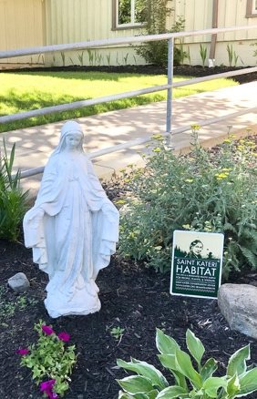
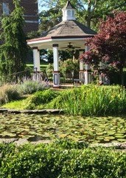
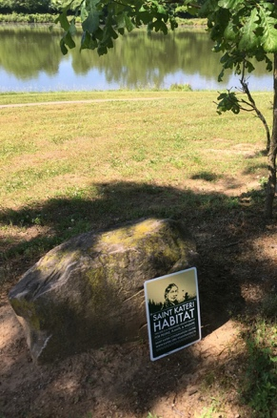
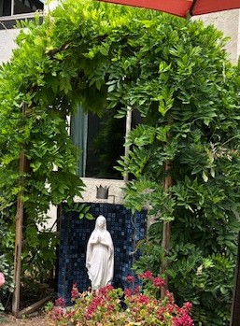
Thousand Oaks Covington Chardon Toledo

Sisters of Notre Dame JPIC National

