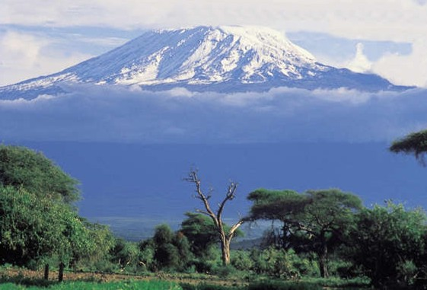

From the Roof of Africa

Sisters of Notre Dame
Holy Spirit General Delegation
August 2021 Newsletter Volume 13 #4

General Visitation—Leadership in-service
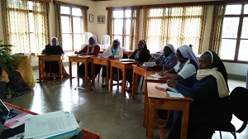
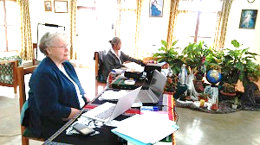

What a privilege to host Sisters Mary Kristin and Mary Sreeja from July 9th -26th 2021! Originally the plan was to have the General Visitation in our Holy Spirit General Delegation way back in May of this year. Because of Covid -19 situations, this was not possible. Sisters Mary Kristin and Sreeja arrived in Arusha on July 7th. They were so much prepared to begin the in-service programme with the new leadership team composed of seven members. In this programme, the leadership team had their days of learning, discussion and sharing. They also had a day with formators, the local superiors, and the administrators of institutions in our Holy Spirit General Delegation. They also had time to meet the novices. In between the programme, Sisters Mary Kristin, Mary Sreeja, and the delegation team had an opportunity to visit the Cultural Heritage Centre in Arusha, Nduruma farmland and Simanjiro in the Maasai land.

wagon August 2021 Newsletter Volume 13 #4 Page 2

The leadership team had multiple opportunities to interact with one another, with Sisters Mary Kristin, and Mary Sreeja the facilitators of the in-service programme. The Sisters were helped to integrate what they were learning with the current realities in the Delegation, the Church and the World as a whole. In addition, Sisters Mary Kristin and Mary Sreeja were available and willing to answer the questions asked of them. They explained the leadership roles and the important Church documents such as Canon Law, the Congregational documents such as the Constitutions, SND Philosophy of Resources, Mission Policy Handbook, Leadership and Emotional Intelligence, the Internal Governance Structures, Delegation Guidelines, Congregational Manual on Formation Programme, Record Keeping, Long Range Planning, the October 2020 letter that introduces the new Chapter theme, etc. All these and more were so enriching to the leadership team. At the end of it all, the leadership team felt energized, encouraged, supported, and ready to move forward in serving the Delegation and the Congregation through which the Church sends each one of them.
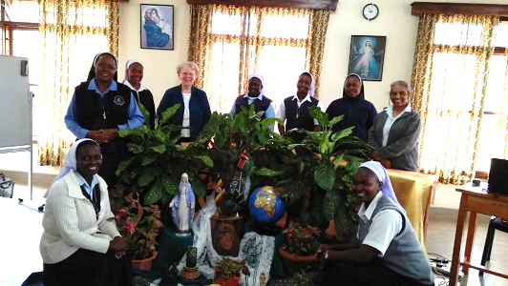
Sisters around the beautiful ambience arranged by Sister Mary Pascalia and the Novices.
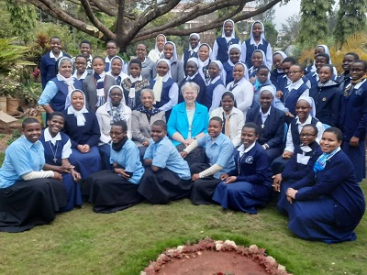

On July 18th, Sisters Mary Kristin and Sreeja had a meeting with the formators together with the leadership team. After this, the formators took time to review and update the formation manuals. Also, the group of local superiors and the leadership team had their meeting in which they received valuable input from Sisters Mary Kristin and Mary Sreeja.
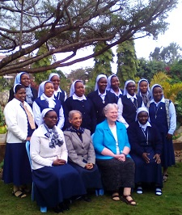
The Sisters had an opportunity to reflect on the handouts given to them by the facilitators and they too shared their experiences in their roles as local superiors in taking care of the sisters and other responsibilities entrusted to them. Group discussions were a source of learning for all. There were days of relaxation, though limited by the Covid -19 situation to visit many places. Our Sisters managed to visit one of our communities in Arusha-Simanjiro where they had good time with the Maasai people. Before going to Simanjiro, they had visited Nduruma land and came home with a lot of produce from the farm.

wagon August 2021 Newsletter Volume 13 #4 Page 3

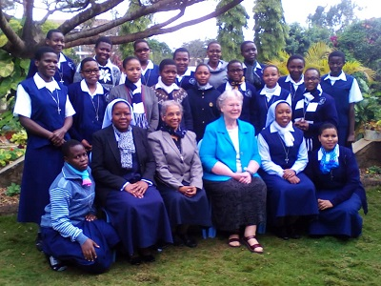
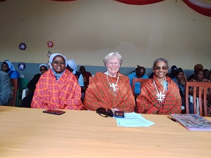

Our Sisters’ visit to the Maasai land

In general, the In-service Programme was excellent. The Sisters completed the programme with the right attitude ready to carry out their responsibilities. This period created awareness, increased the knowledge, communication skills, planning skills and self-confidence among the Sisters. They felt ready to continue the mission of Christ in the Delegation with the help and support of the General Government and the Sisters in the Congregation keeping in mind the General Chapter theme; “Renew the Face of the Earth; Cultivate a Culture of Encounter and Caring”.
The whole Visitation and in-service time was crowned with a “Thank You Programme” to Sister Mary Kristin who has generously served the Congregation and loved the mission in East Africa with her whole heart.
Congratulations for the Excellent School Results!
St. Julie Model Primary School is grateful to God for the miracle of the excellent results obtained in the Primary Leaving Examinations for the 2020 academic year. Twenty-three students sat for the exams and all passed with a first grade. We are grateful to the school management committee, teachers, parents, Notre Dame Sisters, our pupils and all the well-wishers

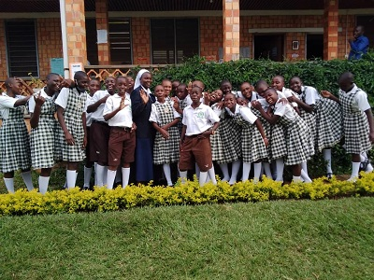

for the tremendous support accorded to the school which has led it to reach the highest peak of its academic performance in these examinations. It is fitting to give praise to the Lord for his love and mercy. We can exclaim like the psalmist in psalms 107:1 “Oh give thanks to the Lord for he is good, for his steadfast love endures forever.”
The school is grateful to all the generous donors for their support. During this Covid-19 time, it has not been easy to manage the school. There has been a lot of financial hiccups which have made it difficult to pay the teachers remunerations as well as taking care of the everyday needs of the school. May God bless all those who support our school. St. Julie School has maintained its vision and mission of providing education based on Christian values. It has ensured that children are spiritually, physically, socially and morally trained, psychologically and academically formed.

wagon August 2021 Newsletter Volume 13 #4 Page 4

In our education we give priority to the poor because it helps us to give witness to Christ and to Gospel values.

Academic excellence at Notre Dame Academy
Truly it is good to give thanks to our almighty God who has worked hand in hand with the staff and students behind the excellent results that we have obtained. The students at Notre Dame Academy in Buseesa like any other school in Uganda suffered a lot because of the lockdown due to the pandemic of Covid-19. Despite that, they worked hard with a lot of commitment to their studies. The head teacher worked so hard in collaboration with the teachers to prepare the students. Now all are rejoicing at the good results!
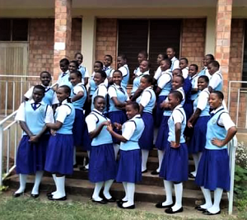
“I joined Notre Dame Academy in January
this year -2021. I was welcomed in the school by Sister Mary Christine Syombua our
Delegation superior who was the headteacher by
then along with Sisters Mary Petronila, Mary
Catherine and the school staff. I witnessed
thorough preparations for this class; they were
motivated, encouraged and given special
attention by the teachers. Sisters and the staff
kept the spirit of excellence, and I too
joined especially during the time for briefing.
Our students picked up a lot from all we shared
with them. I appreciate the team spirit and I
promise to continue with the same spirit in order
to keep up the excellent performance of our students here. Thank you all for your prayerful support. Together let's move forward to create a better world to live in and a bright future for our generations to come.”
Sister Mary Magdalene Musila, SND
Associates Programme
The Associates in Nairobi, Kenya formed a small committee to organize a thank you and farewell programme for Sister Mary Annete who established the Associates programme in Kenya and has been the Director. The Associates, both men and women, came dressed in their African attire for the programme on the 8th of August. Most of the Associates came in the afternoon of this day dressed in their beautiful African attire.
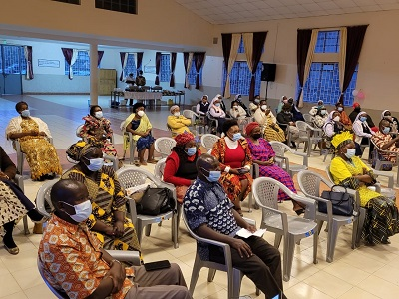
The first part of the programme was a prayer service on PowerPoint followed by entertainments and all five groups took turns to present an item which was fun-oriented but with deep meaning of what they have experienced in the life of Sister Mary Annete. Some of the items were presented by the whole group of Associates and Sisters. The Sisters also had an activity to present related to their experience of living and working with Sister Mary Annete.

wagon August 2021 Newsletter Volume 13 #4 Page 5
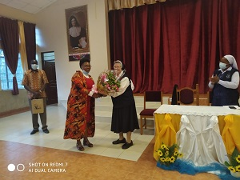
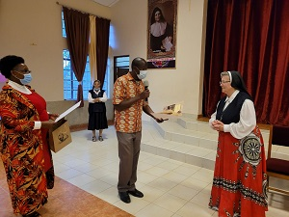
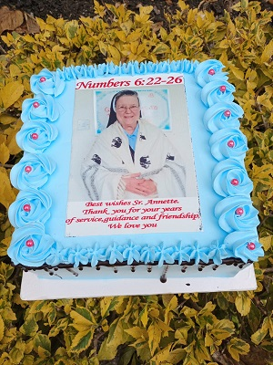
Entertainment was followed by the speeches from one representative of the Associates and then Sister Mary Christine the Delegation superior was introduced and invited to give her speech. Gift giving followed. Sister Mary Annete was given a special card with very inspiring and touching messages from the different five different groups of Associates. She also received a bouquet of flowers as a symbol of the love and care she shared with the Associates. Sister was also given an African wrapper and they helped her dress up. She looked like an African woman in it. It is a tradition that at every function or celebration there must be a cake for all to share. And so, they gave to Sister Mary Annete a beautiful cake with her photo and words of appreciation. She was so happy at the sight of that beautiful cake! All was done to appreciate her for she has been and done in her time in Africa.

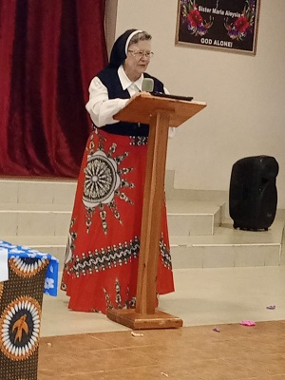
Sister Mary Annete gave her own speech and thanked the Associates and the Sisters for this very special day of appreciation and for being a part of her life. Anthony one of the pioneer associates gave a vote of thanks on behalf of all the associates of Notre Dame in Kenya.
The last activity was a grand supper shared together and then all went to their respective homes at around 7:30 P.M. It was a great day of sharing joy, thanking Sister Mary Annete for who she is and what she has done on the African soil. “Thank you, Sister Mary Annete for loving the child of Africa.” That was the response to the narration prepared by Marceline one of the Associates who composed and mentioned everything Sister Mary Annete has done, and how she has made them feel a part of Notre Dame family during her time here in Africa.

CONGRATULATIONS SENIOR SIX -PIONEER CLASS!!
How good is the good God!! How should we express our heartfelt gratitude to God! His marvelous, bountiful and gracious fervors have resounded again and again, through the excellent performance of our senior six- pioneer class of 2020 in Buseesa, Uganda.
Success is an outcome of united efforts, total commitment and positive attitude towards the ultimate goal. Hearty appreciation to the Notre Dame family for all the support, affirmations and guidance accorded to the students. The school owes much gratitude to our dear Sisters Anita Marie Stacy, Mary Christine Syombua, and Sister Mary Magdalene Musila the current headteacher for their leadership roles in the school.
wagon August 2021 Newsletter Volume 13 #4 Page 6

Once again, bravo to the pioneer class for making Notre Dame Academy shine with good results. Thank you, the teaching and non-teaching staff for the holistic education you are giving to our students at Notre Dame Academy. We thank the Almighty God for the good start and ask for more blessings upon all our schools. We wish our pioneer stars prosperity in life as they continue growing in knowledge and wisdom in higher levels of education and pray that they live up to the ideals of Notre Dame. We appreciate the hard work of the teachers and supportive staff.
Sister Mary Catherine, SND
Thank you and Farewell to Sister Mary Mukti
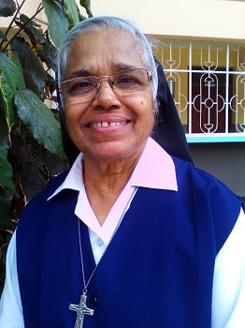
Sister Mary Mukti has been a missionary here in Africa since 2005 and returned to Patna, India on August 8th of this year. Her ministries included: Local Superior, Medical Out-Reach, Delegation Superior of the Tanzania/Kenya Delegation, Director of Temporary Professed Sisters, Director of Aloysia Children and persons with HIV/AIDS in Njiro, and Tertian Director. Sister is greatly responsible for the birth of our Aloysia Home in Kiomboi, Tanzania for children living in difficult environments. Sister Mary Mukti is highly appreciated by all the Sisters in our Holy Spirit General Delegation. She has played a great role in the development and growth of individual Sisters and the Delegation as a whole. May the Lord continue to bless and protect her.

Thank you and Best Wishes to Sister Mary Annete

Our dear Sister Mary Annete has been a missionary here in East Africa since 1998. She has accomplished a lot and she returned to the USA on August 20th of this year. She has served as Class three teacher at St. Julie School, vocation animator, and Formation Director in the Buseesa, Uganda mission. In August of 2004, she was transferred to Arusha, Tanzania. While there, she worked as an assistant novice Directress, was in charge of postulants, and the Delegation Secretary for about 11 years. In 2019, Sister Mary Annete was the Tertian Director in Nairobi, Kenya. While in Nairobi, Kenya she has served as the Delegation Secretary, Associate Director, and was in charge of Come and See Programme. She has carried out all these responsibilities
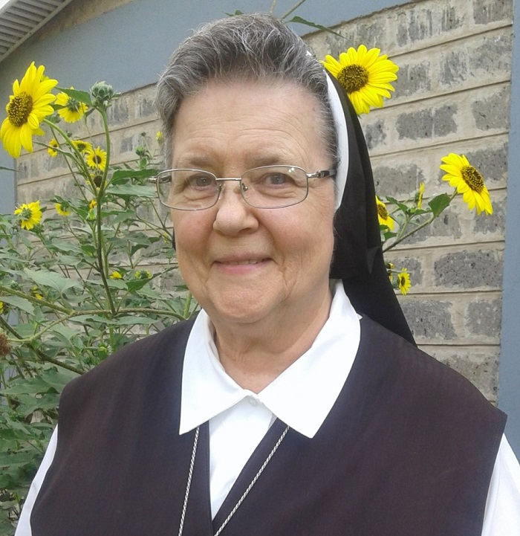
with a lot of dedication and love. Establishing the Associate’s Programme in Nairobi, Kenya is a great achievement where there are five groups now with a total of about 40 members. The Sisters in our Holy Spirit General Delegation cannot thank you enough our dear Sister Mary Annete for all you have been and done. May God bless you.

Dear Sisters and friends, the newsletter team is very grateful to Sister Mary Annete who has been so instrumental in collecting, writing, proofreading, organizing and putting together the articles for our Newsletters in a creative way. She has been so kind and keen in updating all of us on the important events in our Delegation. May God bless her as she has returned to the U.S.A. We now welcome Sister Mary Sunday who is now part of the Newsletter team.
Thank you and enjoy the above articles indicating what has been happening since you received the last newsletter from our Holy Spirit General Delegation. God bless you all.
From the newsletter team: Sisters Mary Teopista, Mary Namita and Mary Sunday.

