From the Roof of Africa

Sisters of Notre Dame
Holy Spirit General Delegation
April 2021 Newsletter Volume 13 #2

Our New Delegation Superior Elect
On January 24, 2021 we received the news that we had been waiting for. When we left our Delegation Assembly on December 31, 2020 in Njiro, Tanzania, we had been in discernment for new leadership. In a meaningful prayer service at the end of that Assembly, we had submitted our suggestions for leadership placing them in the envelopes held by Sisters Mary Sreeja and Teopista. The sealed envelopes were to be taken to Rome for further discernment by the Superior General and her Council. We left the Assembly knowing we would hear the news of the appointment sometime in January and it did come!
Sister Mary
Christine Syombua, SND
Sister Mary Christine has been recently appointed as the new Head Teacher at Notre Dame Academy in Buseesa, Uganda. Prior to that ministry, she has been local superior, Head Teacher, Teacher and Delegation Council Member. She has had an opportunity to travel to Rome, Germany, India, and Mozambique. She has a Post-graduate Diploma in education and has many qualities that will provide her continued leadership in our delegation.
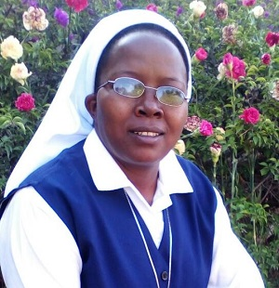

wagon April 2021 Newsletter Volume 13 #1 Page 2

We are most grateful for her acceptance of this ministry and for the new Delegation Councilors representative of Uganda, Tanzania and Kenya: Sisters Mary Margaret Mbuba, Elizabeth Wanza, Rozaria Katusabe and Gladness Shayo. May God bless us as we prepare for the Installation of our new leadership in May, 2021.

A Day to Remember in Simanjiro, Tanzania!
The day of blessing of the new water tank for Loiborsiret village was surely a day to remember. On January 9, 2021, those present for the celebration included all the members of the village government, leaders from nearby villages, and those who were there when the Sisters of Notre Dame first arrived in the Simanjiro district in northern Tanzania. The celebration included Holy Mass by Fr. Karduni, a Maasai priest; then the whole crowd moved to the pump house and the tank, singing and rejoicing for the gift of water that the Congregation is offering them.
On the previous day, the almost eighty men worked together from 8-11 A.M to dig a trench for the water pipes from the well to the water tank. The Sisters were delighted to witness this collaboration. People took care of every expense for the celebration and had many comments worth noting: “Loiborsiret can’t be compared to any other village in the Simanjiro district.” “We are proud of the Sisters of Notre Dame and want to give 100% cooperation.”
“We have a beautiful school building and lovely surroundings with trees, greens, and we are fortunate. When we get out of the house, we are stepping into the international school.”
The water tank is a gift of water from our SND Congregation. Prior to its construction, people from the village drew water from stagnant water holes after the rainy season. The new well will serve 4,500 people, including the children at our Notre Dame Osotwa School and some families in Loiborsiret village. The village is large; consequently, those who live farther away from the well may have to walk about 10 kilometres (over six miles) to fetch water.
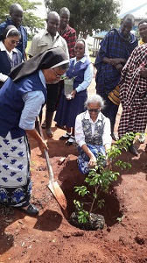
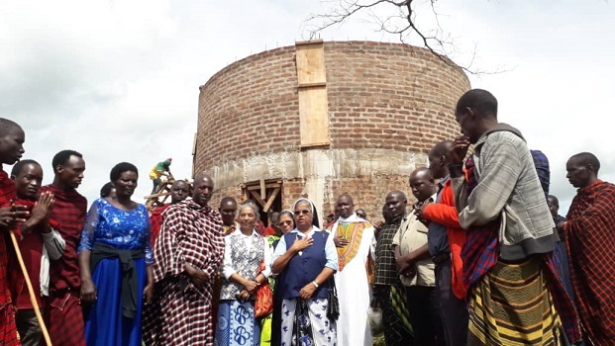

April 2021 Newsletter Volume 13 #1 Page 3

Having Sisters Mary Sreeja and Mary Roshini present for the blessing ceremony added to the occasion, and they were given the Maasai cloth to wear. The Sisters are filled with gratitude to the good God who has been so active in the mission and in the Maasai community. As part of the JPIC program, every significant person plants a tree, so it was particularly appropriate for Sister Mary Sreeja to plant one, especially on the birthday of Sister Maria Aloysia. The Sisters have every reason to rejoice and remember! By Sister Mary Rashmi
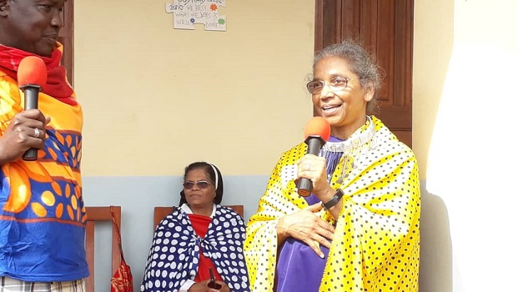
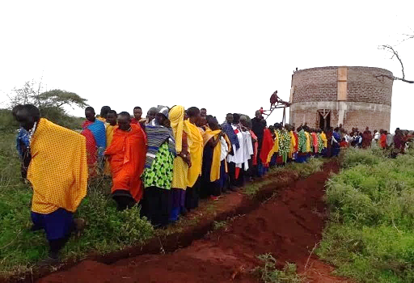

NOTRE DAME COVID -19 PANDEMIC OUTREACH—Lyamutundwe, Uganda
A heart that gives is a heart that receives!
From June to October 2020, the Mpala, Uganda community, through Sister Mary Mukti’s friends, managed to feed about one hundred and sixty families. Each family received four kilograms of maize flour, rice, and two kilograms of beans. Apart from sharing with the families, the community also shared with 250 differently abled orphans under the care of the Missionaries of the Poor who have two homes for them. These children were abandoned by their families. The Sisters reached out to 30 HIV/AIDS-affected orphan children with their guardians (these were given supplies for a month). We began sharing with you in our July 2020 newsletter about this outreach.
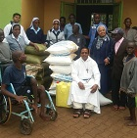
Now again, in February of 2021, we shared the same amount of food with 100 different families who had not received food last year. In collaboration with the Missionaries of the Poor who have an orphanage, we helped to distribute food supplies to them as well, and the joy on their faces was the expression of their gratitude.

April 2021 Newsletter Volume 13 #1 Page 4
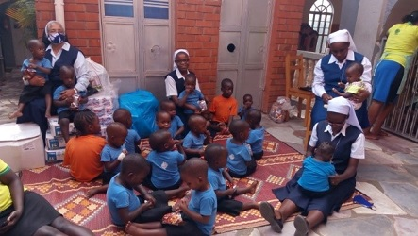
Our next outreach was to Mama Teresa Home
run by Fr. Raymond for the infants abandoned
by one or the other parent. There were 19
children from birth to five years. It indeed was
heart-breaking to know their own mother or ???
father had abandoned them. They were
brought to Mama Teresa Home by the police.
The dedicated services of the helpers were
very touching.

A New Outreach
Seeing the situation of women in the society, especially the majority who came for food, Sister Mary Mukti with the help of Sister Mary Annet Namakula, introduced the topic of beginning a women’s group. The Sisters in the community felt that it was an opportune moment that God was calling us to help to start a women’s group to empower them so that they can improve their lives. The group was invited, organized, and consulted to see if they were willing; most of them agreed. Of the 34 women who came for the meeting, 21 actually formed the group.
While Sister Mary Mukti facilitated the meeting to form the rules and regulations, Sister Mary Annet did the translation and Sister Mary Jescah added points from her experience with women’s groups in Simanjiro and Zinduka.
The women were divided into two groups according to their area of residence.

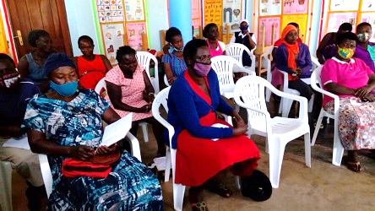

They elected their leaders and decided to save a certain amount of shillings and deposit it every month. They also decided to contribute a very small amount on a monthly basis for a welfare fund for those who are sick and dying in the family of any group member. We hope through the formation of this new women’s group that we will be able to empower our marginalized women in Uganda. By Sister Mary Jescah, SND
During this time of Covid-19, many people lost their jobs and began to do something which would sustain them. The Sisters were buying mushrooms to help those who were growing them, and an idea came that the Sisters could also grow mushrooms; we decided to do just that! A Sister studying at the University of Kisubi agreed to teach us. It was enjoyable as well as fun. Finally, we are enjoying the fruit of our labour and eating our own mushrooms!

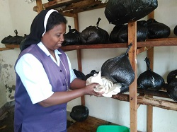

April 2021 Newsletter Volume 13 #1 Page 5

Farewell to Sister Mary Jyosita in Tanzania
“You are a spring of water: life-giving, a Sister, friend, energy, presence and more to our delegation, Congregation, and formation house.” These were words of gratitude to Sister Mary Jyosita.
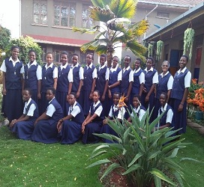
On 19th December 2020 we the novices appreciated
our dearest formator, Sister Mary Jyosita, for all that
she had done in our lives. The theme of this day was
“You are a spring of water, life-giving to us.”
The preparation of this day began on Friday
evening with decorating, cooking and special prayers
for her. On the real day, we had special prayers,
Holy Mass, special breakfast, and a short program.
“Love changes everything,” a song taught by
Sister Mary Pascalia, brought deep meaning to the
theme of the day.
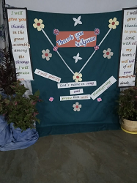
In the afternoon we had a delicious lunch followed by the very well-prepared program from our first year and second year novices. In the evening, we had very special prayers led by the novices with the help of Sister Mary Pascalia. Supper was served in the Upper Room and all the Sisters from the Njiro and Zinduka communities joined us to colour the evening. We had a very well-prepared program from different groups of novices who united to make a different, Laudato Si, Fratelli Tutti and Muriheri Forti presentation. Each group expressed in words, actions, and songs all Sister Mary Jyosita has been and what she has done to make our Novitiate life so lovely.
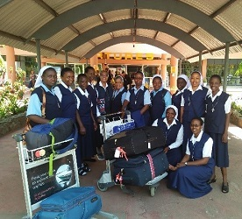
Sister Mary Jyosita was very happy and appreciative for all
that we had done for her on that day.

February 4, 2021 was a day with many emotions. In the
morning, we prayed for Sister and had Holy Mass celebrated
by Fr. Sebastian. While each novice had expressed her
gratitude to Sister the previous day, we were still sad
to see her go. Sister Mary Jyosita left us with words of
wisdom: “Remain united, you are valuable and
precious like a diamond.” Sister left at 1:00 PM for
Kilimanjaro Airport accompanied by eight Sisters and
five novices.

April 2021 Newsletter Volume 13 #1 Page 6

We take this opportunity to thank our dear Sister Mary Kristin, Sister Mary Roshini, and all the Sisters for allowing Sister Mary Jyosita to be part of our life here in East Africa. We will live to tell the story!!
By: Sister Mary Pascalia, SND and Novices

Happy Appreciation Day in Syokimau, Kenya

There was so much excitement at our Notre Dame School in Syokimau, Kenya on 8th March! For days, the Head Teacher, Sister Mary Namita, had been overseeing and many times preparing songs, skits, and dances with the children. Her energy was unbelievable. You can imagine organizing programmes with little three-year old and four-to six-year-old children. These children comprise that part of our school called “House of Children.” Sister Mary Roshini’s message as Delegation Superior to the teachers was, “Teaching Minds, Touching Hearts, and Transforming Lives;” one they will surely remember.

After the morning prayer service, each child from their respective classes, gave a short speech of appreciation to their teacher and presented a small bouquet and monetary gift. Then came the programmes organized by the students in Classes 1-5; these students were in the main building and tried to share their creativity and independence. You can well imagine the amount of work and love that Sister Mary Namita put into organizing this day. It culminated with sharing the cake which is a traditional part of each celebration.
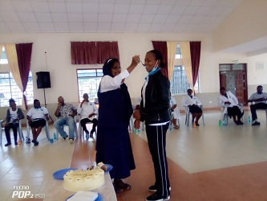

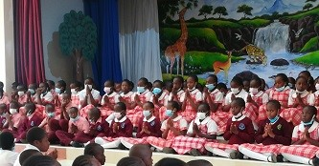

April 2021 Newsletter Volume 13 #1 Page 7
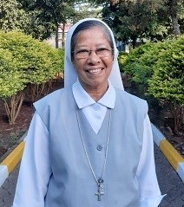

Farewell to India

January 27, 2021 marked the day of departure
for our dear Sister Mary Aruna who has been
a missionary in Africa for 23 years. Sister
arrived safely in Bangalore, India and was
welcomed by our Sisters there. God has
surely blessed her in her missionary journey
even to Papua New Guinea and the Philippines
over the years. We wish her God’s blessing.

Sister Mary Jyosita has been a missionary here since 2014 and returned to Patna, India on February 4, 2021. As Novice Director, she helped prepare many young women in their formation journey towards being wonderful Sisters of Notre Dame in the future. The Sisters and especially the novices will cherish the memory of this loving and dedicated formator.

We pray God’s blessing on both of these Sisters and we will surely miss them in our delegation.

We come now to the end of our April newsletter. We hope that you found it informative and enjoyable. You can look forward to another newsletter in the coming months. May you have a most blessed Easter filled with the joy and peace of the Risen Lord.
The newsletter team: Sisters Mary Annete, Namita and Teopista, SND

