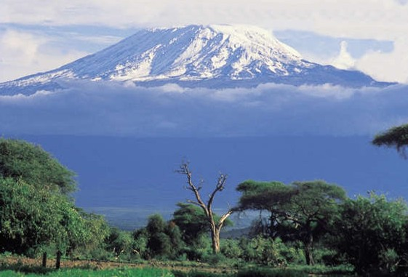

**From the Roof of Africa**

[](http://snd1.org/)

***Sisters of Notre Dame***

***Holy Spirit General Delegation***

***August 2019 Newsletter Volume 11 #2***

***A world of good news!***

It was a great joy to welcome Sister Marina from Rome. Sister is the Treasurer General for our Congregation and was able to take time from her many responsibilities to be here with us in our Holy Spirit General Delegation. Both Sister Marina and our Delegation Treasurer Sister Mary Pramila spent time visiting each of our communities and institutions to get an overview of the financial situation, land and various activities that enhance and affect our finances. We are so grateful for all the time and energy she took and for her wonderful spirit, truly of “joyful simplicity” that she shared with each of us. God bless you Sister on your continuing ministry for our Notre Dame Congregation.

***Rome***

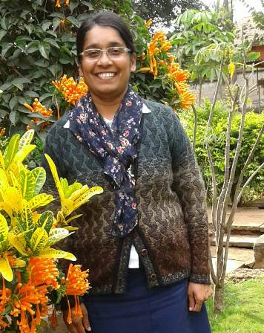

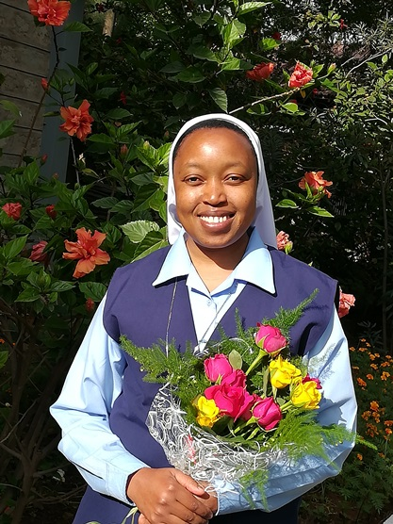

Another Sister from our Delegation, who is studying in Rome and visiting us for a short time was Sister Mary Pascalia. Sister came to apply for and receive her East African Passport and to visit with her family. Here are some of her reflections.

*One more year for the time being!*

*Looking back over the past two years of my studies at the Pontifical University of St. Thomas Aquinas in Rome, I express my gratitude to Almighty God who has given me this great opportunity through our congregation.*

*station wagon*  ***August 2019 Newsletter Volume 11 #2 Page 2***



*My studies of the religious sciences that I am undertaking at the university are gradually helping me to deepen my knowledge and love for Jesus and his mystical body, the Church. These studies have helped me to meet the reality of the church in the past and present. The History of the church that sounded as like a story for me in the past has become so real. Again the lives of saints have become real for me hence my faith is growing deeper. This is because I am learning and I seeing that reality. I thank God for seeing me through the second year of my studies.*

*Another great privilege and learning opportunity is in the wonderful gift of the Casa Madre Community. The experience of the international community has taught me many lessons. I am ever grateful for the love and support of every sister in the community. Although in the delegation we have intercultural living, still the life at the Motherhouse community offers more opportunities to practice, learn more, and get to know the congregation in a deeper sense. I am humbled by the wonderful gift of the Sisters of Notre Dame I have met so far, each sharing their giftedness with others in the community and in the ministries entrusted to them, moving mountains in different ways and turning stones into Gold, as sister Aloysia said. The fact that many sisters from different provinces of our congregation live in Casa Madre and others come for congregational gatherings such as the Young Sisters Gathering, those coming for Pilgrimage and the Formators’ Conference, have definitely created an impact for the better in my life.*

*I am thankful to God for each of you my Sisters in our delegation for the love, care, concern and prayerful support you give to me while I am away for my studies. By Sister Mary Pascalia Ndunge, SND*

A very Hearty welcome dear Sister Mary Anjali. Enjoy a fruitful time in Holy Spirit General Delegation." Sister is presently in Arusha teaching the novices and Candidates. We’ll share more about her ministry later.

***Patna, India***

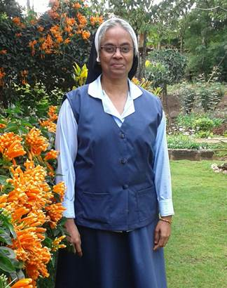

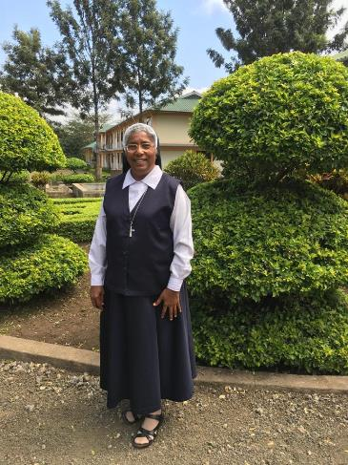

Our dear Sister Mary Kusum returned to India on July 16 after 22 ½ years in ministry here in our Holy Spirit General Delegation. She reached out to so many people at the parish church of St. Joseph, Ngarenaro but especially to the students, staff and the non-teaching staff at St. Joseph Secondary School. Her ministry as local superior in the community and treasurer gave her many opportunities for selfless giving and we know that she has spent many hours on the road shopping for the boarders.

*station wagon*  ***August 2019 Newsletter Volume 11 #2 Page 3***



In these last eight years at Kiomboi in the Singida, Diocese Tanzania as a treasurer, manager of the school, and local superior, she went out of her way to maintain the compound and especially the new property. She made many trips and spent hours trying to secure all the legal documents necessary for that mission.

We will surely miss you dear Sister and are so grateful for all you contributed to the growth of our mission and delegation. Surely God will bless you in your new ministry in India.

***East Africa-Kenya***

“In a large household there are vessels not only made of gold and silver but also of wood and clay, some for lofty and others for humble use. If anyone cleanses himself of these things, he will be a vessel for lofty use, dedicated, beneficial to the master of the house ready for every good work. **2 Timothy 3: 20**

When I was asked to write about my ministry at Vincentian Retreat Centre, Thika, where I am ministering for the last one and half years, I asked myself, “what shall I write about?” and this is what I was inspired to share.

A testimony is a witness to the Lord who called me to serve Him unconditionally. “I was a sinner, but Jesus justified me by the free gift of His grace.” (Rom 3: 24)

At one of the retreats conducted recently there were more than seven hundred or so people. During the morning and

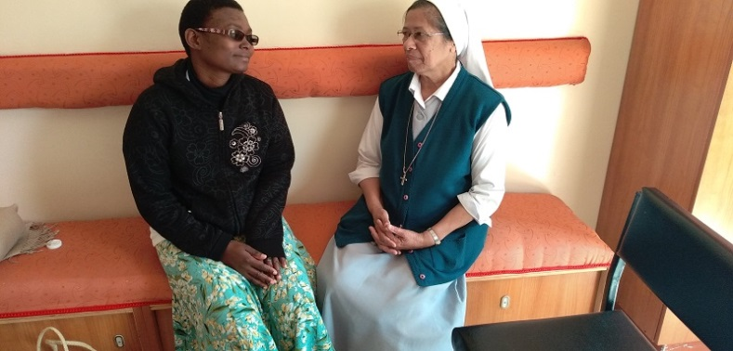

evening adoration, prayers, and scripture talks, many people who have come for healing, and deliverance are healed. One young lady had a malady/ condition which would be eventually healed. So some of the team members asked me to come and pray with the person during the service, but as I went next to the young woman to pray, she moved very fast and away from me. After the common prayer time and night prayer of protection, I met this young lady and asked her to meet me the next morning. I said my Jesus, you have given me all kinds of gifts and breakthroughs with people, but this one, how could she go home not being healed.

I went to bed that night and the next morning had forgotten about what I had said to the lady. After breakfast she sought me out in a crowd, and reminded me in some confused words about my promise to her. She could not communicate properly, but was babbling. I was very concerned, and said to my Jesus, I am helpless, and if you make her well, I will fast and pray for five full days. The words were just out of my mouth and I wondered how I would ever fast for five days. But a promise is a promise. I said to the woman, go sit in the Divine Mercy Chapel for some time, I will come. I ran up to the small chapel for the sisters now frightened, and with outstretched arms begged to the Lord Jesus, to do everything for her, because: Lord you know what her difficulties are. I gathered up enough courage and within ten minutes or so, took her to pray.

This girl then spoke clearly and shared her little story. A year ago, she lost her job, she could not speak to anyone properly with an understanding language, but could only pronounce unutterable words. Her husband went away leaving her with one child and she was left without anyone to care for her. A friend of hers paid for the transport and brought her to the retreat center for healing as the friend was also making the retreat. What joy Jesus gave to both of these persons that day. A week ago when she met me this is what she said, Sister “I prayed to Jesus that, if possible, let me see sister once again, and

*station wagon*  ***August 2019 Newsletter Volume 11 #2 Page 4***



if not bless her; Jesus granted that wish. Now she has a small rented house and her child is going to school, Jesus returned her original speech to her and she found a simple job.

I meet people who come to pray, asking for prayer or counseling during the day, people of all walks of life with sometimes multitudes of burdens. Some people may be affected by evil spirits, or a family line of satanic bondage. However, Jesus knows his lost sheep. What Jesus does for each one is beyond my comprehension. Many times, visibly, I am moved with tears to see the Father’s love for His beloved son Jesus. I am just the broom in the hand of my Jesus who called me and He says: “Even in your old age I am He who has called you and will care for you.” So those who were asking me what do I do with my life in VRC, this is the answer; I do nothing, “BUT HE DOES EVERYTHING”. Dear Sisters, Come and rest in the arms of Jesus at VRC and make one of the retreats and you will continue to be His messenger all your life. Isn’t that our real mission? *By Sister Mary Aruna, SND*

***Our New St. Veronica Church in Syokimau***

The official blessing of our new St. Veronica Church took place with our Bishop Norman Wambua officiating. Almost all was in readiness interiorly. The choirs sang melodiously, the children danced to the beat of the music and all the parishioners sang and participated with full vigor. Our Sisters Mary Namita, Mary Mwende and Berita were instrumental in preparing the altar and Sister Mary Namita was on the committee helping with the ambiance around the altar and decorations. We are happy to finally celebrate our daily Masses and Sunday Liturgies in our new church.

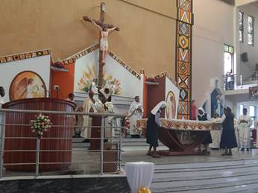

On August 3, Sisters Mary Roshini and Annete made their way to the Good Samaritan Retreat Centre near our convent. We had been preparing the retreat day for our six Associate Candidates who would make their Covenant the next day. Fr. Boniface, an Augustinian Priest joined us for the morning sessions, and provided an opportunity for the Sacrament of Reconciliation as well as the celebration of the Eucharist.

***Welcome to our 6 new Associates and our 12 new Associate Candidates!***

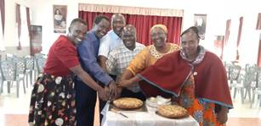

Both Sisters Mary Roshini and Annete continued the afternoon sessions with presentations and opportunities for reflection and questions. The group participated so well and we know that their Covenant Day was blessed.

*station wagon*  ***August 2019 Newsletter Volume 11 #2 Page 5***



On August 4th we also welcomed 12 new Associate Candidates with the celebration of Eucharist and the prayer of the new Candidates for Association. Our whole group numbering 32 in their Associate Relationship with the Sisters of Notre Dame is vibrant and surely lives our charism in their daily lives.

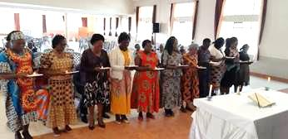

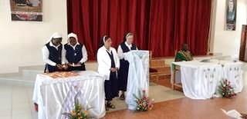

May all of our Associates and Associate Candidates be truly blessed. May each one feel the support of her companion Sister and our world-wide Notre Dame Community.

*By Sister Mary Annete, SND*

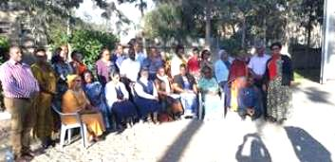

***East Africa- Uganda***

**Your Word Oh Lord is the Lamp to My Feet**

July 12th was another big day for 10 pre-postulants in our Mpala, Uganda community where they took another step in their formation journey. In the group, two postulants come from Kenya, three from Tanzania and five from Uganda. We thank Sister Mary Immaculate and Sister Mary Noela for preparing them to come to this stage of their formation. Sister Mary Prerna, their new Formator had been preparing them and they chose the theme was ‘Your word Oh Lord is the lamp to my feet.” Sister Mary Colette, our Assistant Delegation Superior spent a day with them, reflecting on this theme and accepted them into postulancy. We thank her for her love and sacrifice for us. We were happy to have Sisters Mary Teopista, Scovia and Rose Marie with us on that great day and we thank Sister Mary Tina and the community for making all the preparation for this day. *By Sister Mary Prerna, SND*

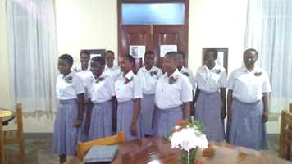

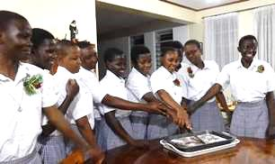

*station wagon*  ***August 2019 Newsletter Volume 11 #2 Page 6***



**SECAM Golden Jubilee Celebration.**

The Symposium of the Episcopal Conference of Africa and Madagascar (SECAM) celebrated its Golden Jubilee on the 28th of August at Namugongo, Kampala, Uganda. There were more than 200 Bishops present from all the countries of Africa. The theme for the Celebration was “Church-Family of God in Africa, Celebrate your Jubilee, Proclaim Jesus Christ your Savior.”

In his homily, the main celebrant emphasized that the family should be the source and root of faith by: praying together as a family, taking care of children in a respectful manner, and by giving opportunities to the children in church activities which will help them grow in the Spirit of God. He also said the kingdom of God starts on a personal level with me then it becomes us. We should abandon all behaviors and attitudes which do not help to prosper our continent. We thank you God for the gift of the Catholic Church in Africa and Madagascar. Thank you God for the gift of the Ugandan Martyrs who planted the seed of Christian faith in Africa.

There were many priests, religious men and women, youth, St. Kizito children from different schools and the laity. It looked very beautiful when children processed with the flag of each African country and we prayed for each country. For us postulants it was a great opportunity to be part of this historic event. In that big crowd it added to our joy when we were able to greet Bishop Isaac Amani, the Archbishop of Arusha and Bishop Vincent Kirabo, the Bishop of Hoima Diocese. *By the Postulants*

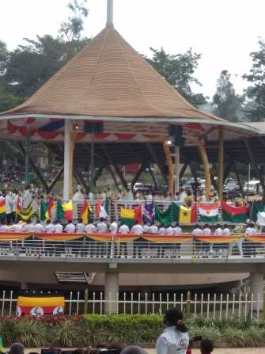

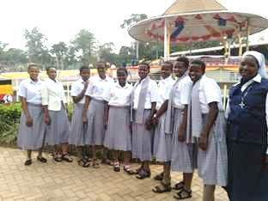

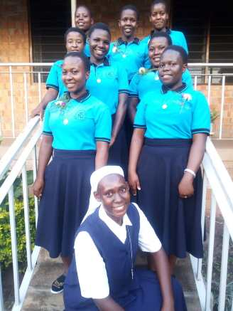

Welcome to our new pre-postulants in Uganda. Sister Mary Immaculate, their Formator, prepared them. She also has a new helper in this part of their initial formation in the person of Sister Christine Marie. We know that all those on this part of their journey will receive much help from both Sisters.

*station wagon*  ***August 2019 Newsletter Volume 11 #2 Page 7***



***East Africa – Tanzania***

**The Spirit of the Lord is upon me**

June 26th, the day of entrance to the Novitiate, was a great long-awaited day for our 11 postulants and for all of us in the Holy Spirit General Delegation. We are blessed to have our new novices representing four different countries: Kenya, Mozambique, Tanzania and Uganda. For their postulancy they lived in Uganda and now travelled to Tanzania where they will spend the next two years of their novitiate. The theme for their intensive preparation was, ‘The Spirit of the Lord is upon me”. It was a day of joy and gratitude for our Delegation and to thank

God for their generous “yes” to the Lord. Sister

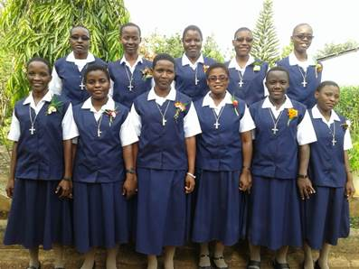

Mary Roshini, our Delegation Superior accepted

them to the novitiate. Many sisters from nearby

communities were there to witness and to

celebrate this day . Sister Mary Jyosita and the

second year novices put all their efforts to make

this day beautiful for everyone and especially

for our new novices. *By Sister Mary Prerna, SND*

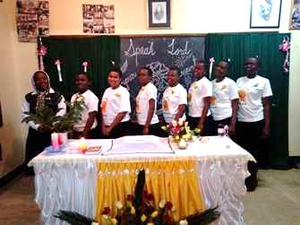

Seven new Candidates were welcomed into that stage of the initial formation. Sister Mary Noela is their Formator. The Candidates had as their theme “Speak Lord, your servant is listening.” Many of the Sisters from Zinduka and our Njiro Notre Dame Convent were able to be there for their prayer service and we heartily welcomed them all. *By Sister Mary Noela, SND*

***Perpetual vows and first vows***

On June 15th we celebrated the Perpetual Vows for five Sisters in Uganda and on June 22nd for two more Sisters in Tanzania. Both celebrations were well attended. Sister Mary Annete, who had been their tertian director, travelled to both countries along with Sister Mary Roshini, our Delegation Superior. Each of these seven new perpetually professed Sisters, pronounced her Vows clearly and loudly with the conviction in her heart, proclaiming that she will live these vows faithfully for her whole life.

*station wagon*  ***August 2019 Newsletter Volume 11 #2 Page 8***



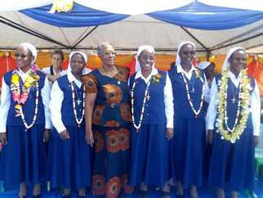



On both occasions, the Bishop of the respective diocese was present and this added to the solemnity of the celebration. In Uganda, some of the former students of St. Julie Model Primary Boarding School were present, as well as the students of both the primary and secondary school, staff, relatives and friends and many priests and religious graced the occasion. The weather was perfect for this outdoor celebration.

In Tanzania, the celebration took place in Lourdes Hall of our Notre Dame Secondary School. The Aspirants had prepared the Holy Childhood Children for their dances for the occasion and the youth choir did their best to make the day colourful. *By Sister Mary Annete, SND*

***News Corner from Notre Dame Osotwa Mission, Simanjiro, Tanzania***

We have many reasons to thank and praise our good God for the first quarter of the year that is just passing. First of all, we are blessed with 210 students in School and 29 boarders in our Aloysia and Ignatia Boarding Houses! Two students are from an orphanage and another from a very difficult environment. Every day the children are becoming more active and committed to study.

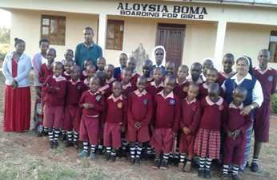

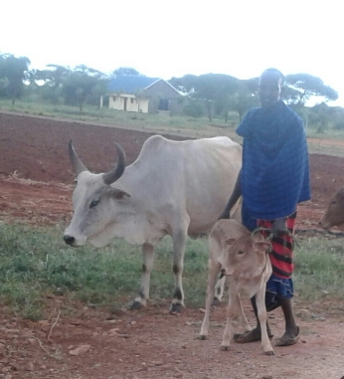

We received a very unique gift this year! The chairman of our out-station knew that the Sisters had several boarding students and were having problems getting enough milk. He gave us a surprise when he sent us a cow and its calf so that we could have sufficient milk for all. With our drought, milk has been a big problem for almost two years. Now the cow is brought in the evening for milking and taken back in the morning. We get about four liters of milk daily and we may have this privilege as long as the cow has milk.

*station wagon*  ***August 2019 Newsletter Volume 11 #2 Page 9***



**A New Green House** has brought new hope to this dry area. Any kind of green and fresh vegetables are not common items here. We are so grateful to Mr. Peter Junk from Germany who raised the funds for the green house by selling specially made birds’ nests and other items in his parish.

***Installing a Water Gauge***

We are grateful to God that **Notre Dame Osotwa has received Certificate of Registration for our Boarding Houses**. Sister Mary Winfred Nduku, the Head Teacher worked very hard for it. Our students had a friendly football match with the Government School in the neighboring village and of course, we won the match! That is not all, our students had a debate with the Secondary School students of Loiborsiret and a football match to conclude. We were proud of our children who won the game and scored more in the debate.

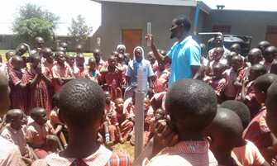

We had our first ‘**Visiting Day**’ for our boarding students and all the parents were very happy. One parent commented, “What did God place in the hearts of the Sisters that our children are totally transformed in such a short period that no one even talked about going with us?”

We had the long awaited ‘**Get Together of Notre Dame Zinduka – Osotwa Women’** **at** **Osotwa** to celebrate Women’s Day! Sister Mary Kellen came with about 56 women in two vehicles to celebrate with us. They faced many challenges to reach our place because they missed the way and went a long distance! We had been waiting very long for a few drops of rain. But, as the group was nearing Loiborsiret, it started raining. The bus got stuck in the mud around 4 kms away from our place that each one had to carry her shoes and walk through the slushy black cotton soil to reach our house. All the pain and difficulties were washed away when our Maasai Women welcomed them with songs and dances! We had a wonderful time sharing our experiences, hopes and dreams, laughter and fun! All went back home rejoicing and counting the blessings of a wonderful day!

It was a grand day and all the children from the village nurseries of Lesoit, Mukonoo, and Muriet were present. The Aloysia children, tailoring girls, and all the teachers from the Nurseries gathered at Notre Dame Zinduka Women’s Centre to celebrate African Child’s Day. There were parents and committee representatives from Muriet and Lesoit as well. The main blessing was to have children from Zinduka Nyota Nursery Lesoit come for the celebration unlike the previous year when no child came from there as they were only three years old and their parents were reluctant to send them.

***African child’s day celebration***

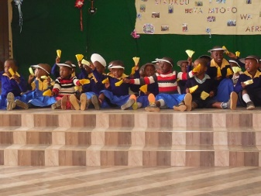

Happy African child’s day!

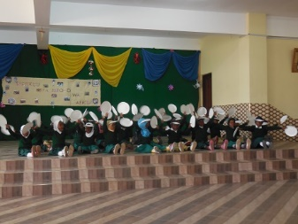

The invited guests were all on time. The occasion was blessed by the presence of our Holy Spirit General Delegation Superior; Sister Mary Roshini, Sister Mary Anjali, a Sister from India who came for her experience in “Sisters Without Borders,” and Sister Mary Mukti, the Socio, Health and Pastoral Ministry Coordinator. Some of the Sisters from Njiro and Zinduka communities were also present.

*station wagon*  ***August 2019 Newsletter Volume 11 #2 Page 10***



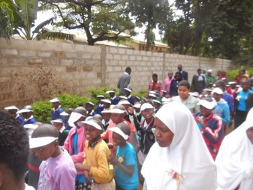



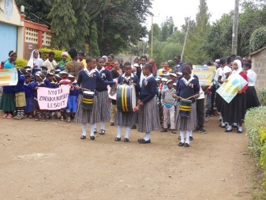One of the invited guest Mrs. Magere who is also our parishioner and a guardian in Notre Dame Secondary School promised to give 500,000/= from September for the sugar for nursery children. The Novices and Candidates were actively helping the children in their various needs. The Chief Guest was Dr. Anindita from India. She has supported five of the Aloysia children. Two of them are doing the diploma course and three of them are in lower primary at Osotwa Notre Dame School.

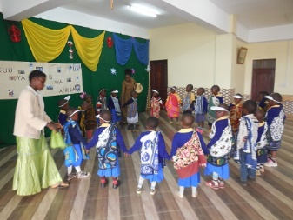The event began with a procession from the Notre Dame Zinduka Women’s Centre. Each group held its banner high as

they processed. The children had prepared

various items from what they had learned in their classes. Although there were common activities, each was presented in a unique and creative manner. It was very inspiring to see how the village children were empowered to have self-confidence and courage. They had mastered well the contents of their presentations. Bravo to all the great teachers!

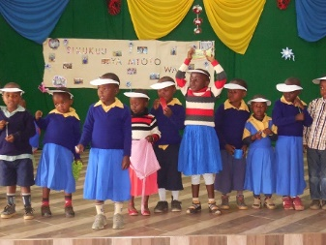The event was culminated with gifts for all the children and lunch for all who were present. This day would be a memorable day in their lives! We thank God for His provident care.

*By Sister Mary Kellen, SND*

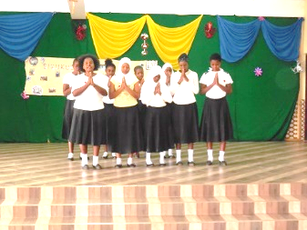

*We hope you have enjoyed our very informative newsletter. We’ve tried to capture what is happening and have presented some new areas. We look forward to meeting you again in a few months with more exciting happenings in our Holy Spirit General Delegation.*

*From the Newsletter Team: Sisters Mary Annete, Neelima and Namita, SND*