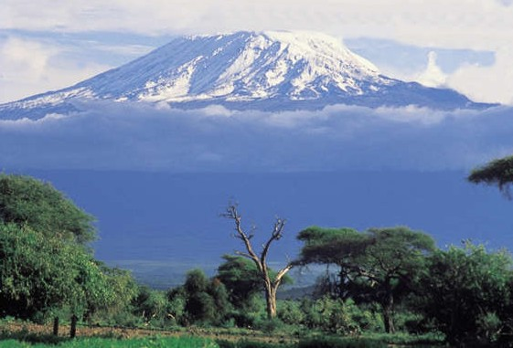

From the Roof of Africa

Sisters of Notre Dame
Holy Spirit General Delegation

August 2018 Newsletter Volume 10 #2

Our Delegation Loves to Celebrate New Life

Installation of Delegation Council
The New Holy Spirit General Delegation Council was installed on the Feast of Pentecost, May 20, 2018. This was a wonderful opportunity to celebrate the reappointment of Sister Mary Roshini and welcome the new council for 2018-2021: Sisters Mary Colette Theobald, Teresa Kimario, Christine Syombua and Therese Marie Nabakka. The simple celebration was part of our Pentecost Liturgy and ended with the traditional African cutting of the cake. Sister Mary Roshini also reappointed Sister Mary Pramila as Delegation Treasurer and Sister Mary Annete as Delegation Secretary. May our Administration Team be blessed.
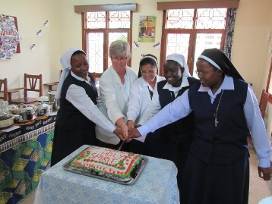
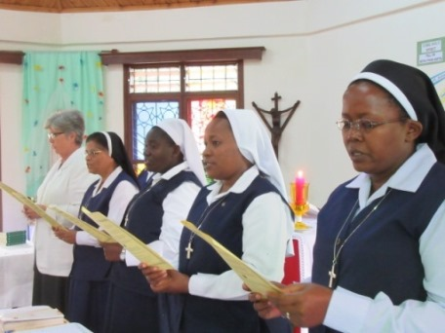

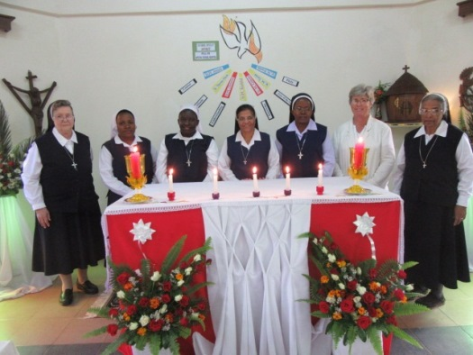

station wagon August 2018 Newsletter Volume 10 #2 Page 2
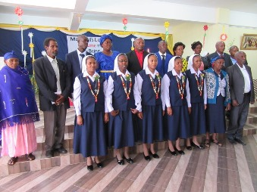
Our Holy Spirit Delegation welcomed five new temporary professed Sisters who made their First Profession on June 9th. The families and the Sisters joined in this wonderful celebration of vowed life. Each newly professed Sister towards the end of the day received her new appointment for ministry in our delegation and they will be welcomed in their new communities after their home visit. Hearty welcome Sisters Mary Flavia, Maria Jackline, Mary Digna, Mary Catherine and Mary Mwende.

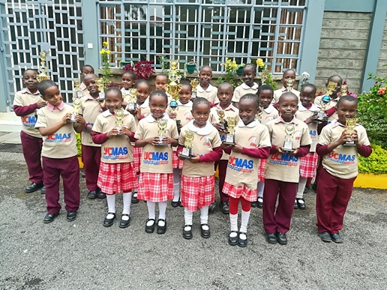

UCMAS Competition
WE introduced the UCMAS (Universal Concept of Mental Arithmetic System) in our Notre Dame School, Syokimau during the academic year for classes 1-3. The students have to buy a UC tool with three other books and that becomes the UCMAS Kit. There is a special teacher from the UCMAS team who gives three periods a week. Fifty-three students from the school participated in the A grade 5th

National Competition at Parklands, Kenya on June 9, 2018. As soon as they arrived at the venue, they were all given numbers and taken to the hall where they were given the instructions and a paper with 150 sums to be completed within ten minutes. The marking of the paper was done as per their grades. Two of our students won the championship trophy and many others got 3rd position. All the participants were awarded certificates. It was indeed a very unique experience for our students to interact and compete with students from various schools. By Sister Mary Namita, SND

Mukuru Slum Experience
Our pre-postulants in Kenya: Grace, Getruda, Anne and Judith were given an opportunity while in the last six months of their pre-postulancy to go to the Mukuru Slums one day a week. This particular centre serves children with physical and mental disabilities. The pre-postulants also had the experience of going into the homes in the slums and needless to say it was a life-changing experience for them. They discovered skills in themselves they didn’t know they had, were challenged in handling children with different disabilities and from various backgrounds and also went with the social worker into the slums to visit the homes, especially of the children who were not attending classes. Every Wednesday they returned eager to go back the next week.

On Thursday morning each week, they entered into a time of prayer and reflection and this was followed by a theological reflection facilitated by Sister Mary Annete their Formator. They had much to share and took time to reflect on each other’s experiences.

August 2018 Newsletter Volume 10 #2 Page 3

Relating their experience to the life of Jesus was a spiritual aspect that led to further prayer and reflection by each of them. They shared the action step they would take because of their encounters with the poor and also offered an action step for the whole group. They wished their experience was
longer and can only hope that someone in the future can be part of a full-time ministry at this centre. They expressed their gratitude for this experience to Sisters Mary Roshini and Annete for providing this opportunity for them. By Sister Mary Annete, SND

Midlife Transition
Midlife transition was all we could hear. In our local communities, Sisters teased about this time in one’s life which kept each of us on our toes ready to know more about this 'great transition'. Some even nicknamed the seminar 'crisis'. The long awaited days were on 4th, 5th and 6th June, 2018.
Our facilitator, Sister Mary Roshini, came well equipped with enough materials and up-to-date power points. After the opening prayers, sister distributed papers which had questions to see who really was in in this stage. After putting ticks where applicable according to the points given, Sister inquired from each of us how we had rated ourselves. This gave us a clue that each one of us needed the course.
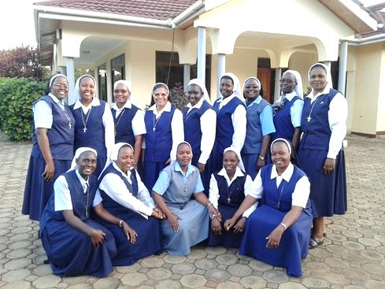

We had many topics which gave us tips to making a smooth midlife transition. We went deeper into developmental years and its tasks, especially taking a journey inward in order to actualize our potentials. We came to realize that unless we go through this, we just remain as young adults, confused and unreconciled with the past. Among the interesting awarenesses we received is that “we are who we have been looking for.” The major developmental task of midlife is to confront the young and old within oneself hence actualizing what God has placed in us. No one reaches midlife without some scars or significant failures. So our task is to affirm both good and bad to go on with life creatively dealing with hurts that others have caused and what we have caused.
We addressed the issues of sexuality, attachment and separation and the need for intimacy as well as the need to be alone. After inputs and power point presentations, we felt we were helped in these areas and this led us to discover that we need to confide our confusing experiences to people whom we trust for help.
Every evening we had light moments with one another. We were in three groups and each group had to prepare entertainment which helped us to laugh and enjoy to the full. As a matter of fact, we laughed till we forgot to take entertainment photos!!! By Sister Mary Christine Syombua, SND

Second Christology Retreat
Our second gathering for the Congregational Christology Retreat was held from June 10th - 18th at the Frescobaldi Centre of the Passionist Sisters in Arusha. Sisters Mary Roshini and Mukti were the presenters and all the Sisters really felt renewed and refreshed in the retreat and a greater love for our Constitutions. Already the next group will be preparing for the retreat in Arusha in December where a number of our temporary professed and professed Sisters will be present. The third and last of the retreats will be given in Uganda in January when we will be able to say we have been greatly renewed with the gift of our Constitutions in our lives.

station wagon August 2018 Newsletter Volume 10 #2 Page 4
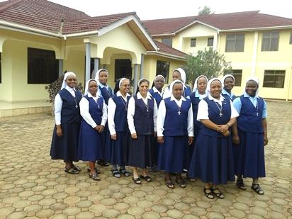

Our second group of Retreatants and their facilitators.

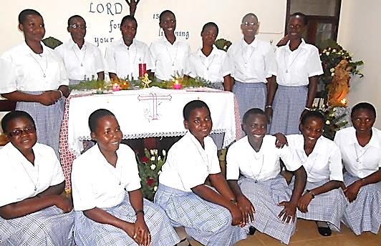

Celebrating our new Postulants
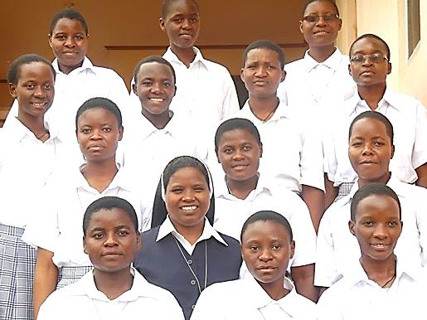

It was a real joy on June 20th to welcome
13 pre-postulants to the Mpala, Uganda formation community. Seven young women travelled from the formation house in Buseesa, Uganda; four travelled from Mozambique with Irmã Maria Irene and three travelled from Syokimau, Kenya. This multi-cultural group of young and talented women celebrated their entrance into postulancy on June 25th. Sister Mary Prerna, their Postulant Director and the Mpala community welcomed them to this next stage of their initial formation. Much joy was experienced that day through the meaningful prayer service, the festive meal and all the fun that took place afterwards. Hearty welcome to each one of you to our Notre Dame family.

Celebrating Our Third Group of Associates
On July 1st we were happy to welcome our third group of eight Associates. Celebrating with the Eucharistic Liturgy by Fr. Mawete, these eight women and men made their covenant on how they will live the charism of the Sisters of Notre Dame in their daily life. Sister Mary Roshini, Annete and Namita, the companion Sisters for these Associates welcomed them by putting on their Associate pins so graciously donated by our Sisters from Rosa Mystica Province in California.

station wagon August 2018 Newsletter Volume 10 #2 Page 5

They were warmly welcomed
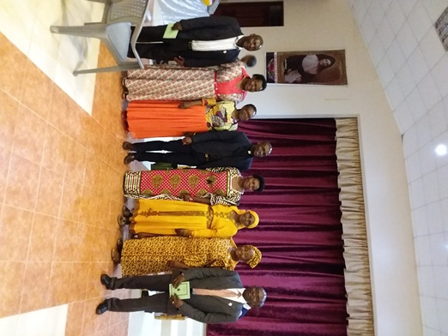
by the first group of six and we
enjoyed an evening together and
celebrated a festive meal.
In their expressions of gratitude
one could feel and experience our
Notre Dame spirit and the joy they
felt to be part of the Associate
Relationship. On August 5th, we will
welcome the next group of nine
Associate Candidates.
God is truly so very good.

The Visit of the new Archbishop to Simanjiro

May 13, 2018 became a day to be written in golden letters for the faithful of Loiborsiret, Simanjiro!
Archbishop Isaac Amani Massawe made his maiden visit to the Maasai Land of Simanjiro to bless the newly completed church at Loiborsiret and for the First Communion of 48 candidates from various out-stations. Our Notre Dame Osotwa Boma was privileged to welcome our new Archbishop into our home before he proceeded to the church. As he stepped out of the vehicle the first greeting was, “Oh! Sisters, how did you manage to reach so far away in this remote place? ”
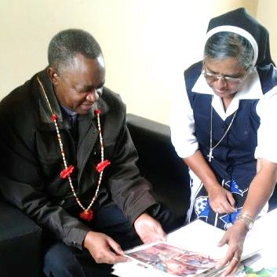
He was very pleased to notice the transformation and change that has taken place as he viewed a few
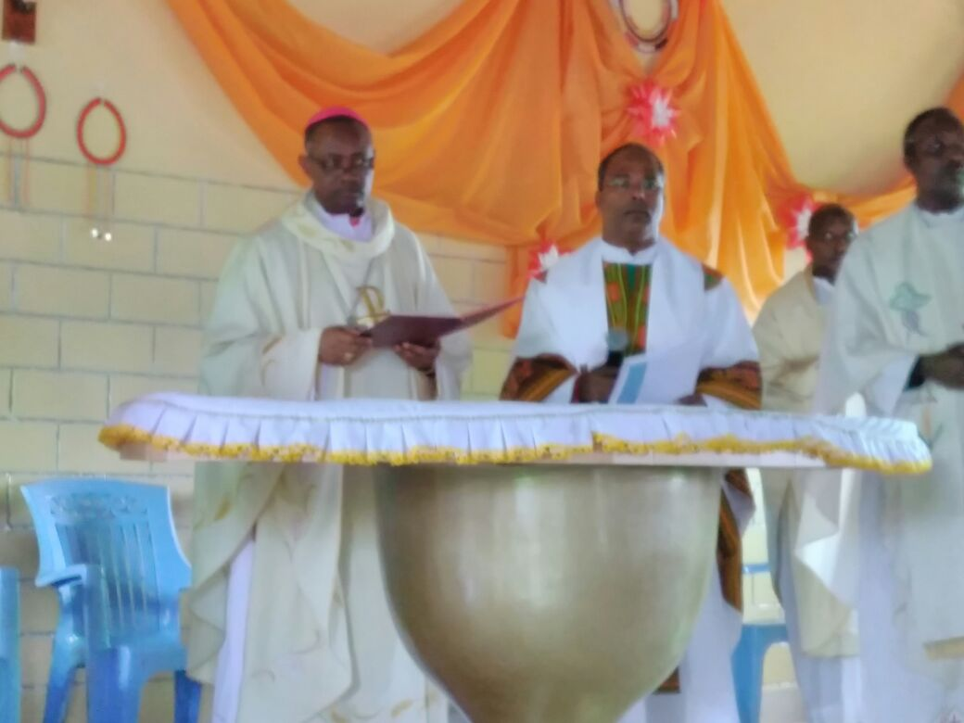

photos of our beginning. He expressed much appreciation and gratitude about our presence in this mission and what we are doing.

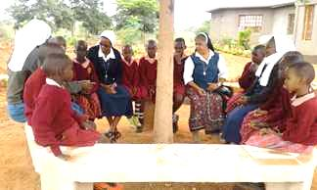
Having our novices with us together with Sisters Mary Jyosita and Mukti made our Notre Dame presence more visible on that day! The ‘Church Blessing’ of our out-station at Loiborsiret was extra significant for the Sisters here because all these years we have been praying or having Mass under the tree or sitting on stones in an unfinished church without even a proper floor. Yes, God who has always taken care worked wonders through our simple, humble people with the help of friends and well-wishers. Our Sisters played a great role in making this dream a reality!
By Sister Mary Rashmi, SND

station wagon August 2018 Newsletter Volume 10 #2 Page 6
It has taken more than 10 years to complete this church. Through active participation in the church activities, in the Small Christian communities, our Sisters tirelessly motivated the young and old to become partners in “Building our Church! Slowly, but steadily, through
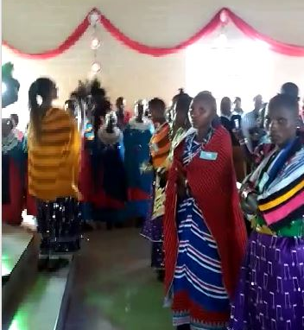
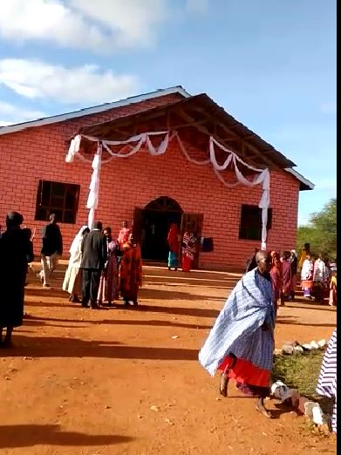

small contributions, people gathered the bricks. Some contributed cows or goats or sheep as their thanksgiving when we made the house-to-house “Way of the Cross.” The youth members were organized and motivated by Sister Mary Rashmi, to each contribute a box of tiles. Bringing our Catholic women together, we were able to get some cement and other materials. Different families were encouraged to donate a “bench with a kneeler” on which their names would be written. Individuals came forward to donate the altar cloths, decoration materials and other small items.

Our Christian community became more and more active as things started shaping up. They cleared the area, painted the church and raised funds and donated cows and goats to feed over 2000 people including all those who came from the 23 out-stations under our main parish stretching to more than 100 kms. from one end to the other. Since there is no priest or Eucharistic celebration here, our Sisters had to play an active role to be part of everything that had to be organized with the help of the “Planning Committee” and the “Parish Council.” Now our colorful, well completed church with tiled floor, forty kneelers, a beautiful altar and an organ is the talk of Simanjiro and everyone comes for the Sunday services! God be praised!

A Boarding House for Our Maasai Children!
Children who walk long distances, cutting across the forest, facing wild animals and many other challenges have a ‘Home’ now. We have started accepting boarding students and we have twelve children already. The house for the girls is ready and the other one is in the making. We thank dear Sisters Mary Kristin, Sreeja and others who have permitted us to begin this service in our mission for the children who live in very difficult environments. We thank and praise God for the Dialog Projekt together with our German Province for coming to our aid at every step especially by helping to construct the boarding! We also welcomed volunteers from the Dialog Project who will be with us in the next few months to continue their wonderful support in the building of our school.
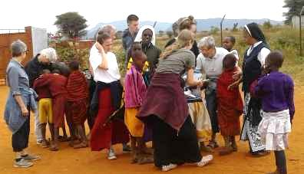
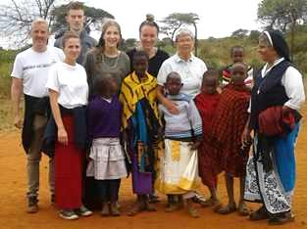

station wagon August 2018 Newsletter Volume 10 #2 Page 7
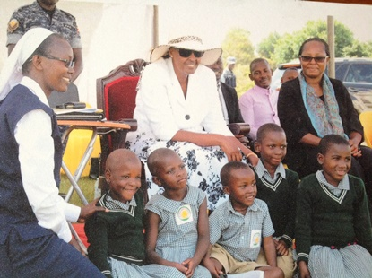
International Day of the African Child
The International Day of the African Child
is celebrated in various parts of Africa. This year
Notre Dame Academy, St. Julie Model Primary
School and St. Julie Nursery School joined in the
Uganda National Celebrations. They are held in a
different district, and this year we were pleased that
they were being held in our own Kibaale District.
Representatives from the primary and secondary
schools were sent to Kampala for a leadership
seminar. Our children were asked to write articles
for a magazine, prepare arts and crafts, and provide
entertainment on the actual day of the celebration which was on 16th June. The guest of honor was the First Lady of Uganda, Janet Museveni. She was greeted warmly as she entered and as she visited various booths set up to honor the day. Her speech was very moving as she reminded the large crowd about the value of the African child and the responsibilities of parents, teachers and community members to protect all children. Three schools, out of many who performed before her arrival, were selected to perform before the First Lady and one of them was St. Julie Nursery School. Five children recited with great animation a poem about parents loving and raising good children.

St. Julie Model Primary School Graduate Is Ordained
On 7th July 2018 fourteen priests were ordained
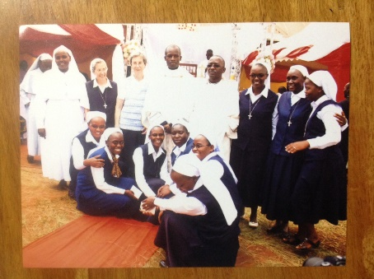
in the Hoima Diocese. Among them was
Mugabi John Mary, a former student of the first
class of students in St. Julie Model Primary School,
Buseesa. The Sisters and the school community
rejoiced that his ordination marked the second priestly
vocation from our school. In addition, he is the brother
of our Sister Mary Assumpta, SND! At this thanks-
giving Mass at his family home, Rev. Fr. Mugabi
John Mary shared with all of his guests how very much
The Sisters of Notre Dame and his primary school
experience influenced his spiritual and moral
development, and eventually his priestly vocation.
By Sister Mary Colette, SND

Congratulations
Congratulations to our dear Sister Mary Phyllis who graduated with distinction from Jomo Kenyatta University of Agriculture and Technology. Over 3000 had graduated that day and the event was well attended. Blessings on you dear Sister as you continue your studies to the next level.

station wagon August 2018 Newsletter Volume 10 #2 Page 8

Sisters Without Borders
When I returned from my home visit in Germany May 20th 2018, I was in the company of Sister Mary Aidan Richards from England. She had decided to follow the call of “Sisters without Boarders” for three months. Today after more than two months, I can say she enjoyed her stay with us in the “bush” of Buseesa, Uganda. Sister was open to a different life style and she helped in many ways in the Formation House, in St. Julie Primary School and in the convent. We are grateful for her contribution and we will miss her.

Sister Mary Aidan had the opportunity to participate in many different events and celebrations from the various and rich expressions of the African culture. I am sure all these were an enriching experience for her life as it is for us “oldies”. We thank her very much for her stay here with us and we wish her God’s abundant blessings for the years to come. By Sister Maria Bernarde, SND

“In May, three months seemed a long time, but in July, I realised the time has flown! Have I been busy? Yes, but not overstretched in any way. My work in the Formation House has been a delight. It has covered no less than three sets of young women; one set has been constant so we have established quite a relationship. I helped them with English and Religion. For the latter I took the New Testament, how it was formed, who wrote the Gospels and when. We looked at the Infancy Narratives in Luke and Matthew and then a number of miracles in Mark. English was a mixture of grammar and prose. In school I mainly helped a group of new recruits from P3 with reading and spelling. We used library books and I know that their confidence has grown. In the convent, I found the young Sisters hard to identify in the beginning and I still make mistakes! Many of us enjoyed watching the Football World Cup together though I couldn’t understand why they didn’t want England to win! I soon got used to the African living and conditions – cold water etc. but I shan’t mind a warm shower and hot water for washing my clothes. Thank you Sisters for accepting me, making me feel so welcome and generally looking after me. I’d love to return but I think that age is no longer on my side, who knows.
By Sister Mary Aiden Richards, SND

Frost and chill, bless the Lord
Praise and exalt him above all forever!
Fire and heat, bless the Lord,
Praise and exalt him above all forever!

As we draw this newsletter to a close, the winter is upon us and for some of you the heat of summer. We hope you enjoy reading all about the various experiences in our delegation and the many activities in which we are engaged. Our next newsletter will highlight our General Conference in Arusha and many other activities. Do let us know how you enjoy our newsletter and surely we welcome any constructive comments that will help to make our newsletter even better. God bless each of you.
The Newsletter Committee: Sisters Mary Annete, Neelima and Namita, SND

