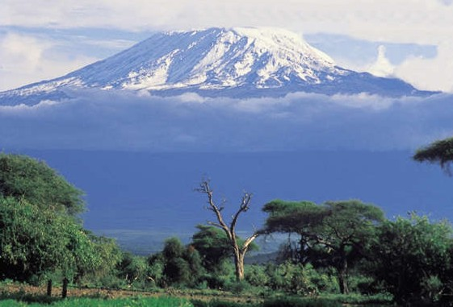

**From the Roof of Africa**

[](http://snd1.org/)

***Sisters of Notre Dame***

***Holy Spirit General Delegation***

***April 2018 Newsletter Volume 10 #1***

***Christology Retreat***

Our Christology Retreat was held at the Canossa Spirituality Centre in Arusha, Tanzania. We welcomed Sisters Mary Sreeja and Kathleen Burns who facilitated the retreat. What a gift and blessing this was for the 16 sisters who made this retreat. Certainly if we shared all that took place, everyone would know everything about it before you made it. So let’s just say

that you will find the experience more than you imagined. The ambience, presentations and especially the times of prayer are worth the wait. So much time went into the preparation for this kind of retreat by the General Team that we can only say a huge thank you. We know that all our SNDs around the world are experiencing this deeper awareness of the Christological themes in our

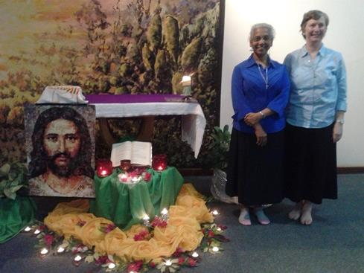

*Constitutions* that makes it so meaningful. The unique video presentations enhance the themes and how one enters into the experience makes all the difference in the world. We can only say, you will be happy that you had this opportunity to make such a retreat. Do look forward to your retreat either from June 10-18th or one of the retreats either in December in Arusha or in January in Uganda. Don’t miss this grace-filled retreat.

*By: Sister Mary Annete, SND*

*station wagon*  ***April 2018 Newsletter Volume 10 #1 Page 2***



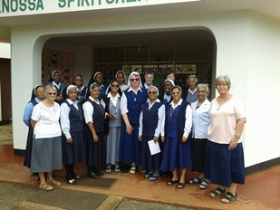

This is the first group that made the Christology retreat in March. It was taken outside the Canossa Spirituality Centre and the group included Sister Ethel Maria who had come to say good-bye to the Sisters before she left for Germany.

***A Big Thank You!***

At our Associate meeting in February, our Associates and Associate Candidates surprised us with a gift. The two Associates, Angeline and Juliana who had attended our Silver Jubilee celebration in December were so impressed by our Notre Dame family and Notre Dame spirit. They knew what we were doing for the poor and marginalized and especially our ministry in Kiomboi at our Aloysia Home. They shared much with the whole group about their experience and as a group collected enough money to sponsor one of the Aloysia children. We were so touched by their “Notre Dame family spirit” and their ability to reach out and share in our ministry in Kiomboi. One of the 27 little girls will be chosen and we will take her picture and share it with them when we have our next meeting. May God continue to bless each one of them.

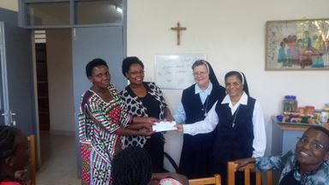

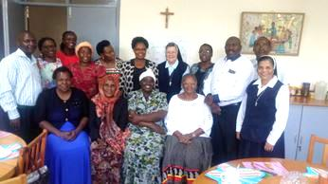

Please pray for the eight Associate Candidates who will be making their covenant on July 1st and for the new 8 perspective candidates who are now coming for their information meeting so they can discern a possible associate relationship with us.

***Sisters without Borders***

Here is a special message from Sister Ethel Maria about her experience after being in Uganda and coming to Tanzania. *After three month in Uganda, I came to Tanzania for the Silver Jubilee celebration and what a wonderful celebration it was.*

*station wagon*  ***April 2018 Newsletter Volume 10 #1 Page 3***



*Yes, I want to be Sister of Notre Dame in this international congregation! Celebrations went on for Christmas and the New Year – including a hearty welcome and programme for me. After that, my ministry in the novitiate began.*

*Like in Uganda, I gave classes in Tanzania on scripture using creative methods. Out of those classes the teaching of the Our Father with RPP (religious pedagogical practice) has been the highlight. I was really touched when the novices shared with the sisters what they have learned and how it deepened their understanding of this important prayer.*

*For the first year novices I presented classes on the History of the Congregation. It was enriching for both of us as I feel blessed knowing all these places of origin and they enjoyed my stories about these places and about my life in Germany.*

*Once I joined the novices for a seminar on the public life of Jesus given by Father Dave Sullivan, M.Afr. Reading the scripture in a theological-scientific way was quiet challenging for them. We had discussions and classes about that in the following week and I discovered the different the view of my German students on scripture compared to the view they have here in Africa. In Germany young people grow up with scientific explanations and they hardly believe that the scripture is “true” in sense of a deeper spiritual truth. The novices get easily the spiritual dimension of the text but struggle*

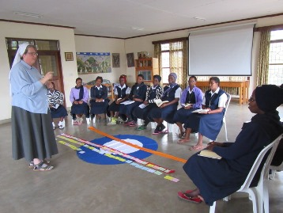

*with a critical scientific way of reading and the*

*different historical explanations sometimes confuses*

*them. I think together we managed to use the struggle*

*in a positive way. I am grateful that I was able to study*

*theology in Germany and experience the deeply rooted*

*spirituality here, so that I can combine these aspects in*

*my life and work now.*

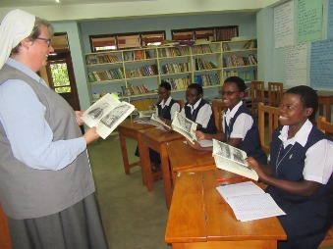



*Besides teaching, I had a lot of wonderful*

*experiences out of which I want to mention*

*three: visits to Simanjiro, Tarangire and Mwanza.*

*I was in Simanjiro seven years ago, and I was looking forward to the visiting this place again. Entering the dining room I was almost on the verge of tears remembering that I put in the stones under that foundation with my own hand. The development of the school was also a big joy. I enjoyed praying in front of the grotto of Mother Mary thanking God for all that*

*station wagon*  ***April 2018 Newsletter Volume 10 #1 Page 4***



*this place meant to me and asking for blessings on everyone and their ministry to and with the people and children.*

*A second thing I was longing for was to see elephants and so it was an overwhelming joy when I got to know that we will go to Tarangire National Park as a community trip. It made me laugh. People, instead of looking at the animals, observed “all the Mzungus (people with white skin) travelling all the way from Europe just to see the animals here”. I turned out to be a “real Mzungu” enjoying from the bottom of my heart the giraffes, lions, even the butterflies in their dance and most of all the elephants in their natural environment.*

*The third experience to tell about is my trip to Mwanza. I visited the Teresina Sisters from the Congregation of St. Theresa of the Child of Jesus who have been living in our convent in Vechta for half a year while doing their PGD studies in Germany. Travelling*

*alone was quite a challenge but worth the experience.*



*We enjoyed being together, sharing memories and talking*

*about similarities and differences of life in Germany and*

*Africa; it was very enriching.*

*On my way back, I visited our sisters in Didia/Shinyanga.*

*This time I travelled with Sister Mary Christine on the bus*

*back to Arusha and that was much more relaxed than*

*travelling alone. This is a summary of my stay here:*

*The best way of travelling along my life’s journey is having good companionship, having sisters at my side travelling with me! I thank all of you for your company in these months! It has been one of the most wonderful and blessed periods in my life! Surely we will stay connected in prayer as we continue our journey to come closer to the Lord!*

*By: Sister Ethel Maria*

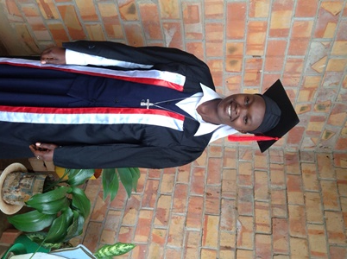

***Congratulations***

Sister Mary Rozaria graduated on March 2nd from the

YMCA Comprehensive Institute. Congratulations dear

Sister on achieving your goal and already putting into practice

all you learned at your ministry at St. Julie Nursery School in

Buseesa, Uganda.

***Perpetual Vows in Uganda***

On 1st March 2018 the Sisters of Notre Dame of the Holy Spirit General Delegation praised the good God on the occasion of the perpetual vows of Sister Mary Sunday Kusemererwa. The venue for the celebration was St. Julie Model Primary School in Buseesa, Uganda. Many of Sister Mary Sunday’s relatives were able to attend the Mass and meal. Sister’s mother was radiant with joy as she witnessed her daughter make vows. Sister Mary Sunday’s father died many years ago, but the family was convinced that their father was present in

*station wagon*  ***April 2018 Newsletter Volume 10 #1 Page 5***



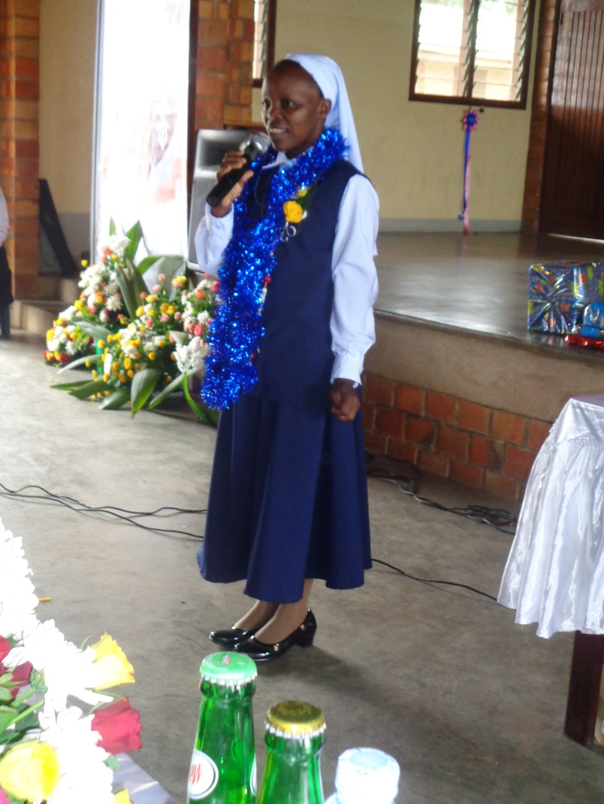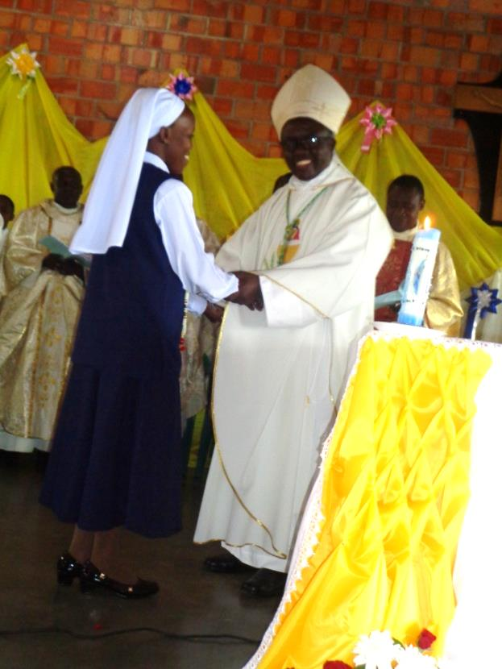

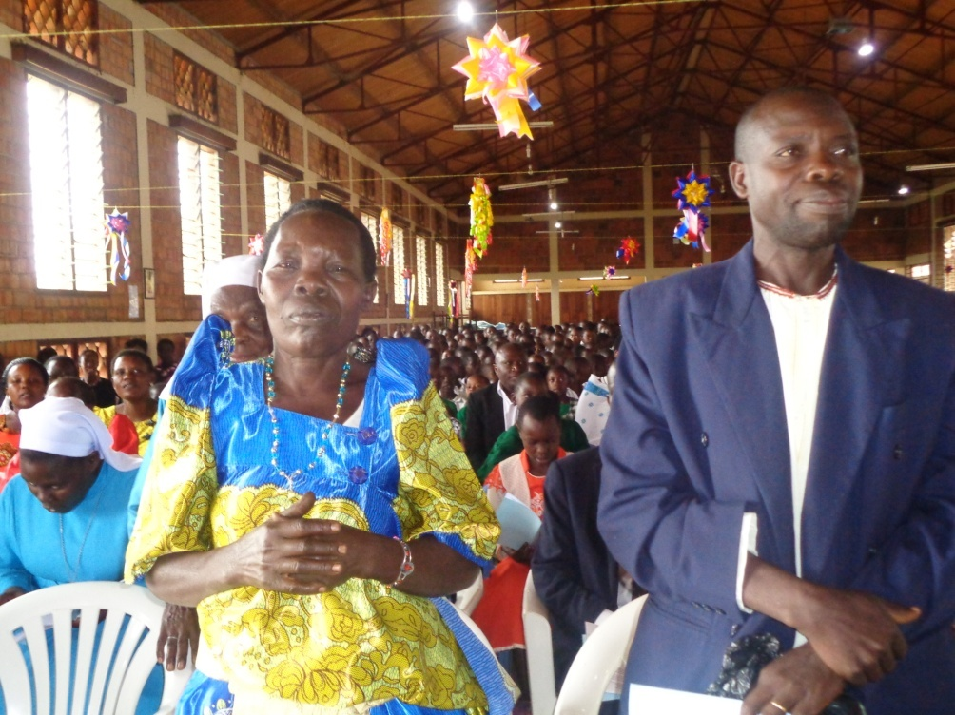

spirit. The main celebrant was Bishop Kirabo Vincent, Bishop of Hoima Diocese. Many priests were present including the parish priest of Buseesa, Father Tuhairwe Godfrey. The children of the primary school and secondary school were present lending their voices in song and their bodies in dance. Many Buseesa villagers attended to witness this important occasion

***Installation of His Grace, the Most Rev. Isaac Amani Massawe***

The Holy Father Pope Francis on 27th December, 2017 appointed Rt. Rev. Isaac Amani Massawe, Metropolitan Archbishop of Arusha. Formerly the Bishop of Moshi, Archbishop-Elect Isaac Amani becomes the fourth ordinary of the Archdiocese of Arusha whose Suffragan Dioceses include Mbulu, Moshi and Same.

Archbishop Isaac Amani was installed as the Archbishop of the Catholic Archdiocese of Arusha on 8th, April, 2018, in a ceremony that was also attended by His Excellency John Pombe Magufuli, the President of the United Republic of Tanzania as the Guest of honor.

The installation Mass was also attended by H.E. Polycarp Cardinal Pengo the Archbishop of Dar-es-Salaam; the Apostolic Nuncio to Tanzania Most Rev. Marek Solczynski, Catholic Bishops and a number of government dignitaries.

**[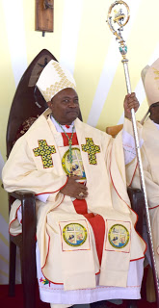](https://3.bp.blogspot.com/-7HNVlvzZ_pY/WtDcyWO-zaI/AAAAAAAAJkk/RLH4IHBc1800g_q6V0e32SAnjIqPmccfACLcBGAs/s1600/arusha+5.jpg)**

|  |
| --- |
| [https://3.bp.blogspot.com/-iLdYJp3PeQs/WtDc9jVrZ_I/AAAAAAAAJko/m29soZ5B8JIPp7WrBNmy66ZcaXBEP-NlQCLcBGAs/s400/arusha%2B6.jpg](https://3.bp.blogspot.com/-iLdYJp3PeQs/WtDc9jVrZ_I/AAAAAAAAJko/m29soZ5B8JIPp7WrBNmy66ZcaXBEP-NlQCLcBGAs/s1600/arusha+6.jpg) |
|  |

*station wagon*  ***April 2018 Newsletter Volume 10 #1 Page 6***



Addressing the congregation after Mass on behalf of the government, President Magufuli commended the work of Religious Leaders especially in easing the governance of the country. “I promise to work very close with you especially in ensuring that peace prevails in this country, I will not let you down,” he said.

Delivering his vote of thanks to the congregation gathered, Archbishop Amani stressed the need for collaboration among leaders despite having different religious beliefs or political ideologies. “Everybody must have guts with our country Tanzania; let us create well an ambience for working together for development of our people,” he said. He appealed to all the people of Arusha and the country at large to join hands and work for peace.

It was a great, wonderful, and blessed day as the large crowd gathered together to be the eye witnesses. We were very happy to be the part of this holy and joyful celebration as sisters of Notre Dame in Tanzania. *By: Sister Mary Phyllis, SND*

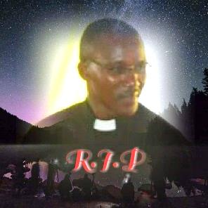

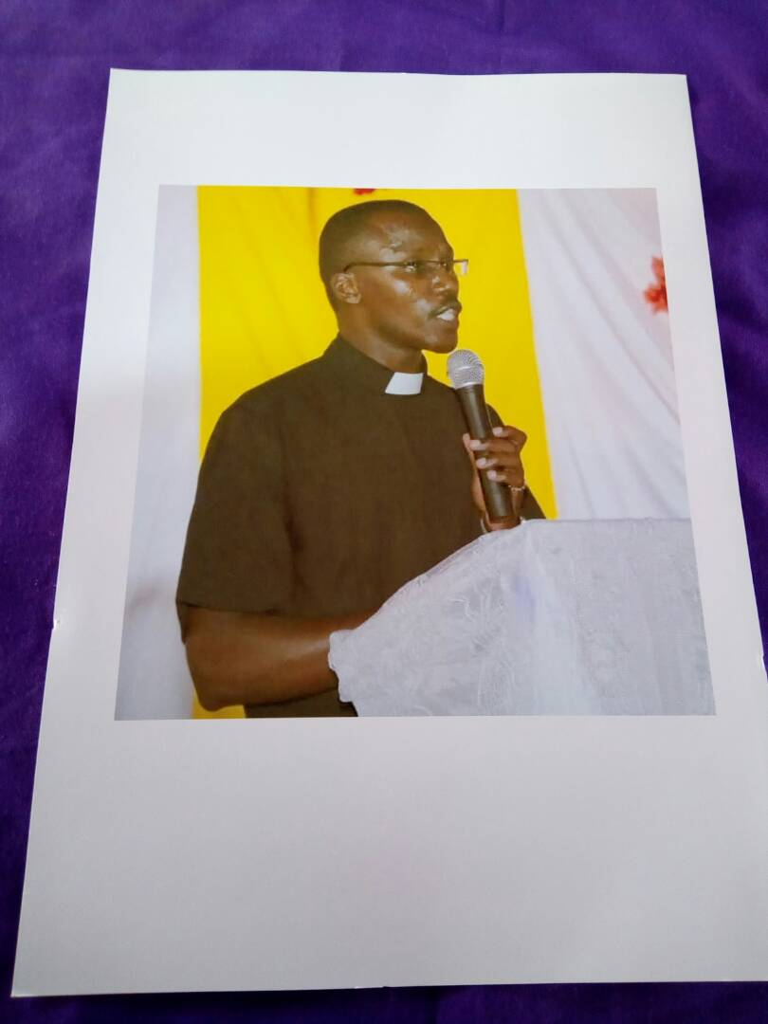***DIDIA, SHINYANGA COMMUNITY***

**The song is ended but the melody lingers, the pain passes but the beauty remains**

**Father Richard, you will remain in our hearts forever.**

**As we were reflecting upon the mysteries of the Lords passion on Good Friday, little did we know that the life of our beloved Fr. Richard Mtui had been claimed in a tragic car accident at 1:00 A.M. that morning. The car he was travelling in had a head-on collision with a Scania vehicle which killed Fr. Richard instantly; the driver escaped and the other passenger was seriously injured.**

**As we were getting ready for the Way of the Cross, Father Mathias received a call from Fr. Omondi informing him about the death of Fr. Richard. Father Omondi had been called by the police from Kiomboi. Father Mathias, Brother Ngonyani and Teacher Patrick immediately left for Kiomboi to find out if it was true. Meanwhile the parish priest of Kiomboi, Fr. Moshi, was also informed about the death of his fellow priest. When Fr. Moshi recognized that it was Fr. Richard, he informed our sisters in Kiomboi. The sisters immediately responded by going to the scene of the accident, to police and to the mortuary where Father’s body was identified. Soon Sister Kusum sent a message to Sister Mary Livia informing her about the shocking news. The sisters broke down upon receiving the news and were inconsolable but they were urged by Bother Deus one of the Salesian Brothers to be calm and silent about the news until it was officially communicated to the rest of the community especially the students. Finally at 7:00 P.M. during the rosary , the news was broken to the students.**

**It was very difficult for anyone to believe, people remained in shock and denial. It was late for Fr. Mathias and his companions to return to Shinyanga that same day. They were joined by Fr. Boniface and some Brothers from Dodoma community. We are grateful to our sisters in Kiomboi community who took care of the Salesians while in Kiomboi.**

**The next day after police investigations and postmortem, the body of Fr. Richard was transported to Shinyanga accompanied by the Priests and Brothers from Shinyanga and Dodoma along with Sisters Teresa Marie Nafula and Sawmya from the Kiomboi community; Sisters Mary Esther, Livia, Noela, and Beata our candidate and Fr. Melchades, a Salesian priest who came from Dar-es-salaam, were waiting for them at Shinyanga town. As soon as the body arrived all went to Mwadui were the body was kept in the mortuary. Upon arrival at Mwadui all went to the parish for a short prayer service.**



**Arrangements were made for the Requiem Mass in the community on April 3, 2018. At 10:30 A.M. the body arrived in the community and we received our beloved Father with the deepest sorrow and pain. At 11:00 A.M. the Mass began and was presided over by the Bishop of Shinyanga Diocese, Bishop Liberatus Sangu. Many priests, religious, Christians and students attended. During Mass many people expressed their hearty condolences and Fr. Matthias gave a beautiful tribute to Fr. Richard on how he lived his life faithfully and fully. After Mass the people were given a chance to pay their last respects and this was followed by lunch and the body of Fr. Richard was taken back to Mwadui mortuary.**

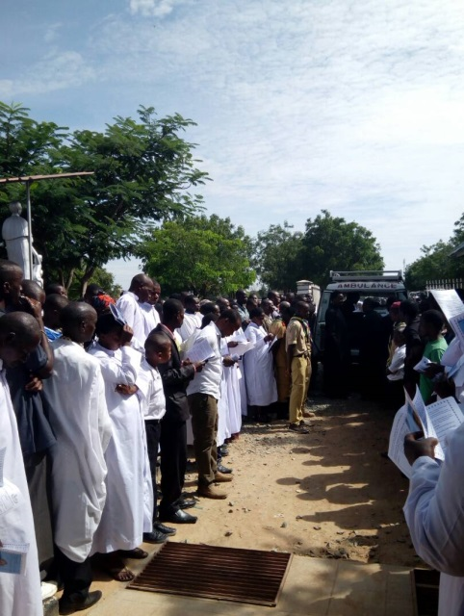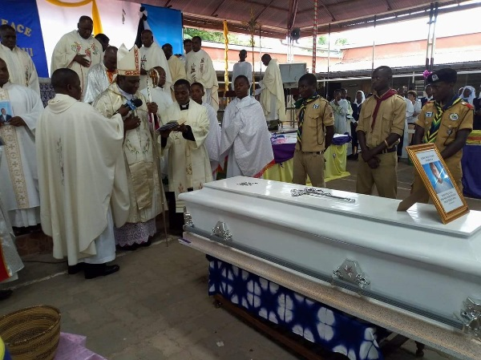

**On April 4, 2018 Fr. Richard’s body was taken to Moshi where he was to be laid to rest. So many people accompanied the body from Shinyanga; priests, sisters, students and Christians in large numbers. The journey started at 4:00 am and arrived at Moshi at 6:30 P.M.. We were received at St. Joseph’s Hospital where we were taken to the chapel for a short service for Father which was prepared by the Brothers and led by Fr. Simon Asira the Provincial of the Salesians. The family of Fr. Richard could not accept that their beloved was no more. After the prayer service, viewing Father’s body took place and it ended at 8:00 P.M. The body was taken back to the mortuary to be prepared for the funeral the next day. The sisters were taken to Don Bosco community for supper and later to sleep at the convent of the Sisters of Kilimanjaro . Sister Mary Sawmya, who had accompanied the body of Fr. Richard from Kiomboi to come and comfort the sisters in Didia community, returned back to her community at Kiomboi.**

**April 5th will remain a sad day in the life of each person who experienced the life of our Rector and friend Fr. Richard Mtui. The day of departure was the most painful moment since the death of Father Richard occurred; the day of laying him at his final resting place. Over 145 priests not to mention all the religious men and women and so many friends and people were present for the funeral. During the Mass many people gave their condolences and tributes to Fr. Richard and many acknowledged his holiness and hardworking spirit, so inventive and love for the poor. We Sisters of Notre Dame who have been living and working with Fr. Richard in our school community were called to share something about Father’s life. We then went to the grave yard to bury our beloved Father which was very painful. After the funeral, people were peaceful and began to accept the reality.**

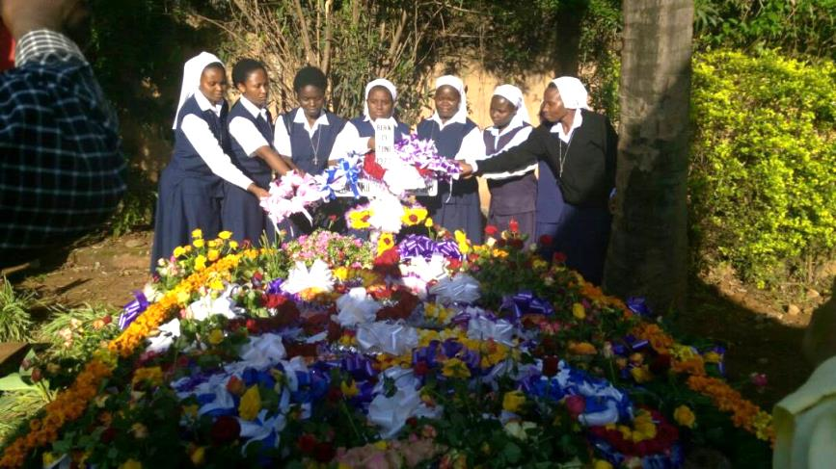

**They that sow in tears shall reap in joy.**

**I am sure that we have won a powerful intercessor in heaven for us**

**On April 12, 2018, we had a Requiem Mass organized by Fr. Melchades for our beloved Fr. Richard Mtui for the sake of the students and staff who were not able to attend the funeral. The day before the Mass, Fr. Melchades Lukanyaga met different groups of students and staff to have a little counseling with them on grief. He also invited each student and staff to write a love letter to Fr. Richard expressing all their feelings towards him, they could be feelings of love towards him or unforgiveness for parting unexpectedly, or sorrow or anger and allow themselves to go through the pain and come to accept the fact that Fr. Richard is no longer with us. So during the course of the Mass, everyone who had written something was called forward to present their letters and they were collected in two big boxes, they were then kept by the image of Fr. Richard as if he was the one receiving them. Later all the letters were blessed and burned and beautiful prayers were offered for him. After Mass everyone seemed more peaceful. We know that Fr. Richard will remain alive in our memories as we recall his inspirations and good works.**

**At the end of the Mass, Fr. Melchades urged everyone to keep the Fr. Richard alive by living some of his virtues. As the community of Don Bosco, the members agreed to make the silver jubilee very successful in honor of him since he died in the course of preparing for the celebration, but also to set up a building in honour of him.**

**of him.**

*station wagon*  ***April 2018 Newsletter Volume 10 #1 Page 10***



***As we bring our newsletter to a close, we offer our deepest sympathy to our Sisters, Priests, Brothers, students and staff for the loss of Fr. Richard Mtui. Surely, they have a powerful intercessor in heaven for all of them.***

***On another note, we congratulate our Sisters for all that they have been doing to incarnate our good and provident God in our Delegation and other parts of the world. We look forward to welcoming our new novices on April 28, 2018 and our new postulants at the end of June. God is good all the time and all the time God is good! Amen! Alleluia!***