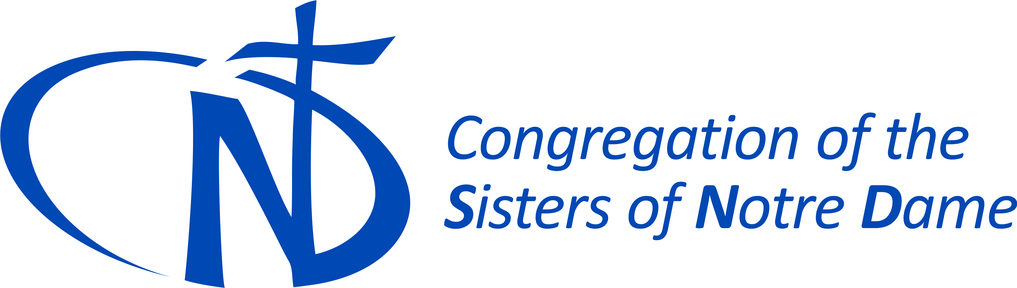
Latest News Updates
snd1.org ⏐ May 8, 2017

4 Latest News in snd1.org
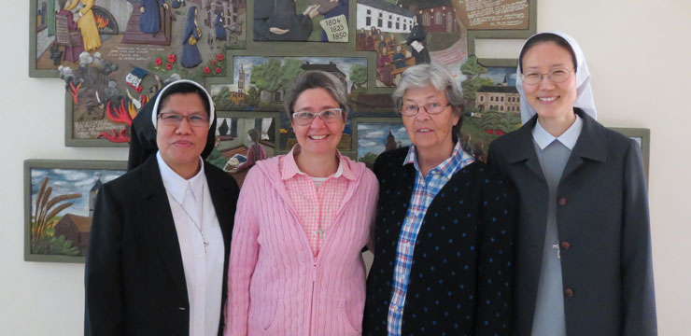 | 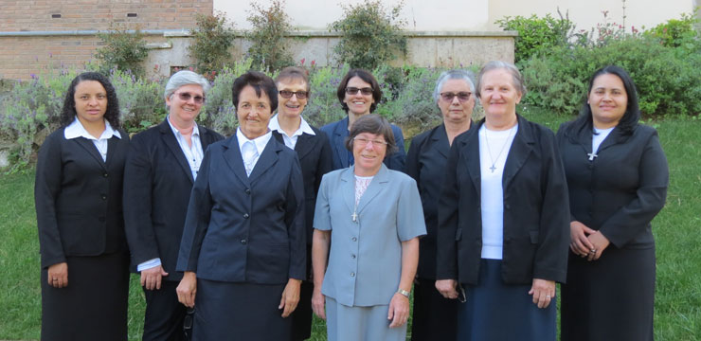
International Community Inservice, Rome, Italy | Brazilian Pilgrims in Rome, Italy
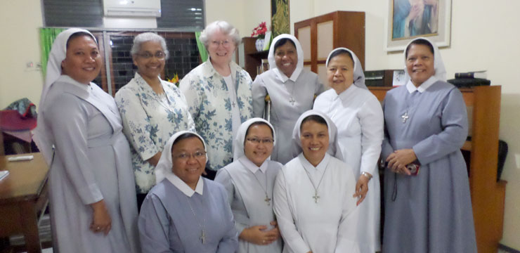
In Service Program Jakarta, Indonesia | Spring picnic with migrants, Suncheon, South Korea
And More News in snd1.org

Reserved section of snd1.org : reserved.snd1.org (SND only)
Then login : If you don’t know the login information for the reserved section and SND Resources, please contact your provincial secretary.

SND Mission “Ad Gentes” Programs : Find the document under “Documents / SND Mission “Ad Gentes” programs”
Congregational Fund Documents Updated : Find the documets under “Congregational Fund”
And More News in reserved.snd1.org

Resources Center of snd1.org : resources.snd1.org (SND only)
Then login : If you don’t know the login information for the reserved section and SND Resources, please contact your provincial secretary.
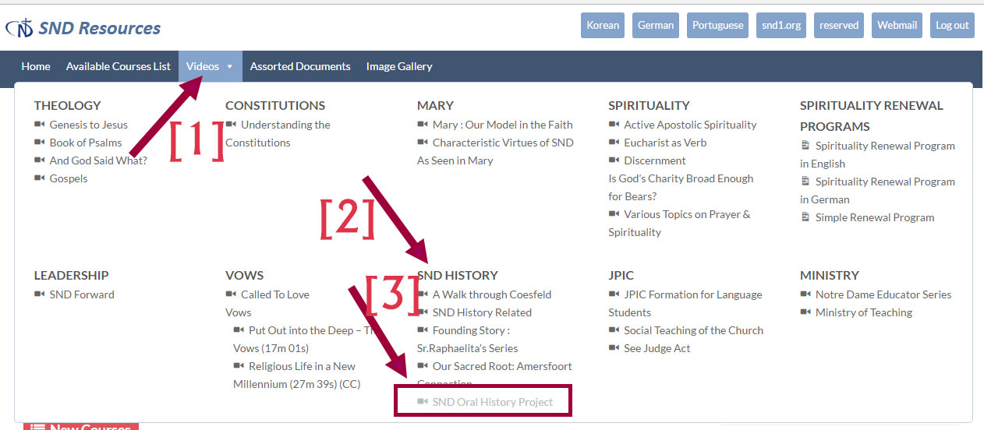
SND Oral History Project Videos : Go to “Videos / SND History / SND Oral History Project”
Videos are in German with German subtitles. Some have English, Portuguese and Korean subtitles.
Recent Updates : in “SND Oral History Project”
English Subtitles updated :
Vechta / Sister Maria Anselama
Coesfeld / Sister Maria Irmgarde
Coesfeld / Sister Maria Thiatilde
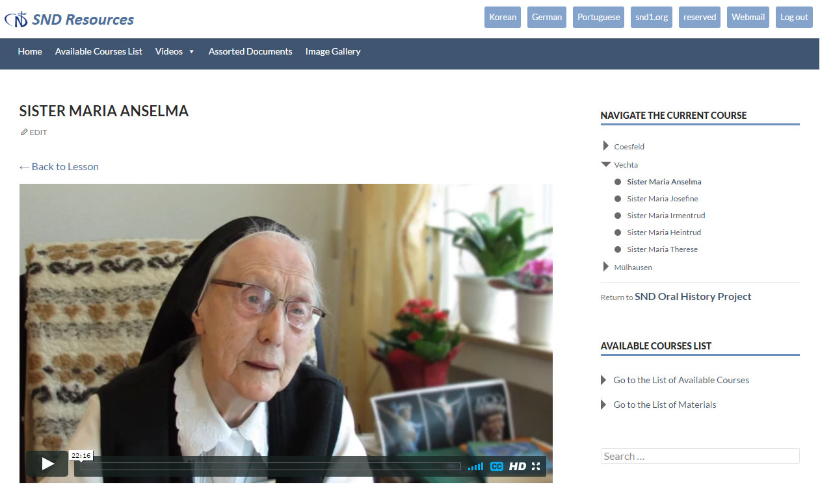
Portuguese Subtitles updated : SND Oral History Project
Vechta / Sister Maria Heintrud
Vechta / Sister Maria Anselama
Mulhausen / Sister Maria Dorda
Mülhausen / Sister Erika Maria
Mülhausen / Sister Maria Mechtilde
Mülhausen / Sister Maria Ruthilde
Mülhausen / Sister Maria Severian
Coesfeld / Sister Maria Hatwig
Coesfeld / Sister Maria Hubertine
Korean Subtitles updated : SND Oral History Project
Coesfeld / Sister Maria Thiatilde
And More Topics in resources.snd1.org
In this SND Resources section, on the top menu, click on “Available Courses List”, you will be surprised to see how many materials are updated there. Enjoy!!!

