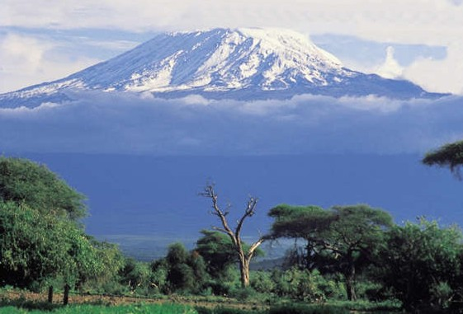

From the Roof of Africa

Sisters of Notre Dame
Holy Spirit General Delegation

January, 2017 Newsletter Volume 9 #1

Jubilee Bells are starting to ring!

The day has arrived for us to open our Silver Jubilee Year!

The day of our actual arrival in Arusha, Tanzania, East Africa was November 26, 1992. As this special day became a reality, each community prepared to celebrate the beginning of our 25th anniversary of our arrival in Africa. Looking back, let us look at our beginnings in preparation for coming to the sacred soil of Africa. This is taken from an account by Sister Mary Shobha, one of our pioneer sisters.

“The seeds of missionary zeal were planted in the heart of the congregation, when our Superior General, Sister Mary Joell, accepted the invitation of Rt. Rev. Bishop Fortunatus Lukanima, D.D., of the Diocese of Arusha, Tanzania, to “Come and See” the apostolic possibilities in his diocese. Accordingly, Sister Mary Joell and Sister Mary Odette came to Kenya, Tanzania, and to Mozambique to see the possibilities. After making a firsthand study of the situation, the various Provincials of the Congregation were briefed on the situation at

January 2017 Newsletter Volume 9 #1 Page 2

the Pre-Chapter Conference held in Patna, India in October 1990. Suggestions for involvement in the Missionary activities were asked for after much prayer and discussion. The Province of our Lady of the Assumption, Patna, India offered to send the personnel in order to share whatever resources they had.
Accordingly, our Provincial Superior, Sister Mary Shobana, asked for volunteers to submit their names by August of 1991. The immediate need of the diocese was to provide teachers for the existing Diocesan Higher Secondary School for Girls at Ngarenaro Parish. Accordingly, Sisters Mary Aruna, Shobha, and Thara were appointed to be sent to Arusha, Tanzania by the Provincial Superior and her Council.
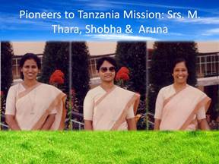

Preparations were made to release them from their respective appointments as Principal of Notre Dame Junior College of Education, Bangalore; Principal of Notre Dame Girls’ Higher Secondary School, Musgutri, P.P.; and Principal of DeNobili Hindi Medium School, Dhanbad, Bihar. The Sisters were released from their respective duties at the end of the academic sessions of their respective school systems.

As part of our preparation, we were given various opportunities for rest and relaxation, home visits, along with preparation to equip ourselves to face our future in Arusha, Tanzania. We attended a driving school to obtain a driver’s license, some basics in Computer Science and the learning of the new language, Kiswahili, the National language of Tanzania. Sister Marie Clarice from Chardon, Ohio sent us a set of tapes and books of a Basic Course in Swahili. We were lucky to have a student from Kenya in Patna, Mr. Felix Kamba, who would come every day to teach us in the evenings. We were also given time out for Renewals, retreats, Community Building sessions, and Orientation into our Mission which was followed by a five-day retreat at Atma Darshan, Patna, by Rev. Fr. John De’Mello, SJ.

The date of our departure was set for October 31, 1992 but it had to be postponed since the Bishop of Arusha would be in Rome for his “Ad Limina” visit and would not be present when we arrived. Hence, we set the date again for November 22, 1992 from Patna to Bombay by train and from there on November 26, 1992 to Arusha by Ethiopian Airlines.”

This begins a short history prior to arriving on November 26, 1992 to the sacred soil of Africa. Be assured of other stories of our early history in various communities of our Delegation.

January 2017 Newsletter Volume 9 #1 Page 3

Opening of the Jubilee Year Celebration

The Delegation community joined the Mount Sinai community to mark the opening of the Silver Jubilee Year. The day began in the morning with the celebration of the Holy Eucharist at the CMI Fathers’ chapel. At the end of the celebration we sang Julie’s Psalm as the final hymn.

In the evening, the sisters also invited the CMI Fathers’ community to the Mt. Sinai Convent parlour. Sister Mary Aruna, one of the pioneers, cut the ribbon of the inner entry door to the house symbolically opening the Jubilee Year. All present applauded in joy and happiness. She then welcomed everyone to the community dining room where a short introduction was read of the humble beginnings from St. Joseph, Ngarenaro. The temporary professed sisters continued with a presentation on the mission development until today. It was indeed a moment of gratitude to God for our pioneer Sisters - Sisters Mary Aruna, Thara and Shobha and for the gift of each one of us for all we have contributed to the development and expansion of our African Mission and the entire General Delegation.

We know that each of our convents celebrated in some way this grand opening of the long awaited Jubilee Year. May God continue to bless each one of us as we join in celebrating.
By Sister Mary Kellen, SND

Transformational Servant Leadership Course

"In five days we had a wonderful and enriching workshop on TRANSFORMATIONAL SERVANT LEADERSHIP facilitated by Dr. Jeanne-Marie Tapke, PHD and our own Sister Mary Shauna from Covington, Kentucky. Dr. Jeanne-Marie is an Associate of the Sisters of Notre Dame in Covington. During this time, we learned how we can become transformational servant leaders. We gained knowledge on how a servant leader should be in connection with the profile of a Sister of Notre Dame. We received new insights on how to resolve conflicts, engage in decision making, and have clear communication, work with change management and various ways of building relationships using social skills.

The highlight of the day was the videos we watched on transformational leaders like St. Teresa of Calcutta, Fr. Damien of Molokai and Oscar Romero of El Salvador. Each of these leaders inspired and challenged us to look into our own lives to make the necessary changes that we have to make to be a servant leader. We were
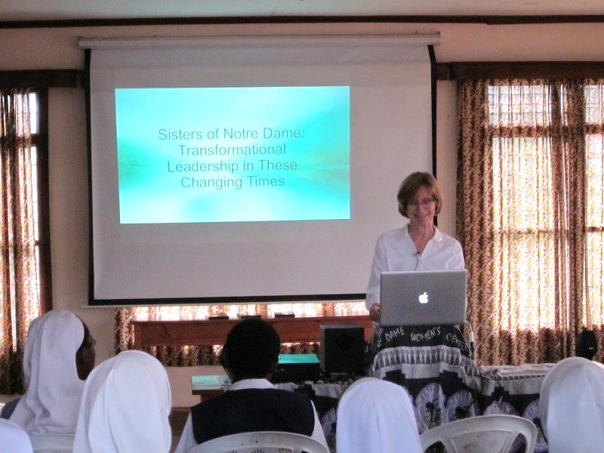
inspired to note that the servant leader makes a lot of
self-sacrifices to transform themselves and the world
around them. We in turn are required to make the
necessary changes to be effective leaders in our
communities, ministries and the wider world.

January 2017 Newsletter Volume 9 #1 Page 4

We are grateful to our Sisters who organized this programme for us, in particular to Sisters Mary Kristin, Sreeja and the General team in Rome and Sister Mary Roshini and her team in the Holy Spirit General Delegation. Sister Mary Shobha, the Director of the Temporary Professed Sisters, accompanied us throughout the workshop. They were elders and role models for us together with Sister Mary Mukti and the facilitators. We appreciated this precious opportunity given to us and we
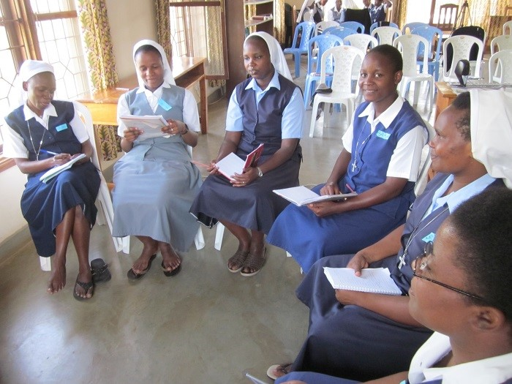

are grateful to all those who walked with us as we go into our own communities to actualize all the learning that has taken place in our lives. God bless you all. By Sisters Mary Jescah, SND

Our SND Teacher Training Course
It was a wonderful experience for us to have this TTC program or as it was called our Apostolic Orientation Programme. It was enriching, educative, and encouraging because we learned and gained many things. The different classes and opportunities included jolly phonics, how to be an effective teacher, skills in leadership, teaching methods and skills of teaching, how to prepare schemes of work and lesson plans, philosophy of education, guidance and counseling, and computer skills. Sister Mary Colette, our education coordinator was our main facilitator. We also appreciated the work done by sisters from other communities as well as some lecturers from Thongota
College, Africa Nazarene University and our own
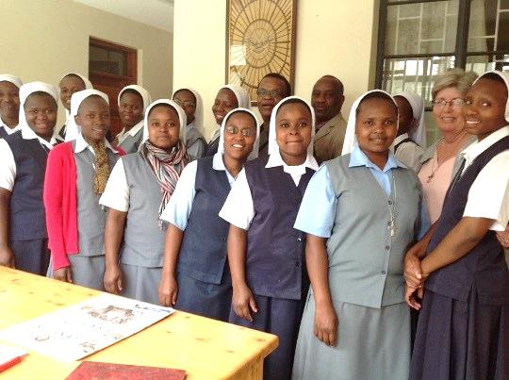
teachers in Notre Dame at Lyamutundwe, Mpala, Uganda.
We had some spiritual exercises such as visiting some
holy places and prayer houses; for example, going
through the “Holy Door” in the Year of Mercy, visiting
Namugongo Shrine of the Ugandan Martyrs and
Kigungu where the first White Fathers landed in Uganda
in Uganda.
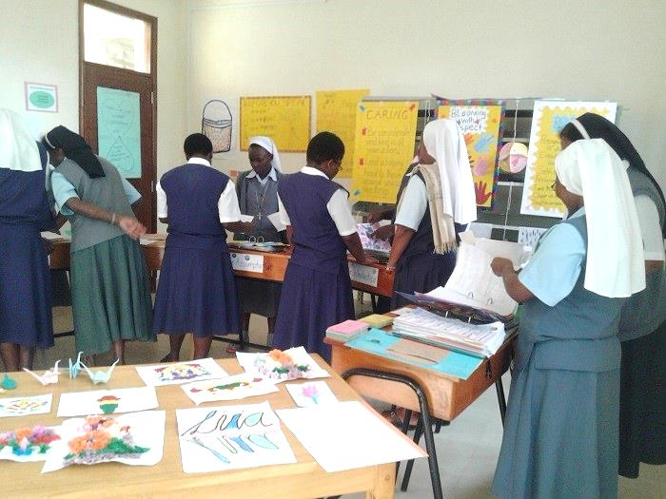
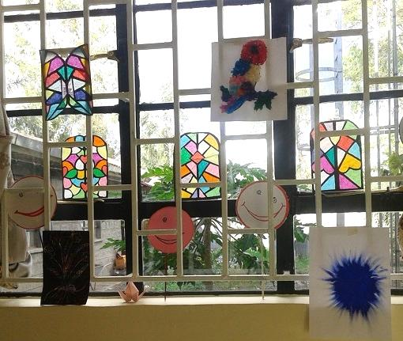

Our thanks go to Sister Mary Namita, the local superior of the Delegation Centre who hosted us and gave us an opportunity to do our teaching practice from our Notre Dame School on site. We are grateful to Sisters Mary Tina and Aruna who allowed us to observe some teachers teaching in their school as well as allowing us to teach some lessons. We feel more prepared to enter into the classroom in the coming year. We entrust all to our good and provident God. God bless you all. By Sisters Mary Edna, Winfred M., Sicholastica Marie, Mary Tibahwerwa, Mary Assumpta, Winfred M., Pascalia K, and Livia.

January 2017 Newsletter Volume 9 #1 Page 5

Special Visitors
What a wonderful gift it was for our Delegation and especially for our novitiate community to welcome two sisters, Sister Maria Yohanisa from Indonesia and Sister Maria Hwan-Hee from Korea. Both of these sisters are students at the Angelicum in Rome and are in a diploma program for formators. They came during their holiday time to help out in the international novitiate under the guidance of Sister Mary Jyosita, the novice director. Our novices have the wonderful privilege of coming to know the internationality of our Congregation in yet another way by the visit and sharing of these two sisters

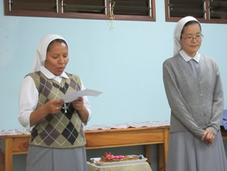
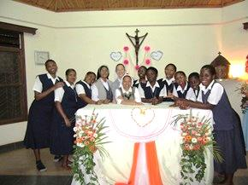

The novices interviewed these two sisters while they were with the novitiate community and these are some of their reflections:
Sister Maria Hwan-Hee shared with the novices her vocation story and it touched everyone. She feels she is sustained by God and the community and feels so happy to be in Notre Dame. She found and experienced love in Africa. “The sisters are always open and the climate is so WOW”. Sister was able to share elements of her Korean culture and also learn from the African culture. In sharing, she expressed gratitude for the opportunity to come to Africa, experince life with the novices and give of herself with her own gifts and talents.

Sister Maria Yohanisa shared with the novices her experiences of her ministry in the orphanage and social work. She shared about life in community and told the novices the positive things about community life and also what can break a community. She was touched by the openness and courage of the African people and of the novices, especially their source of joy, prayerfulness and growing hospitality. Sister was impressed with the novices’ visits to the village every Friday and how they show great love and respect for the people.

The novices learned much for the visit of these two sisters as they shared their gifts and talents and they also know that the sisters gained much from their time in the novitiate and the experiences they shared.

All of us in the novitiate want to thank our Superior General Sister Mary Kristin for this opportunity to share again in our internationality and to have and experience mutual sharing. By the First Year Novices in our International Novitiate Community, Njiro, Tanzania: Sisters Maria Domingas, Maria Jackline, Brenda Marie, Sisters Mary Julitha, Digna, Catherine, Flavia and Mary Mwende

January 2017 Newsletter Volume 9 #1 Page 6

Our Spirituality Renewal stays alive

Our dear Sister Maria Bernarde wrote a beautiful poem/reflection after the Spirituality Renewal programme that still stays alive in the sisters. Many in the session she attended appreciated her sharing and we wanted to include it this newsletter.
- Behold the cross, the tree of life -
For acceptance, courage, perseverance let us strive
Through darkness to light
Through sorrow to joy.
2. It is God’s holy ground
Courageous women put their feet
Said “YES” when heard his call:
“Come, follow, let us meet.”

- St. Julie, Sr. Aloysia, Sr. Ignatia
They all had listening and open minds
They searched for God with all their hearts
And found and answered “YES”.
4. Love for the poor, care for the neglected
Teaching children was their goal.
Forward they went, trusting with all their soul
In God’s goodness and provident care.

5.

Indonesian sisters’ visit

5. Their way was paved with stones,
Misunderstandings, sickness, yes rejection,
But all was carried with patience,
Hope and the conviction
That God is with them at their side,
That he carries their crosses
That his outstretched arms embrace them in love.

6. With joyful, simple, humble hearts
They took up their daily tasks.
Nothing was too much for them
Because of knowing all the time:
God is good and present in their work.

7. Today we walk in their footsteps
And continue this great work with pride.
We carry our crosses with love, gratitude and courage.
We cherish our sacred heritage
In one heart, one hope, one mission, going forward
carrying the cross of love and life
As faithful Sisters of Notre Dame into a needy world.
By Sister Maria Bernarde, SND

January 2017 Newsletter Volume 9 #1 Page 7

Come and See in Uganda
The young women started arriving prior to the actual date of Come and See. By the afternoon of the 11th of January, St. Julie Formation House was filled with young women from various parts of the country. It was a great joy to welcome them. It was important to get to know the names of each person. During recreation a game was introduced for this cause where the last person had to mention every person’s name present; this was very exciting.
Various gifts and talents were portrayed through singing, dancing, role plays, etc. The young women felt happy and at home being with the sisters and candidates and appreciated the love and care they experienced from each person. As God calls people in diverse ways, some sisters and candidates shared their vocation stories and others handled various topics pertaining to our congregation. This was a time of listening and discovering God’s personal invitation to religious life and to get a feel of what it means to be a Sister of Notre Dame.
For our Eucharistic celebration, the Parish Church was made available because it was hard to accommodate everyone during the Eucharistic celebration in our chapel.
Special appreciation goes to our sisters who have done a significant job of reaching out to various parts of the country spreading God’s goodness and provident care through vocation promotion and for participating actively in our Come and See programme. May the good God bless you! By: Sister Mary Immaculate, SND

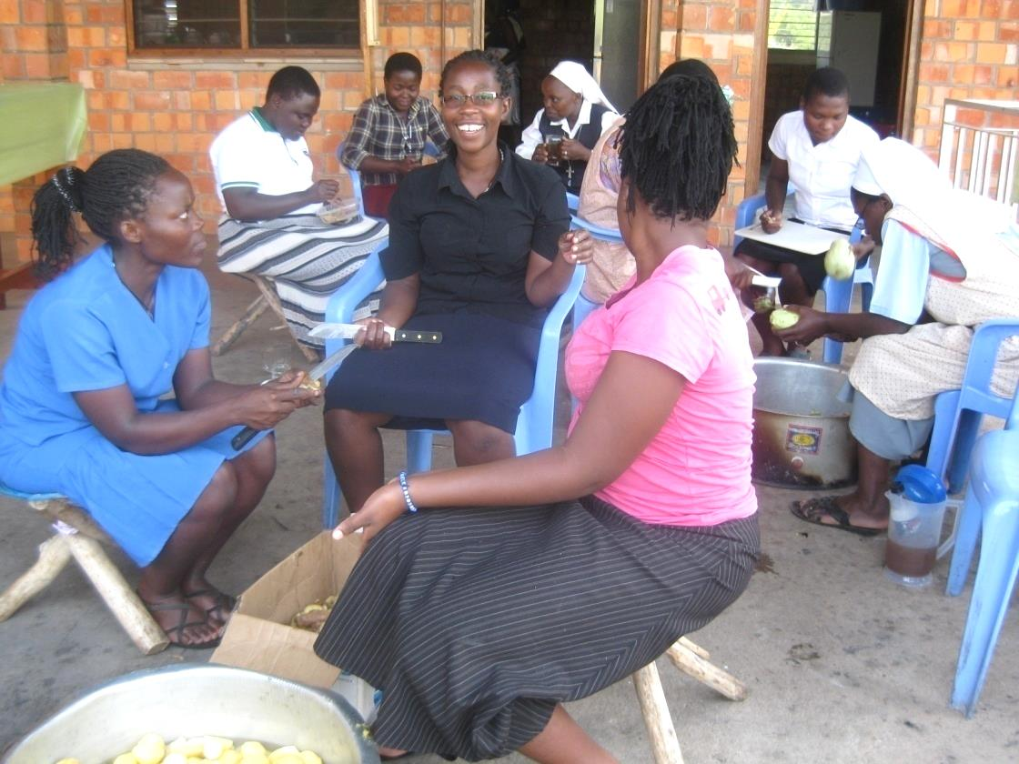

From the newsletter team: We hope you enjoyed our first edition of the New Year! In the coming months we will continue to highlight our foundations and ministries as we celebrate our 25 years on the sacred soil of Africa.
By: Sisters Mary Annete, Shobha and Namita, SND

