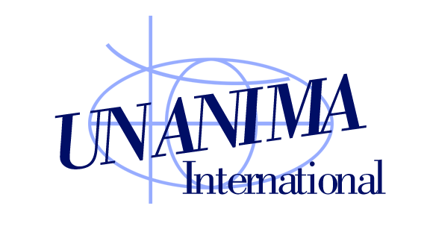

**Update**

**July 2016**

**NEW COALITION COORDINATOR SELECTED!**

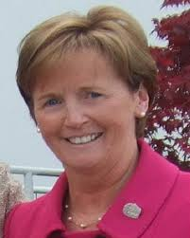And you already know her--Jean Quinn **DW** has agreed to become the third Executive Director in UNANIMA’s history. Jean is well prepared for the task, after many years of administration and most recently an internship with UNANIMA at the United Nations. Current Director Michele Morek **OSU** says that “As soon as I met her a couple of years ago, I thought—here’s someone who can do my job when I retire from UNANIMA!” Negotiations are still underway, but Jean will probably be starting sometime later in this year. You will be hearing more about her as that time nears. Meanwhile, we thank Jean for listening to the promptings of the Spirit of Wisdom…

**A NEW FACE IN THE OFFICE:**

Alex Satterfield (right) is volunteering with UNANIMA for one month this summer, joining intern Sister Nonata Bezerra **SND** (left). From Owensboro Kentucky, USA, Alex is a student-athlete at Brescia University, getting a double major in Pre-Law and Psychology and working during the school year/ summer at a law firm. She is particularly interested in the issue of human trafficking, and excited to be working on that subject at a global level with UNANIMA. We are glad to have her, especially since she will be sitting in for us at the UN High Level Political Forum (HLPF) in July, taking good notes as the HLPF begins its review of how countries are beginning to implement the Sustainable Development Goals (SDGs).

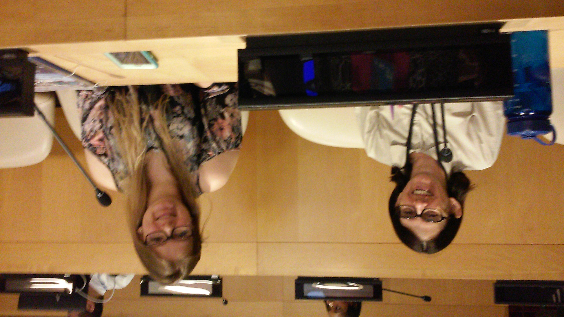

**HOW IS YOUR COUNTRY PROGRESSING?**

Speaking of the High Level Political Forum (HLPF), excitement is building about the July meeting. The HLPF is the newly-created UN body responsible for seeing that the Sustainable Development Goals (SDGs) are being carried out. The SDG process is now at the national level, with individual countries responsible for meeting their targets. This is the first meeting of the HLPF since the SDGs were formally accepted, and twenty-two countries have volunteered to undergo “National Voluntary Reviews” this first year. At the following link you can find a list of the 22 countries and a file where they put the report they are giving to the HLPF. Is your country on the list? Have they done what they said in the report? <https://sustainabledevelopment.un.org/hlpf/inputs>

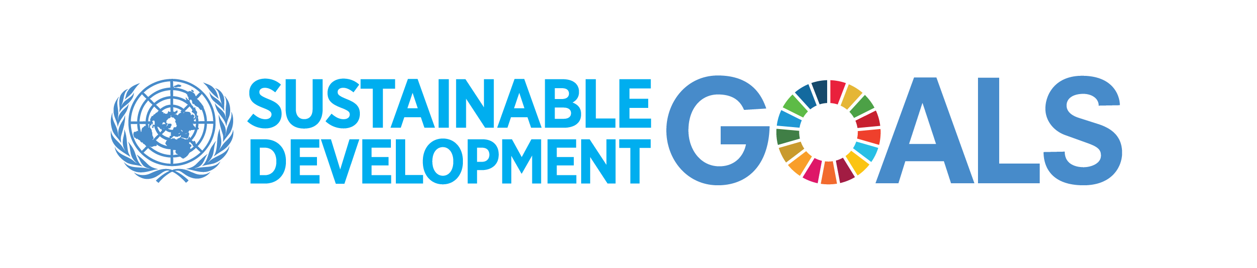

**“YOUTH FOR PEACE” NEED YOUR HELP!**

The 2016 theme for the International Day of Peace (21 September) is “The Sustainable Development Goals: Building Blocks for Peace,” highlights how ending poverty, protecting the planet, and ensuring prosperity for everyone all contribute to global harmony. The Education Outreach Section of the United Nations Department of Public Information needs your help in getting young people between the ages of 15-24 throughout the world to submit 10-15 second videos (in English) on how the Sustainable Development Goals can build peace. The most engaging videos will be featured on the United Nations International Day of Peace YouTube channel and at an official event at United Nations Headquarters in New York on 16 September. Videos will start appearing on the channel ([www.youtube.com/channel/UCpLhcvaNT33Bs8ZvB4j6d8w](http://www.youtube.com/channel/UCpLhcvaNT33Bs8ZvB4j6d8w)) from now through 21 September, the International Day of Peace. More details can be found at:

<http://www.un.org/en/events/peaceday/pdf/Invitation%20to%20Submit%20Videos%20for%20International%20Day%20of%20Peace.pdf>



**HELP US FIND WOMAN OF COURAGE NOMINEES FOR 2017!**

Don’t forget, we need YOUR ideas for our Woman of Courage nominee for next year. See the June Update for suggestions. Or just send us her name and an explanation of why you think she would be good!

**SECRETARY GENERAL (SG) SUPPORTS NGOS**

SG Ban Ki-moon denounced the shrinking democratic space and the threatened freedom for civil society organizations, NGOs, and human rights defenders, especially at “the last place this should happen, at the UN.” He was deeply disappointed that the ECOSOC (Economic and Social Council) NGO Committee denied accreditation to the *Committee to Protect Journalists* for the seventh year in a row. (However, the US called for a vote, which got the issue out of that committee, and opens the negative decision to possible reversal by the whole ECOSOC body). Ban Ki-moon also condemned the exclusion of LGBT organizations from a high level UN meeting on *Ending AIDS*, saying that “these NGOs are close to communities affected by the epidemic, and must be part of the response.”

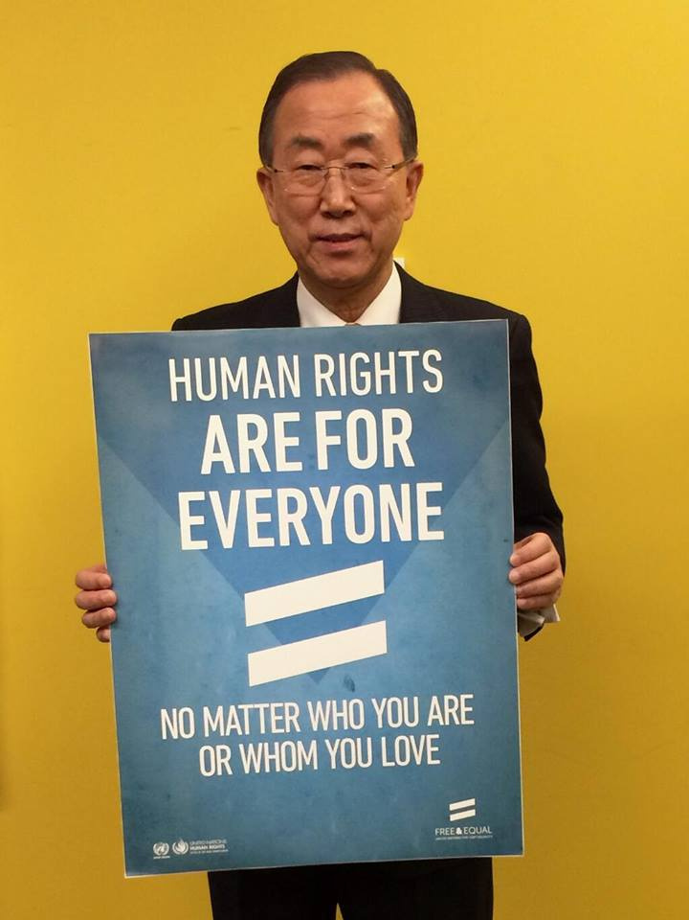

**POPE TAKES THE LEAD AGAINST TRAFFICKING:**

Following Pope Francis’ lead in combatting different forms of modern slavery—human trafficking, forced labor, trade in organs and organized crime—the Pontifical Academy of Social Sciences invited a large number of judges, prosecutors and magistrates from many different countries to a high level meeting. This new “Summit” is the latest in a series of important meetings organized by the Academy with the same purpose: in 2014, with the leaders of the main religions that exercise influence in the globalized world, and in 2015, with mayors of large cities of many countries. See <http://www.endslavery.va/content/endslavery/en/events/declaration.html> and <http://www.endslavery.va/content/endslavery/en/events/mayors.html>)

**ARE YOU ATTENDING THE WSF?**

Sister Gabriellaof Talitha Kum (the UISG organization against human trafficking) invites anyoneattending theWorld Social Forum (WSF) in Montreal this year to contact her there. The event will take place from 9-14 August. Representatives from the US and Canadian Catholic sisters against human trafficking groups (USCSAHT and CATHII) will attend the WSF. Talitha Kum and CATHII have organized events in English and French.

**UI AND SOCIAL MEDIA:**

In June we celebrated the one-year anniversary of *Laudato Si’* by doing a post on Facebook. UNANIMA has been working for a year to have more of a presence on Social Media, “tweeting” from every major UN meeting we attend. Follow and “like” us on Facebook and re-tweet our tweets!



**RESOURCE FOR PROTECTION OF MIGRANTS:**

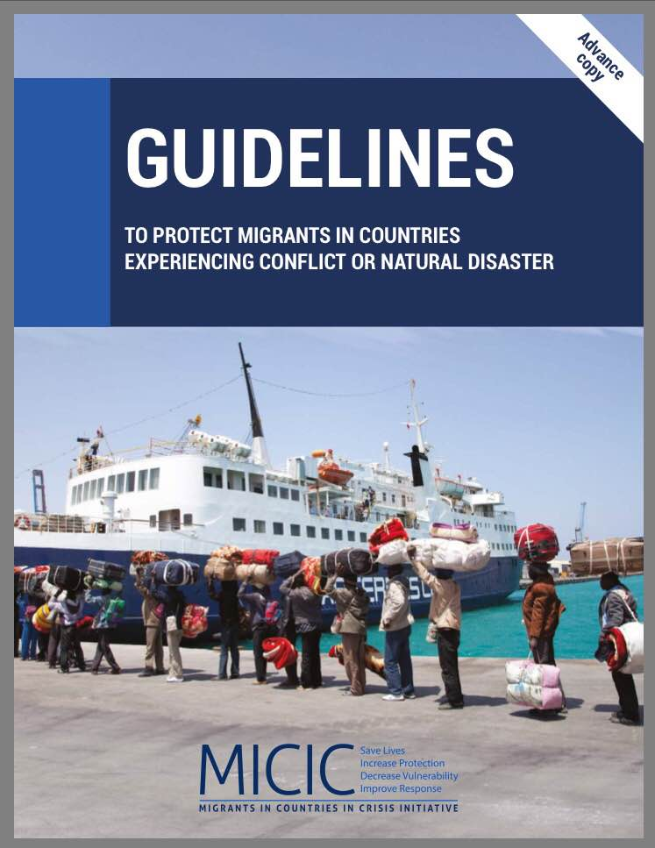

The *Migrants in Countries in Crisis* (MICIC) Initiative is a very practical guide for agencies and countries dealing with people trapped in countries when there are natural disasters or conflict. Imagine if you are a worker, a missionary, or even a tourist trapped in a country undergoing a crisis. You need help and resources. You are not a refugee, so the international conventions for refugees would not apply to you. This guide is full of (unusually) practical suggestions for people who might “fall into the cracks” of other kinds of help for migrants.

The resource is online now at <https://micicinitiative.iom.int/> but only as an “Advance Copy” in English. It will be translated into all UN languages by the end of the year.

**CLIMATE CHANGE AND WATER AND MIGRATION AND TRAFFICKING AND…**

Last year was the world’s hottest on record, perhaps the hottest since the invention of agriculture 10,000 years ago. Many more are facing water shortages, fires, droughts, and famines. Refugees become vulnerable to increased poverty and human traffickers. Many believe that the crisis in Syria was spurred in part by conflict linked to a multi-year drought, and the suffering of many environmental refugees in sub- Saharan Africa and Small Island Developing States all underline the effect that climate change is having an effect on many of UNANIMA’s focus areas. We celebrated World Oceans Day on 8 June, and learned that eminent scientist Stephen Hawking predicts that as the earth warms even more, large amounts of carbon dioxide will be released from the ocean floor, speeding global warming even more. But observers at the Paris UN Climate Change talks in December noted the impact of *Laudato Si’* and other faith-based advocacy. We can make a difference.

**FLASH POINTS:**

* Sister Margaret Scott **ACI** of the **Handmaids of the Sacred Heart** is on the Media Subcommittee of the Philadelphia anti-human trafficking coalition, preparing for the US Democratic political party’s convention. The coalition is made up of Catholic sisters, church groups and organizations. They are putting their logo in huge letters on three central bus stops near the convention center, where they will give out information and engage visitors in discussion. The message “*Stop Human Trafficking*” will be up in rotating lights on a tall tower. The NUNS ON THE BUS are coming to Philadelphia during the Convention, and have been asked to do an event with the local group. The planning group has also organized visits/ training for all the hotels in Philadelphia and near the airport, with excellent results. –Margaret Scott **ACI**
* 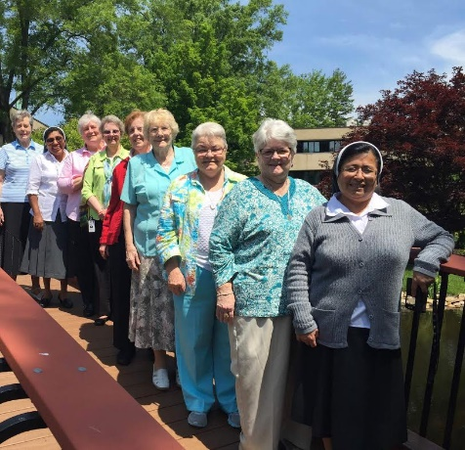The **Sisters of Bon Secours** hired Sister Mary Beth Hamm SSJ last year as coordinator of their International JPIC Committee, with members from Ireland, France, Peru and the US (pictured). They had their first in-person meeting at the end of May, and found it energizing to meet in person for three days, getting to know one another more deeply, and sharing hopes and their commitments to JPIC. In the context of Contemplative Dialog they focused on deepening their understanding of and commitment to action on Chapter commitments: ***ending violence, crying out against human trafficking, promoting ecological health.*** Mary Beth produces a monthly newsletter available to their membership (sisters, associates, volunteers, and colleagues) in all countries in which they minister--one means of inviting members to engage in study and concrete action on Chapter commitments. –Fran Gorsuch **CBS**
* As part of Human Rights Week, designed and organized by the Student Committee for Human Rights at Collège Sainte-Anne de Lachine (Quebec, Canada) and the Head of the College’s Spiritual and Community Animation Department, more than 150 students, on two separate days, were introduced to negotiation through a simulation of the United Nations. Their task was to find solutions in order to end the war in Syria and carry out their obligations toward Syrian refugees. The students who took part came away with a greater awareness of the challenges involved in dialogue between nations. The activity ended with a meeting with a Syrian refugee and a Muslim who was hosting a Syrian family. Renaude Grégoire from the **Sisters of Saint Anne** Social Justice Office was present at this event and briefly presented the commitment of the Congregation at the United Nations with UNANIMA International.

–Renaude Gregoire

* 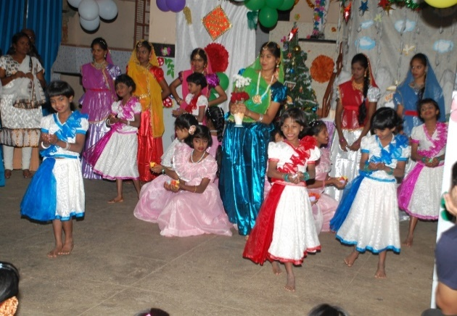Asha Deep (“Light of Hope”) is a ministry of the **Daughters of Wisdom** and the first shelter for girls living on the streets of Bangalore. Presently there are 60 girls from 4-20 years old living there, receiving an education and preparing for life. The staff also visits their families to offer help and rehabilitation.