April 2016 Newsletter Volume 8 #2 Page 4

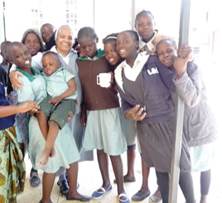
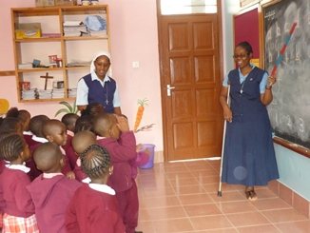

So many children surrounded Sister Mary Mukti.
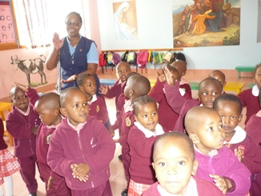
Sisters Mary Sujita and Mukti were responsible
for making this experience possible for the tertians.

Sister Mary Lavenesse had experiences at our Notre
Dame School in Syokimau with the Montessori I
Children. Due to the poverty of language, I could
communicate with children most with the language
of love. I appreciated each child for the respect and
cooperation they showed to their teacher. I
acknowledge the high discipline due to the great love
the teachers give to the children. Anytime a new
person comes, the children have so many questions. They wanted to know what happened to my
leg and why it wasn’t there and why I use a crutch. Once those questions were answered, that
was the end and we could enjoy each other and work together. I feel so grateful for the
opportunity to be in the school and learned so much. By Sisters Mary Margaret, Winfred,
Phyllis, Teresa, Susan, Kellen, Therese Marie and Lavenesse, SND
We’re grateful to the tertians for the wonderful article about all their experiences and know that all of you, our readers, also learned much from what they shared. May this reaching out to others continue in the future.

A Heart for real knowledge

Mt. Meru University that we attend is under the Baptist Church. It is wonderful for us to be in this Institution. The presence of God is felt in the whole atmosphere. Sisters Mary Emmah Cindy and I are very grateful that we are among the thousands of the students who are studying here. The
university is located along Nairobi Road as you leave Arusha town. It has well equipped facilities and has about 200 acres of land. Previously it was a theology center for the Baptist Church and the students resided on the compass itself which had many cottages. Currently these cottages are dormitories for the university students. The joy we experienced when we first came to the University is that after the 1st session of our new academic year, we all assembled in the chapel from 9:30 A.M. to 10:00 am. Now our 1st semester is over and indeed we did our very best. We are in our 2nd semester and soon we'll be sitting for Exams. Dear sisters, we rely on your prayerful support. By Sister Mary Magdalene Musila, SND

April 2016 Newsletter Volume 8 #2 Page 5

A heart for the Word of God
We are so grateful to our dear Superior General, Sister Mary Kristin, for inviting Sister Mary Kathleen to bring all her gifts and talents of spirituality and scripture to our novices, postulants and tertians
We the Novices and Postulants of our International Novitiate in Njiro, Arusha, Tanzania are very grateful to Sister Mary Kathleen Burns, SND for walking with us through the Scriptures during the month of February. This study and reflection on the Scriptures has helped us to “Encounter the Word and Engage the World.” Even though some of us were deeply troubled to know that some stories are not historical, they are truths to teach us about God the Father’s infinite love for his beloved sons and daughters. The Holy Spirit has inspired us and touched us. By Sister Mary Winfred, NND

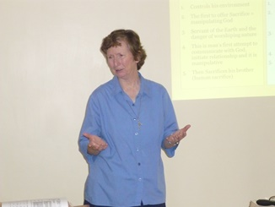

Let’s hear a few comments from our second year novices: From Sister Mary Winfred: The study of Scripture has motivated me to read and pray the Word of God daily and build a personal relationship with God. Jesus is the Living Word. Sister Mary shared that free will is given only to human beings as it is revealed in the salvation history. It challenges me to walk the way of truth in my daily decisions. Sister Sicholastica Marie says I was touched by the story of Adam and Eve and the free gift that was bestowed on them to choose between good and evil. I realized that this strong pull between choosing good and evil is still continuing in the world. Our personal choices have the power to build the world or to destroy the world. Sister Mary Assumpta says the study of Scripture opened my eyes and ears to understand that the Holy Spirit is active and alive even today. It is up to me to dispose myself to see him and touch him and to be transformed. Sister Mary Pascalia was touched by the way God uses nature and human beings to reveal his true nature. The Holy Scripture is showing me the way to faith, hope and trust; hence, the need to look for direction from the word through daily reading of it.

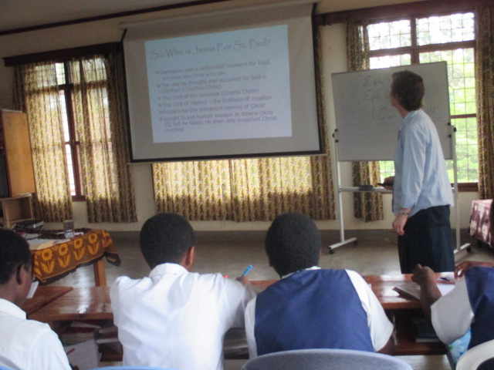
For Sister Juliet Marie, I came to understand that God will fulfill his promises to me in his own time and his own way. Father Abraham is my role model. Sister Ema Virginia says now I am able to read the New Testament in the light of the Old Testament. It gives me much more depth in my Scripture meditations and pericope. It created an interest in Reading the Old Testament. Sister Turesse Marie came to realize that Jesus is the fulfillment of salvation history and Scripture is God’s love letter to human beings especially to me.

April 2016 Newsletter Volume 8 #2 Page 6

Sister Finita Marie says I was touched by the relationship between the Isaac of Old Testament and Jesus the only Son of God. I’m challenged to read and understand the word of God with its prototype in the New Testament. Sister Mary Livia shared that the authors of the Scripture wrote the inspired words to teach and instruct the people of God. The Old Testament people and the present people faced the same problems. We can find an answer to all the problems by reading and reflecting on the Scriptures.
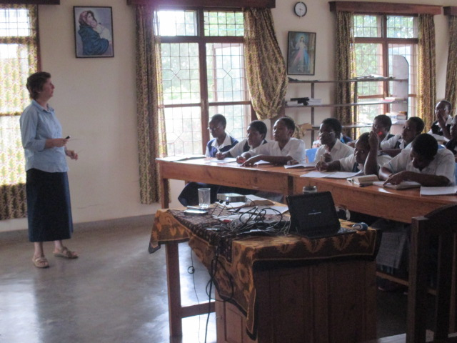
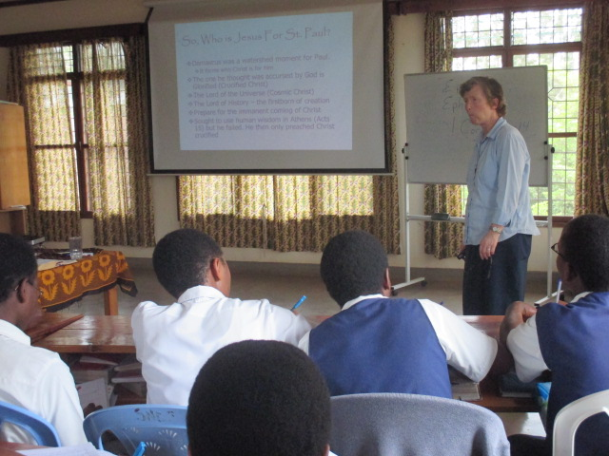

A heart for our new Bishop
Six years of vacancy were over. Our good friend Bishop Byabazaire Deogratias died in February of 2014 after a long illness. During that illness, the diocese was under an Apostolic Administrator,
Bishop Lambert Bainomugisha. Bishop Deogratias was the one who had invited the Sisters of Notre Dame to come to his diocese in 1995, and through all these years until his sickness he was a good supporter and friend.

While Pope Francis visited Uganda in November of 2015, he appointed the new bishop for the Diocese of Hoima, Rev. Fr. Vincent Kirabo, a Professor at St. Mary’s Major Seminary in Ggaba. The people also were very happy with this appointment because Bishop Vincent is not only a son of this area, Kahunde Parish in Kibaale District, but he was also our parish priest in Buseesa from 1998-2003. So he is no stranger to us.
Sunday, February 28, 2016 was his ordination and consecration as Bishop at the Cathedral of Our Lady of Lourdes in Hoima. Sisters Mary Judith, Bernarde, Anita Marie, Violet Marie, Immaculate and Paulynne left by our Land Cruiser very early in the morning and made our journey on the bumpy, dusty roads towards Hoima. We arrived at Kolping House two and a half hours later to refresh ourselves and to greet the Bishop's family. Teacher Joseph on our staff, is the uncle of the newly appointed Bishop and was so proud and happy to see and greet us!
Everyone had to go through a very thorough security check and that meant the President of Uganda would attend the function. In front of the cathedral, about 25-30 tents were erected for different groups of people. Everything was well organized. President Museveni arrived a bit late but he had his own tent and was surrounded by some of his cabinet members. Also King of the Bunyoro, Dr. Solomon Gafabusa Iguru had his own tent where he sat with his traditional guards with spears and shields clothed in bark cloth. He was a very close friend of our dear departed Bishop Deogratias and so came to honour the new Bishop at his consecration.

April 2016 Newsletter Volume 8 #2 Page 7

The Sisters were ushered to the section for women religious. We were a great Notre Dame contingent! There were over 200 priests in attendance and more than 20 bishops and archbishops coming from all over Uganda; it was all very impressive! There was a special tent for the immediate family and also for political dignitaries. All in all, there were thousands of people in attendance.
Several choirs, dancers and drummers had prepared the liturgy which was presided over by the Archbishop of Mbarara. Bishop Vincent proclaimed with a strong and loud voice his “yes.” His motto is “Stay with us, Lord.” Every bishop and archbishop laid hands upon Fr. Kirabo and blessed him. He received the crosier, mitre, pectoral cross, skull cap and ring. We were all reminded that in Runyoro the word "kirabo" means "gift" and truly our new bishop is a gift to us and to our diocese! Then each priest came to the newly ordained Bishop, placed their hands in his and promised fidelity and obedience. The men and women religious superiors of congregations were also invited to do the same. Sister Mary Judith represented the Sisters of Notre Dame.
After the Mass, the newly ordained Bishop Kirabo accompanied by the Apostolic Administrator Bishop Lambert Bainomugisha, came to each tent and the new Bishop bestowed his blessing upon the people. They first went to President Museveni, shook hands and blessed the President. Then they proceeded to the King and bestowed the blessing upon him, followed by a blessing for the immediate family. It was very touching and everyone was so enthusiastic and filled with joy. When Bishop Kirabo came to the Sisters' tent we all cheered, waved and clapped! The Bishop continued to each and every surrounding tent and bestowed his first blessing upon everyone! There were many speeches either in English or in the vernacular Runyoro, followed by dances, songs and programmes.

Several days later, Bishop Kirabo celebrated a thanksgiving Mass at his home in Kahunde which was again very well attended. The Bishop came and greeted Sister Mary Bernarde and asked about the sisters in Buseesa; we know we have a good friend in our new Bishop.
Truly this was a wonderful "day that the Lord had made....so let us be glad and rejoice in it!" Please keep Bishop Kirabo in your prayers so that he may shepherd the people he is entrusted with and lead them ever closer to our good and loving God. Surely we look forward to his first visit to our convent and school. By Sister Mary Bernarde and Paulynne, SND
A heart for great news
Life was quite hectic ever since the academic year started on 11th January. Within the course of these two months, Notre Dame Secondary School ventured into different activities such as debate, essay writing, science and mathematics quiz competitions, cultural programme competition both inter-house and inter-school.
We are happy to share with you all the National Examination results of 2015 Form II and Form IV. By the grace of God, the results were good and Notre Dame stood in the 2nd position in the Form IV results and 3rd position in the Form II results in the Arusha Region. We sincerely thank each and every one of you for holding our students in your prayers during their examination days.
In the midst of all, the school organized a seminar for the mothers of our students of Forms I-IV having the theme, “The Role of a Mother in the Upbringing and Education of her Child.” The
April 2016 Newsletter Volume 8 #2 Page 8
resource persons really enlightened the mothers and gave them enough opportunities to air out their questions and to clarify their doubts. Not only the mothers, but the students also got some input on self-concept, self-esteem and friendship in school by Assistant Lecturer Mr. Christopher Magombana from Mt. Meru University, Arusha.
We ask your continued prayerful support for all the teachers, support staff and students. Be assured of our prayers too. A Happy Easter with all the blessings of the Risen Lord. By Sister Mary Thara
A heart for leadership
The long waited day dawned and each one was filled with much joy and excitement for all our Montessori up to Class three students in our school. We could see smiling faces on the newly elected school leaders. All gathered in the school hall ready to begin the ceremony. The school leaders were of Class 1-3 starting with the head boy and head girl all dressed accordingly holding their respective flags. After reaching the stage they fixed their respective flags in front facing the students. The ceremony began with a word of prayer, and then the prefects took the oath promising to work hand in hand with the Administration and be exemplary to their brothers and sisters in the school. Truly it was amazing to see the little ones courageously taking up the leadership and promising to uphold the standards of our Notre Dame Primary School, Syokimau, Kenya. The head boy from Class 3 gave his first speech. As a symbol of leading others from “darkness to light,” all the school leaders received the lighted candles. By Sister Mary Irene, SND
A heart for women with special needs
The members of our St. Francis of Assisi small Christian community (Jumuiya) visited women with special needs at the Missionary Sisters of Charity in Langa’ta. This was part of participating in a spiritual work of mercy during this Year of Mercy and the group chose to do this towards the end of Lent. Sisters Mary Phyllis, Irene, Susan, Theresa Marie Nafula and Jescah were part of this event. In our local community at Syokimau, we had made sacrifices of fasting during Lent and saved that money for the needs of the poor. This trip to the centre offered us an opportunity to use our money as well as that collected by other Jumuiya members to purchase needed items for these women, e.g. rice, oil, beans, etc.

We witnessed God’s love through helping in washing clothes, cleaning, preparing meals and feeding some of the women who are not able to feed themselves. Many are physically handicapped, some mentally, others unable to speak and so we felt blessed and graced that we could share and receive God’s love through these women. We prayed with them and sang and they clapped for joy. We continue to pray for the work that these Sisters are doing with some of the poorest of the poor. By Sister Mary Susan, SND

As we bring our Easter season newsletter to a close, we are filled with much Easter joy at all that our good and provident God has allowed us to accomplish and share with so many. We extended our hearts to welcome the poor and shared in the “good news” of the Scriptures enabling us to incarnate the love of our good and provident God. Look forward to our September issue which will be filled with new and wonderful happenings in our Holy Spirit General Delegation.
Newsletter team: Sisters Mary Annete and Shobha, SND

